BEACH BUMS
CALIFORNIA KITCHEN
April 24th 11AM-12:45PM

FAB 467
Instructors: Chef Hekili Apao and Professor Mohsen Azizsoltani

Managers:
Summer Horvath, General Manager

Taylor Pegram, Dining Room Manager

Devonte Smith, Bar Manager

Emma Tom, Marketing Manager

Victoria Roberts, Executive Chef

Celeste Lozano, Sous Chef

Weifeng Zhou, Pastry Chef and Chief Steward

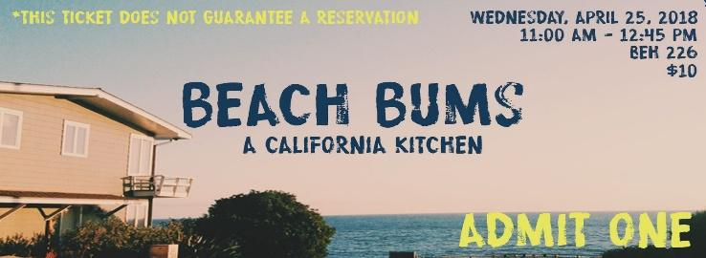

Table of Contents
Food and Beverage Financials
Number of People Served(Summer) 4
Receipts(Summer) 2-15
Actual Raw Cost(Victoria) 16-21
Sales Report(Summer) 22-23
P and L(Summer)……………………………………………………………………………24-26
Comment Card Evaluations
Histogram(Summer) 27
Analysis(Summer) 27-28
Testimonials(Summer) 28-29
Checklists(Taylor) 30-32
Managers Evaluations
Summer Horvath 33-34
Emma Tom 35-36
Taylor Pegram 37-38
Devonte Smith 39-40
Victoria Roberts 41-42
Celeste Lozano 43-45
Weifeng Zhou 46-47
Marketing Analysis(Devonte) 48
Food Photos with Descriptions(Emma) 49-51
Photos of Event(Summer/Victoria) 52-53
Menu(Emma)…………………………………………………………54
Marketing Materials(Summer/Emma) 55-57
Service and Service Recovery
Diagram of Kitchen and Dining Room(Summer) 58-59

Employee Tasks(Summer/Victoria) 60-64
Waiting List(Emma) 65-66
Decoration Analysis(Taylor) 67
Service Recovery Analysis(Weifeng/Taylor) 68
Personnel Analysis
Check in sheets(Summer) 69
Staffing Analysis(Emma/Celeste) 70-71

Number of People Served
126

Receipts
Amazon Receipts: $233.61
Walmart receipts: Cherae and Devonte gave Moshen $53 for Naan Bread
$46.86 is the total of receipts attached
Copy and Send Receipts: The total was $103 without the faculty discount. Steve will call Moshen to settle this charge.

P & L Comparison
Our final P & L for Beach Bums was a loss of $376.93. However, from our forecasted P & L, we thought we were going to lose $506.28 thus we made back $129.35 in food/beverage sales.
Food Sales: For food sales, we projected 120 guests and we had 126 covers which means we made $1260 which is roughly a 10% difference. It was nice to have some sort of turnover.
Beverage Sales: Now, in our forecasted P & L, we forecasted $82.50 but on our meal day, we skyrocketed to $179 which was a $96.50/ 2.17% increase because we sold 33 alcoholic drinks and 41 nonalcoholic. Our servers did a great job in selling our beverages to try to help our bottom-line.
Cost of Goods Sold-Food: Our forecast stated we were going to be buying $950.22 which was 79.2% of our total sales. We re did the requisition and dropped it down to $852.34 which created a drop of 20% in total sales. A $98 drop in our food costs helped our bottom-line.
Cost of Goods Sold-Beverage: Now our beverage cost was increased by $28.16 because of having to buy the rest of our beverages at Walmart. We forecasted $73.83 for our beverage cost which was 89.4% and we ended up spending $101.99 which dropped our total sales to 70.8%.
Gross Profit: We made an increase of $226.22 from our forecasted which is a 14% increase.
Expenses: Our linen, Music, Supplies, Promotion, Employee meal, and R & D expense price did not change from the forecasted to the actual. Decoration had a $39.62 increase because we bought a helium tank for our group and Team 5. Our printing increased by $40.25 because we needed to purchase our comment cards and menus. Lastly, we had 9 comps the day of our meal which resulted in a $27 expense. In total, these expenses were a 24% increase to our expenses.
Final Analysis: Overall, we still lost $376.93. But we did make a 13.31% decrease from the forecasted to the actual. We wish we could have cut expenses in some way. This would have saved us from being in a loss. However, our restaurant looked great and all of our marketing materials looked great; we believe this is why we had 126 covers.

Comment Card Evaluations

Overall, we think our comment card ratings were through the roof. We didn’t receive a bad score on any of the graded sections. We got a perfect score on cleanliness, a B+ on quality of service, and an almost perfect score on atmosphere and food quality. The best additional comment we received was 22 overall great experiences. After that, there was 8 comments about the staff having a good attitude. Some shout outs would be to Jailene, Nayeli, Anna, Maddy, and Oscar.
Some other strengths we had were the atmosphere and menu choice. Most of guests believed that they went well together, and we maintained the theme. As well as having the DJ; there were many comments regarding how amazing the music was and how professional he was. Also, having a vegan friendly option. We thought vegans/vegetarians would not want to come because of our menu choices but our servers made sure they were taken care of. This was great for our management team to read because we think most of our guests enjoyed their time at Beach Bums.
Even though we received a lot of good feedback, we did receive some constructive criticism. Our management team feels our employees were weak the day of and that might be because of each server having three tables with huge amounts of parties coming all at once which can be difficult. As well as being short staffed. It is stressful, so it is understandable. Some of the criticism was getting the order wrong and having it be a long wait to get their food. For future meals, we would suggest to the future leaders to find as many volunteers as possible and give your unexperienced servers less tables. Everyone tried their hardest and most of the comments showed that they understood the circumstances.
Some other issues were the vinaigrette in the salad was too sour. Our team suggests to make sure to taste test before sending it out. It might also be a preference thing, but we want to try to make sure to accommodate to everyone. Another issue was running out of minute maid lemonade. Now, this was because of under forecasting. We did not expect the demand to be so high so if we had to do this again, we would make sure to buy more than enough. And lastly, there was a comment about the drink service to the tables being slower than food service and the additional comment was to have specific runners to run drinks from the bar. Our team liked this comment, but we just did not have the labor to be able to execute.
In conclusion, according to our comment cards, we did fantastic. Our team received a lot of praise from our guests and employees. We tried very hard and of course there will always be issues. But it is all how you handle it and how you execute in the future. If our team did this again, we would take all this advice into consideration to make a better Beach Bums California Kitchen.
On a side note, a piece of advice was left on a comment card that read, “If you put your socks on before your pants, it makes life a lot easier.” Thank you random stranger for this great advice, I will make sure to share this with the rest of my employees, so they are aware. Now, you may read some testimonials from some of our guests.
Parker Wojciechowski: “Beach Bums was a completely immersive restaurant experience. The food was stunning as were the specialty drinks and I loved the DJ & decor. It all set the theme and made the event feel even more special. The customer service by both the waiters and the event hosts was outstanding; they are clearly the outcome of superb training. I only wish Beach Bums was a real restaurant!”
Gianni Giancola: “This was my first time at a hospitality event and I thought Summer and her team did a great job in creating a restaurant. The service was quick and great. I liked how they were able to make my food vegetarian friendly. The price was in my budget. The blue peach on the beach tasted amazing and the peach was the best part. I liked how they had music playing because it fit the beach themed vibe. Overall, it was a great experience.”
Leak Koepp: A “Kelp” Review of Beach Bums California Kitchen
“Our group had a very enjoyable lunch at Beach Bums yesterday. We were seated immediately upon arrival, even though we had a large group. We also had more in our party who arrived late, and they were also promptly seated at our table. The hosts and servers went out of their way to accommodate us, so we could all dine together. The first thing we noticed was the décor – the restaurant had a fun beach/nautical theme which was very tasteful and not at all like the Krusty Krab – a tranquil scene of waves crashing on the beach played on the flat screens throughout the dining room, and the wait staff wore flowered Hawaiian shirts. Even the menus had an attractive beach theme.
Speaking of the menu, it consisted of exactly the kind of light, healthy fare I’d expect to find at a beach café. I ordered the spinach and artichoke dip appetizer with tortilla chips, and it arrived hot and creamy, with a nice seared crust on the cheesy dip. My seatmate’s Cobb salad was fresh and crisp, and the dressing had a nice tang. For my entrée, I had the chicken avocado flatbread, and was impressed with the generous size of the portion. I was more impressed, however, with the taste of the dish; the chicken was moist and plentiful, the bacon was smoky and crisp, and the chipotle sauce was nicely peppery and went well with the flatbread. I ordered the churros with honey and chocolate sauce for dessert and they were the perfect cinnamonny-sweet taste after my spicy entrée. Everything I ordered looked wonderful, and my seatmates’ plates also were attractive and appetizing.
The service was also excellent – Yuni and the other runners/expediters took good care of our large table, and were friendly, attentive, and engaging throughout our meal. One minor complaint is that our food was a little slow coming out, but Yuni and company kept our drinks fresh, and we were having such a great time that we hardly noticed. Also, Beach Bums is obviously a very popular place, because it was packed! But we were kept very comfortable and happy and we would definitely return.”

Checklists
Front of House Checklist for Meal Day

Day Before Meal:

- Decorate
- Check Linen
- Roll Napkins
- Set up tables

Day of Meal Before Opening (Check - In):

- Attendance and Uniform Check (Shoes, Socks, Pants, Top, and Name Tag)
- Check TAM and Health Cards
- Vacuum Carpets
- Step up dining room tables according to layout
  - Checking linens (seam down, centered, no stains)
  - Centerpieces are placed according to photo
- Finish decorations
- Store both cabinets with ice and water
- Clean and put out serving trays and jacks
- Store both cabinets with cups, linens, napkins, silverware
  - Water glasses and silverware are all same size and polished)
  - Napkins are rolled
- Take out trash cans of dining rooms
- Clean and refill condiments
- Make sure there are comment cards, pens, and receipt holders at each service station
  - Refill Paper
- Check service station for setup and cleanliness.
  - Test soda/coffee
  - Clean out trays
  - Set up back station with glasses, ice bucket, sugar, straws, creamers and lemons
- Clean the entry of the classroom by the host stand
- Check ice machines
- Clean all seats (including the bar seats)
- Check/Program POS System with Mohsen
- Check bar for setup and cleanliness
  - Make sure all items are in well
  - Have all glasses polished
  - Ensure caddies, garnishes, and rags are present and prepped
  - Ice well
- Check - In with kitchen staff
- Assign additional help (HMD 253 students)
- Make sure entertainment is ready (music, live band, and projectors)
- Check the lighting in the room

Day of Meal Closing Procedure (Check - Out):

- Clean the entry of the classroom by the host stand
- Turn off ice machines
- Clean all cabinets with ice and water
- Place trash cans back in the dining rooms
- Refill paper in POS
- Clean all seats (including the bar seats)
- Vacuum Carpets
- Ensure all checks are closed
- Make sure we clean/collect all comment cards, pens, and receipt holders at each service station
- Make sure all tables are placed back in the proper closets
- Bring all dirty dishes to dishwasher
- Check service station for cleanliness.
  - Clean floor mats
  - Clean coffee and soda trays
- Check bar for cleanliness
  - Return all items
  - Wipe down bar and wells
  - Label left over garnishes and put in fridge
  - Make sure all glasses appear back in bar
- Return all workers attire for the next class if necessary.
- Make sure take down all decorations in the dining room and bar area if necessary.
- Make sure all glasses and silverware are stored in kitchen
- Make sure all dishes are washed.
- Make sure entertainment is shut down (music, live band, and projectors)
- Return lighting to normal

Back of House Checklist:

Day Before Meal:
- Have station map ready
- Have all recipes printed
- Know what staff members oversee what station
- Make sure all equipment needed is in store and ready for use
- Prep any items needed ex:
1. Chicken
2. Bacon
3. Dressings
4. Shrimp
5. Cut limes
- Make sure all ingredients are in sight and ready to go the next day
- Make sure all prepped items are stored and cooled down in accordance to health regulations
- Make sure all items are labeled so staff knows what items are to be used
- Make sure we are aware how many prepped items we have and for how many guests

Day of Meal Before Opening (Check - In):
- Set up all stations needed with equipment and sanitation*
- Put up recipes at their designated stations
- Check and gather all needed ingredients and prep items
- Ensure POS system is functioning and printing orders servers input
- Check in staff and make sure everyone is in proper uniform- and have their cards
- Ensure all staff is following proper SNHD policies and procedures
- Hold an effective Pre-shift with BOH team
- Assign staff to proper stations
- Ensure staff is aware of the food they will be plating
- Ensure staff is aware of the process in which to execute their assigned dishes
- Make sure plates are at hand and ready according to the dish being plated
- Ensure proper communication and organization within kitchen staff is in place

Day of Meal Closing Procedure (Check - Out):

- Break down all food stations
- Make sure all kitchen equipment and dishes are properly washed and sanitized
- Ensure any leftover ingredients are properly wrapped, labeled, and placed fridge
- Sanitize kitchen tops and make sure all stations are wiped down
- Communicate with FOH ensuring all dirty dishes are placed by the dishwasher
- Air dry all kitchen utensils and equipment
- Put kitchen utensils and equipment away in their proper spots
- Sweep and mop kitchen
- Break down dishwasher sink and clean
- Ensure all kitchen is left clean and organized before any BOH staff leaves

Managers Evaluation
Summer Horvath:
Being General Manager is such a hard job. It takes a lot of organization, persistence, and strong work ethic to keep your team in line. I feel I had twenty times more work than the rest of my management team because I took the role on being the team leader. However, I am glad I did it. I learned so much about my strength and creativity as a leader. Since day one, I made sure we got all our projects in and passed with flying colors.
Now, my team was so great. I believed we worked well together because there was never any issue of getting things done. I gave everyone their tasks and we all got it done. There was no arguing, there was no issues, and we all made sure we were on the same page.
Leading up to our meal day, we had a sit down a week prior to discuss our meal day and we went through all our training manuals. We did not want anyone on our team to feel lost because we wanted our staff to know that they could come to any of us the day of with a question and all of us knew how to answer it.
Now through that week, I made sure we had everything in order and organized for prep day. I bought a bin with supplies for the management team and I designed clipboards with all of us having the same information. Those came in handy approaching our meal.
Now I couldn’t have asked for a better prep day. We got in at 8:30 AM with having all our food for the kitchen and drink materials for the bar. The only thing we did not have was the bread for the flatbread. From 8:30AM to 2:30PM, we prepped our entire menu with no issues. Our team each had their own responsibilities for the day. At 2:30PM, BOH sat down to discuss their timeline for the next day and FOH started Décor. We got everything completely set up and it took a lot of pressure off. The only minor setback was not being able to find our linens. I was not aware to come check the prior Friday, so we had to search for them. We found the linens, and everything was fine. We stayed till 5:30PM prepping the dining room.
I personally got to the dining room at 6:30AM the next morning to start plugging away. A lot of our staff came early, and we just flew through our checklist. Having the employee tasks prior to the meal was such a great idea because no one was wandering. However, one thing that pushed me back was the DJ having trouble with valet, so I had to run to Student Union and help. That time took away from me going through my own checklist, but the rest of my management team got it done. By 10:40AM, the dining room looked amazing, the staff looked amazing, the food looked amazing, and I was confident in our management team. At 10:45AM, my family rolled in and that was the starting of the stress. They had a group of 14 and so we had to add a table to the dining room which messed up the server’s layout. Then we had another party of 14 come in and we had to combine tables. Then by 11AM, we had a packed dining room and the running around began.
During our meal, I feel that our strengths were our communication, marketing, attitude, food and atmosphere. I believe our team had great communication on what each of us needed and we tried to delegate and make sure we all know who was delegating what. We marketed the event very well and had a full house. We had a lot of family and friends come which made it easy to get our numbers. The staff’s attitude was great and made all our guests feel welcome. The food had a lot of great remarks and the atmosphere/theme including the DJ brought it home.
Our weaknesses were being short staffed, long wait times for food, the changes to our dining room and running out of lemonade. I believe if we had more staff, it would have run better because they would not have been getting pulled into so many directions. Since we had a server out, I had to pull a busser, so we only had two bussers for 18 tables Then we had three food runners running 18 tables including the bar. And lastly, we had our servers running around with multiple huge parties. So being General Manger, I had to step in and be a server for four tables because my employees were struggling. Being short staffed, the complaints about long wait times, and the changes to the layout last minute were all factors to the stress added onto our team and the rest of our employees. For future meals, I would suggest finding volunteers or having more in the class, so it is easier to staff the meal days. Lastly, we hit our forecast for our strawberry lemonade, so we ran out of lemonade half way through. We should have over casted and bought more lemonade, so we could have made more beverage sales since we are in the hole $400. But I am proud of my team and staff for hitting all our goals and working hard under the circumstances of the last-minute changes.
My biggest takeaway is being prepared for everything and do not assume anything. I was not prepared for the craziness from the moment the dining room opened. I thought I had everything accounted for and thought it was going to go smoothly. In life, things happen, and you learn from your mistakes. I feel like if we could do this again, we would make sure to ready for the craziness. And I assumed my staff was going to be ready because of all the practice we had. Being Team 4, we had to give all our employee’s new positions, so I think that also became a factor in the struggling because they have not done their positions before. Next time, I would make sure to have more employees, maybe less tables, and more training for those unsure of their position.
I feel like I was a good general manager and my team did amazing. Our team got a lot of praise afterwards for all the work we put in. I wish I didn’t have to be a server for four tables and I wish I could have observed a little bit more but being a leader means stepping in and helping. I needed to help those that were struggling, and I wanted to be there for my staff.
Overall, I believe we did very good and our hard work did pay off. I took lead in this project and I am proud of the work I did. I would love to do this again and fix the mistakes we made. We had a good concept, process, and execution. Lastly, we had such a great team. Our meal day went amazing and I am so blessed to have had this experience. We definitely were not bums in this Beach Bums California Kitchen.

Emma Tom:
Overall, I feel that our service went pretty smoothly. In the beginning, it was a little hectic but as the service went on it calmed down. There were a lot of guests that came in the beginning, so there was a long wait time. At one point the wait time was 45 minutes to an hour. We had to turn away a lot of people because of this. There were many parties that stayed for a while so it was hard to turn tables. We also did not have enough menus. We would constantly have to run back menus to the host stand. Although the service went pretty smoothly there were some servers that were confused and struggling during the service. On some tables the guests would get seated, but the server would not come to take the orders for a while, so the guests would sit there for a while. The service was slow and servers were getting confused with orders and the POS system. If I were to redo this I would make sure all the servers were on the same page beforehand. I would make sure every server knew exactly how to work the POS system so there is no confusion. We should have made sure beforehand that the servers were comfortable with what they were doing. Another thing we could have worked on was communication with the staff. Some servers would fall behind but they would not communicate that they needed help. I would make sure next time to let them know to ask for help rather than falling behind and making the guests wait. There were also some times that the table numbers would be put in wrong, so the food runners would get confused when bringing food to the table. The food runners would bring food to the wrong table, or a table would already have gotten their food and someone would bring more food to the table. The service in some areas were also slow at times. Some tables would get neglected and they would be waiting a long time for their food, while other tables would be served in good time. A lot of people waited long for their food, so I had to run to the back to try and get their food out to them faster. We decided to serve food at the bar, which I thought turned out to be pretty successful. It was helpful because people that only had a party of 1 or 2 could enjoy food without taking up a whole table. This gave us more opportunity to serve more parties. The downside to serving food at the bar was that each seat was considered a table, so we had about ten more tables added on to the other tables in the dining room. There was only one server at the bar, so the service was a little slow. We were also short staffed. One of our servers was not able to be there, so we had to change a busser to a server, which made us short a busser. Many of the tables were not getting bussed when they needed to be. As a result, the tables were not getting turned as fast as they could have. We did have a volunteer as a food runner, but we were also short on food runners. We had three food runners. If I could do this again I would try to get more volunteers sooner. Since we did not know until last minute we would be short a server, we did not have time to get more volunteers. I would try to get more volunteers so we have a backup plan if someone is not able to make it. It would have been better to have more staff than to be short like we were. Towards the end of the service, we ran out of the shrimp tacos and the spinach artichoke dip. We did change our forecast for the artichoke dip to more, but we still did not have enough. We thought that the shrimp tacos and flatbread would be equal in the forecast, but more people preferred the tacos. We would let people know that we were out of those items before they were seated, though, so many of the guests did not have a problem with it. A lot of people wanted their food to go, and we did not have all the to go boxes ready in the back of house. If I were to do this again, I would have a better plan for take out. I would have the servers put a note in with the order that the order is take out and make a plan so the back of house can box up the food right away, instead of having the servers throw it in the boxes. This would have helped with the long wait times too. People could have gotten their order to go instead of waiting for an hour, and we would have gotten more guests. The only downside to serving more guests, would be that we would have ran out of food faster, since we did run out of food with just the guests we had served.

I feel that the day before the service for setup we were very prepared. We got a lot done the night before, so it was easier to set up that morning. The only issue we faced the day before was an issue with the linens. We did not know we were supposed to check the linens the Friday before, because we thought that was done the day before. We were very stressed because it looked like we were not going to have our linens, but the linens ended up being dropped off to the Stan Fulton building. If we would have checked on the Friday before, we could have avoided the unnecessary stress. On the day of the service for set up, we each had a clipboard with a list of tasks that needed to be completed before we opened. We assigned our workers to certain tasks, as to make sure everything got done. We did get started a little late with the pre shift meeting because some of our staff was late, but we were still able to get everything done in good time. We were able to delegate tasks so we were not rushing to set up. After our meal for breakdown was also pretty organized. We had our staff assigned to certain tasks so not everyone was just standing around, and we were able to leave on time. Our marketing was also successful. We sold presale tickets, passed out flyers, sent out an email through the hospitality email, and used word of mouth. On the morning of our service we also had some of our employees pass out flyers outside of the building and around the student union. We could see the success of our marketing by how many people attended. Another thing that helped bring people in was the menu. A lot of people really liked what we were serving and a lot of people came from our poster. We also had a dj, which I think helped to attract people to the restaurant and entertain people. We advertised that we were going to be having a dj and a full bar, which I think was another good selling point. Throughout the semester I think my team had really good communication with each other. We were able to get everything done and we were pretty prepared. We all worked very well together and did not have problems working together. I feel that the managers had pretty good communication during the service. When the back of house ran out of the spinach artichoke dip and the shrimp tacos, they let us know so we were able to let our staff know. If I were to do this again, I would definitely have a more in depth training with the staff. I would make sure everyone was comfortable with serving, and if they were not I would try to give them less tables, give them more assistance, or even switch roles if they are really not comfortable. I would also get more volunteers because it was stressful trying to fill in positions and being short staffed last minute. Although the service was a little hectic at times, I still feel that our event was pretty successful. Our team worked very well together, and we were able to communicate with each other not only on the day of the service, but also throughout the semester.

Taylor Pegram:
Opening a restaurant and being apart of this class, as a worker and a manager has made me have a better appreciation for this industry. The amount of work and dedication to our team and ourselves is incredible. We had a very strong team and a team leader, Summer, and us staying on top of each other is the main reason our meal day was such a success. Successful for my personal goals: fill up the dining room and team goals: be prepared managers.
I was very nervous, morning of, about the attendance. Days before, I was going around the athletic building and the Thomas and Mack Center harassing countless amount of coaches, athletic directors, and student – athletes. I found getting guarantees across the board, very nerve racking. Our attendance during meal day was 126 when we had a forecast of 120 and we stopped letting guests come in at 12:15. I was personally in charge of the Hosts area. Having done this position every week, with two new people who had no experience made it more challenging. Especially since our busiest time was when doors opened. Jessica, our greeter and track keeper, had a difficult time juggling and if I had the chance to do it over again, I would have explaining in detail, my advice. My biggest advice to her would have been to always greet the guest first and ask for a moment to get yourself together and your workstation together. Alex, the walker, did fantastic. Before the lunch, I tapped down instructions and tips but in the moment, it was too overwhelming as a whole. With us serving at the bar, we had to give a set amount of menus to the bartenders. This caused us to run out of menus so fast, plus having large parties (as big as 15) – made it really difficult. If I could do it again, I would have planned for more menus and putting an emphasize on the walker, Alex, and the servers to bring back menus when they had a moment.
The day before our lunch, our general manager, Summer worked our butts off to make sure the day of the meal would be as easy as possible. Not just on the workers but on us. The décor/food preparing took us from 8AM to 5PM and even though it was a headache, it ended up being worth it. Our décor was simple but noticeable. From working the other lunches, it was helpful to see what did and what did not work. I believe that is what we went with: balloons, fishes, surf boards, and the blown up animals kept the known theme appreciated. We also played surf videos on both sides of the classroom so all guests could enjoy and by Mr. Mohsen’s recommendation, we placed the DJ in the center of the dining room. The food preparation was fairly easy although we were missing a few key items. We prepared around the lunch that was going on Tuesday. Areas that we struggled with were following the food sanitation guidelines. For example, one of our group members did not follow the proper protocol when cooling down the chicken. But, Chef made sure to correct us and let it be known that steps absolutely needed to be follow to ensure, at least the Back of the House, would get a good grade.
Our marketing plan served us right. Like stated before, we had a total of 126 guests and we were forced to stop taking names at about 12:15. Our marketing plan surrounded around social media, our inner circle, including friends and family, the athletic population, and the students and staff of UNLV. We had our posters plastered across the campus, little versions placed on the windshield of cars, and asked the front desks of the ASC and Rec Center to hand out flyers as people entered and left the buildings.
In conclusion, this capstone class and lunch has shown me so much that I thought I knew and corrected me. Although food and beverage is not my favorite choice when it comes to Hospitality, this class has made an appreciation out of this industry.

Devonte Smith:
From the start of this semester after reading the syllabus I though this class would be extremely difficult. During the first day of class my suspicions were confirmed. Majority of the first day was just loads of information being thrown at us. After meeting with my group for the first time thing started of slow. By the next class our cohesion began to get better and more organized. Lucky for our group everyone was a team player from the beginning and our General manger always kept us on track. From the beginning, I volunteered to be the bar manger to gain some useful experience in the field. I already had server experience so in my mind that was the next step. I utilized my more than helpful team and we created our alcoholic and nonalcoholic drinks on the second day of class. Throughout the semester I continued to redefine the drinks and make them complete. Moving forward, I notice the bar was a problem area for most capstones. Luckily my lunch was toward the end of the semester, so we had ample time to prepare. The common problem that most groups had were they did not have a simple method of handling the drink tickets or they did not have enough personal at the bar. I made sure to take note of their mistakes, so we would not repeat them. After most groups didn’t seem to have enough tables for all their guest my group and I decided that we wanted to open the bar for drinks and food. This was quite the stretch because at the time no other groups volunteered to have the bar serving food. 2 weeks before or service group 3 also server at the bar. Unfortunately, they did not have a lot of guest, so I could not properly analysis their success, but I still learned a lot. Leading up to prep day I summarized the short coming of my fellow class mates and I came to a few conclusions. I had to gather as many volunteers as possible to help me behind the bar. That area tends to get over whelmed very fast. Having one person and myself was not going to be ideal, especially if we are severing food as well. Additionally, as the bar manager I should not be working as a bartender, but more along the lines of over seeing the operation and helping when necessary. Prep day went extremely well once we got all our ingredients together. In total, we spent a little more than 6 hours in the kitchen prepping food for the next day. Its unlucky that students have to miss classes in order to prep for the capstone. After the kitchen we moved on to the front of the house for the bar I prepped the week before so Moshen and I were on the same page about what drinks I needed. In total we spent an additional 3 hours prepping the front of the house. I feel that prep day is very useful and the fact that we spent a little more than 9 hours preparing for the lunch was another factor why we were so successful.
The day of the Capstones started of a little rocky in my prospective. Regrettably for me I had many volunteers but no actual bartenders form the bartending class at UNLV so that made me quite nervous. In my mind, I still felt that we had strength in number so the more volunteers the better. After 30 minutes of finishing up the bar I was notified that we did not have any naan bread due to some complication. Myself and the TA had to retrieve the items from the store or we would not have an entire entree from our menu. I was willing to take one for the time but it give me 2 hours less tome to finish the bar and train my volunteers correctly which crippled us throughout the service. Once returning from multiple Walmart’s, I had a little over an hour to get everything ready. Needless to say, we barely got it finished in time before the first guest started to arrive. I had three volunteers arrive in total. Unfortunately for me only one arrived 30 minutes before the service, the other two arrived only 10n minutes before and one forgot her tam card at home. Things did not start the way I wanted to. I attempted to catch them all up as quickly as possible. Luckily, I had a bar server that knew the ins and outs of this class already which ensure the section of the bar ran smoothly the entire service. What really saved the bar was the fact that I already had a plan to execute. I wanted half my volunteers on well drinks and the other half on specialty drinks. I felt that if we divide the responsibilities up everyone would know exactly what to do and where to move at all times. Additionally, I had told the severs prior exactly where to place the drink orders and how they would be placed so they could grab the drinks when ready. Although the bar ran smooth we had a few issues. My non-alcoholic drink, the strawberry lemonade was 86 within 40 minutes of the service I grossly under estimated how popular the drink was, looking back I would buy at least 9 64 oz than just 3. The clean was a bit more than anticipated, this was due to me losing a few hours of prep time in the morning, I did not have enough time to get my volunteers caught up on how to use the dishwasher for the bar drinks. My last resort was to us the main dishwashing stations but not all bar classes where the same, so the process was very slow. Dishes began to pile and the area became a little unsightly but toward the end we had it under control once we got the bar dishwasher started. We had more than 20 more guest that what we minimally needed. We had more tips than any other group and I am almost positive the best comments in the class.

Victoria Roberts:
Overall, back of house absolutely excelled on the day of our lunch. We had little to no issues caused by employees or managers in the back. I feel that it went so well because we had such a strong game plan for our prep day, the day of, and the fact that the employees had finally gotten a hang of everything by the time our lunch came around. Every employee was willing and eager to help with any and everything I asked them to do.
For our appetizers, there are a few things I would have changed in order to make our service better. For one, I would make sure to order and make more chips for our artichoke dip as the chip to dip ratio was off for the guests. I would have also made more alfredo sauce for the dip and for the flatbread. Towards the end of the lunch we ran out of alfredo sauce and ended up having to use ranch for the flatbreads because most of our alfredo sauce was used in the artichoke dip.
As far as entrees go, I would have put more employees in charge of making the flatbread. Although the flatbreads are quite simple to make, they are quiet time consuming and the lack of storage for cooked flatbreads also hurt the production time. If I would have had one employee assembling the flatbread, one in charge of getting them in and out of the oven and cutting them, and one adding the final toppings, it would have went much more smoothly when the influx of orders came through. I also wish I would have thought out more about the storage of the flatbreads. Because they cook fairly quickly and are easy to assemble, I assumed that they would be out the door more quickly than they were. If I could do it again, I would have utilized other ovens to keep them warm and crispy, I would have had to also research how to ensure the flatbread would have stayed crisp, because my biggest fear for them was them becoming too soggy. With the shrimp, the first thing I would have done, if I could do it again, was order more. In our forecast, we originally had both entrees being ordered 50/50; however, on the day of service we found that a lot more people were actually ordering our shrimp tacos. I also wish I would have checked the size of the tortillas on our prep day. I briefly glanced at the tortillas on our prep day just to make sure that they were there but I did not verify the size of them, so on our meal day we found out that we were using the wrong size tortilla which made the assembly of the taco more difficult and the look of them slightly less appealing, in my opinion.
Finally, I feel that everything went the smoothest in our dessert section. We had no problems coming from that section, other than the fact that we over-ordered the fruit. The desserts were mostly prepped the day before and for the parts that were not, they were simple and easy to put together. The employees quickly found a rhythm over there and it was smooth sailing.
My biggest issue in the back was myself. I was overseeing everything before it went out, which I did just fine at, but I have a hard time just letting people do their thing. I do not micromanage, but I tend to want to do everything myself. So instead of assigning employees to do tasks sometimes, I would just start doing it myself while trying to do three other things, answer employee questions, and make sure that food was being put out correctly and in a timely manner. The best thing that I did to make our day go smoothly; however, was making a list after our prep day of what needed to be done the next morning and randomly, but evenly, assigning it to employees the day of the meal. This way, all employees were staying busy and productive, and everything was able to get out in time for opening. It also ensured that we did not over prep the day before so that everyone wasn’t just standing around on the day of and food was not to its optimal freshness with the timeline and ingredients that we had. The only other thing I can say about the day as a whole was that communication really is key. We were very good on communicating throughout the semester when it came to all of our assignments, however the day of ended up being our weakest time in communication, but the time we needed it most. At one point, orders were getting entered in twice, given to the wrong tables, tables were getting food twice, and it was just a complete and udder mess, and the back of the house had no idea there was an issue with the POS system until half way through the lunch. It became very hectic at one point, which is what I believe caused the lack of communication, and if we had just assigned one manager from both the back and the front of the house to communicate super quickly if anything went askew, we would have avoided some major issues. Overall, though my back of house managers and staff did an amazing job and absolutely exceeded all expectations for our lunch.

Celeste Lozano:
On our service day, everything went smooth and was, in my opinion, a very well-run day in which all management and staff took part in. Management arrived and was set to go at 7AM, BOH had a few volunteers also there already. Throughout the entire preparation and service all staff was busy at work and efficient in every area, helping make that day a full success.
Evaluating this day from beginning to end it can be seen how effective management was, the arrival early on in the day helped fuel the smoothness that was created throughout the day. The ability of our management staff being able to delegate staff early on in the day was extremely helpful, as volunteers helped us get ahead of schedule, willingly helping in any areas needed. The ability for staff to be flexible and take on roles, that might have not been written down, also helped. This can be seen as people who were set in the dessert station, were given tasks in helping prep more spinach and artichoke dip, and how they were able to help and full-fill multiple tasks. As this was the case, there were challenges that arose within our service day, but these were then taken care of by staff and management.
Some of the challenges included, not having Naan bread, which was ordered but not delivered as the rest of our items were. One of the FOH management team members took it upon himself to get Naan bread for BOH, as he could get away from his tasks for a bit as opposed to BOH management. This allowed for us in BOH to stay focused on the food for guests and getting it to the right quality and freshness needed. Although it arose as a challenge since it wasn’t already in stock, our FOH management member was able to find the bread we needed, and bring back to us in efficient time, which once again helped stay on top of schedule. Looking back at this issue, even though it was resolved, there could have been steps taken to prevent us not being fully prepared with all items. On Pull day, we should have taken it upon ourselves that night to go out and get the bread needed, that way on service day we would have been sure of where the bread was, and not expected that it could have maybe been delivered. A seen on our R&D day, the bread was also not delivered then, in which we also had to go out and buy some of it. As this problem had aroused before, we should have taken this into high consideration and importance, that way no management would have had to leave campus that morning to find high qualities of it service day morning.
Another challenge we came across was as mentioned previously, realizing the prep for spinach and artichoke dip was not enough as we had forecasted. It was an issue we were able to resolve fairly quickly, as management, we pulled aside two people to help prep. What also helped was having all the recipes printed. We got the ingredients needed and asked our two staff members to help us make a new batch of dip. We could have just gone with what we had, and called it a day, turned away and just worked with what we had. Luckily, we had our recipes set and ready to go. It was a good call, as even all the additional dip we had made was later towards the end of service 86’d as well. Being prepared to prep any additional items helped us, not fall behind, and be even more prepared when it came down to opening. We would have done the same thing for our shrimp, although we fulfilled the orders we had predicted, we only had one extra plate of shrimp left. Which was okay, for the fact that we just met our predictions. Although always having more than being worried if we were going to meet our goal or not is better. Besides remaking the artichoke, and having just enough shrimp, all of our other items worked and came out fairly well.
An issue that arose, was one in which FOH played a role in as well. This was seen when tickets would come in with tables that had special orders, yet, the servers came in running after to change or add to their order. This was an issue when they ran in 10 seconds after, for example, the cobb salad appetizer was sent out. This appetizer came with blue cheese on top, and the servers coming in 10 seconds later, this service step was then missed. The guest received their appetizer with cheese, although the good thing is the cheese didn’t come in all mixed already. The guest was able to remove any items not wanted. Although in contrast to this, many tickets would come in asking for no onion on the flatbread, nor the shrimp tacos. Which wasn’t a problem at all, since these two plates had no onion to begin with. It might have been a slight miss communication with the menu, but the plus is it seemed as if this guest request was certainly not ignored. Although there were some ticket problems with the servers and what they in-putted, the back of the house team did an essential job in making sure every guest got their plate of food.
While there were a few challenges, there was also a lot of things that went extremely well. The management team had printed out tasks for each staff member to work on, in case there were down times. The staff were all executed well in different stations, setting the entire team up for success before we opened. This was seen through multiple people helping each other out, and taking in all knowledge gained from previous services into this one. By this time, we were also able to see the strengths and weaknesses of our team members, and we accordingly set each one where we felt they would perform best. This allowed for every team member to be placed in a position they would feel comfortable in and also excel in. Being able to understand our staff helped us be able to run smoothly on the service day as well. In addition, even when times were stressful everyone helped plate, and moved around where they knew they could be needed. Even though we had to manage and delegate at the beginning, when it came to the actual service, the staff knew when it was time to take action, and how.
Another thing that worked extremely well the day of service day, was making sure we took into consideration what our practice day showed us. We believed that adding chipotle peppers, as our first recipe stated was the way to go. Although, the feedback received was that they were extremely spicy for some people, and even lacked “flavor”. This helped us during prep, making sure only the sauce was put on them, and even thinking about marinating the shrimp. This whole process allowed for a better flavor and just a light chipotle kick. Taking that into service day really helped us ensure guests were content and pleased with their food. Avoiding customers not being able to eat their meal or even return food that was too spicy for some of their taste buds. Changing up some of the items ensured consistency and acceptance of our guests on service day.
Overall, our service day was a success, as well as a growing and learning experience. There are a lot of things that went into the making of service day. There were a lot of preparation measures that helped us run through smoothly. We learned that you can be prepared, but it is essential to be overly prepared. If the naan bread would have been there at the beginning, the other member of our group could have focused on something else. Yet we were lucky enough to be able to afford to send someone over in the first place. Yet, this isn’t always the case, in a real restaurant you have to assure your products are in because typically no one can simply leave in that type of environment. We had great learning opportunities which we were able to analyze and learn from. Just as we pushed through challenges, we also saw from previous services what needed to change and what we as a BOH team would do better. This was delegating our staff more and being prepared as a whole. Being second to last really helped us analyze what to do, and how to do it, helping make BOH a very well-organized group.

Weifeng Zhou:
We finished our event on this week. It is undeniable that our event was successful and each guest got served at the appropriate time. As a pastry chef and chef steward, I need oversaw and instructed each member. I also supervised them to ensure that they followed the sanitation guidelines. In addition, the staff ensured that they prepared adequately for the event with all the necessary menu and practiced on each recipe expected. In as much as the staff members were organized for the event, they had minor challenges that they proved to be professional in their respective teams since they utilized their skills to solve the challenges. Thus, the event comprised of both challenges and solutions to them.

The following members did a commendable job in the pastry section:
- Yoghurt Station (Tanner Jackson)
Tanner proved to be a diligent person in the group. He was able to accomplish all the tasks within the stipulated time and thereby satisfying each customer. First of all, he is a clean person and thus no one had to worry about sanitation since he did his work well. He washed and cut fruit in a proper way, and did most of job on this position. Also, he gave me many advises to make sure everything become better. He was able to prepare as per the customer’s needs, which proved to be satisfying. Moreover, when he finished his own job. He started to help churro's station. He knew how to bake churro in a proper way, because he did this on first event. So, he helps the stuff who on churro station, and gave us many useful advises, like how to make churro bake better, what time should we start to bake, how to keep churro in a proper way. Overall, Jackson had a vital part to play and he did it accordingly.

- Churro Station (Tian Ze Yang and Daiki Hayashi)
Tian Ze and Daiki were also great team members who did their work accordingly. They were in charge of preparing churro, which is a Spanish snack consisting of a sweet stripe of fried dough often eaten as a dessert. First of all, they were very hygienic and thus no one had to worry about health complications arising from poor sanitation. I think cleanliness accounts to the diligence of each team player. One of my friend came to my event, and she said this made her eat more than she thought she could considering that it was her first time to eat churro, and she really love it. Notably, Tian Ze and Daiki had prepared churros in excess since not all people who had bought tickets came to the event. Fortunately, since each guest like the churros, they ate more than expected and thus the duo and other organizers did not have to worry about wastes. Another notable issue is that the Yang and Hayashi were fast in every aspect of their activity to ensure they managed to satisfy management's needs on time. Also, before the our open, both of them help the fruit skewers station. They help cutting fruits and making yogurt. We cannot finished everything on time without their help. At the end of the day, they were exhausted but had already accomplished the task successfully. I have to say that both of them proved to be efficient staffs in the event.
- Dishes Station (Yedam Lee and Zi xuan Wu)
Yedam and Zi xuan were in situated in the dishes section to ensure everything was going as planned. The two were very hardworking and proved to be dedicated to their tasks. They were able to clean all the dishes fast without supervision, which showed their virtue of self-control. In addition, they were able to follow all the safety and sanitation guidelines. According to the plan, everything had to be accomplished by 2:15pm, which was achieved through each member’s commitment.

Challenges and Solutions
At the beginning of the event, everything was going according to plan although there were few challenges, which through appropriate strategies was solved efficiently.
- One major challenge pertains to the lack of adequate food runners. When the restaurant opened, the number of customers exceeded the stipulated ratio of food runners, which proved to affect the planned activities. Fortunately, 10 minutes after opening, there were volunteers who enhanced every activity of the day.
- Another problem that arose pertains to taking orders. For instance, guests waited for appetizers on one section when the restaurant opened yet, all the food runners were designated in entree area of picking the food. Consequently, there had to be changes of plans where ticket orders were issued at the appetizer section. Later, the food runners could now pick the entrees after accomplishing the first task of serving appetizers. However, the appetizers were inadequate at first though with efficient planning and coordination, the staff members were able to prepare everything on time.
- One more problem that arose was due to incorrect ordering of food. For example, one guest ordered for shrimp taco though with the exclusion of the shrimp. For this reason, the person in charge prepared it with only cabbages and avocado sauces. However, Chef Hekili saw this and thought that it was incorrect although he consulted the guest who approved that he wanted it without shrimp, so he talked with that guest and double check what is this guest exactly want. When Chef Hekili came back, he allowed the dished to be prepared according to the customer’s request, he adds more ingredients in taco, like red peppers and avocados, to made a special taco for that guest. This dish proved to be impressive since our team was able to improvise a special taco for vegetarian guests. Also, I learned a lot from this little interlude. First of all, when some guests ask for special requests, like can I get vegetarian style for shrimp taco? As a chef, we should go talk with guest, and double check what they want before we start prepare. If someone want shrimp taco without shrimp, I won't just take out the shrimp from taco. Secondly, we should communicate with severs all the time, to make sure what is our guest exactly want. For example, in this situation, as a chef, we should make sure severs tell our guest, if our taco without shrimp, the taco will only have cabbages and avocado sauces, and then we should ask guest if they want any other ingredients in the taco.

In brief, our event was successful. We sold out spinach artichoke dip and shrimp tacos, and we almost sold out all California cobb salad and all desserts. All our staffs arrived on time, some of them came early to help us prepare food at 7:00 am. Also, they all worked hard to ensure every activity was accomplished successfully. In as much as the staff was diligent, there arose several challenges that through consultation and cooperation were solved without raising further problems. For instance, there was a shortage of food runner though through the inclusion of volunteers, the members served all the guests as per their needs. All in all, the week’s activity was successful.
Marketing Analysis
For our event we wanted to bring in 120 people. We went above and beyond our standard goal of 100 and even broke our personal goal of 120 by having 126. A success in our marketing would be our family members and friends. We had more family and friends than anything other target market. In the beginning, we had two large parties that nearly totaled 30 guests. We used a variety of different strategies to draw in our guest and ultimately, we were successful. Our target market was faculty, students, student athletes, and outside guests. Each team member will be responsible for 5 presale tickets. We ended up sale 30 out of 35 which is a comfortable 86%. We implanted marketing by utilizing word of mouth, flyers, Facebook and our own beach bum website. We started our advertisement 2 months ago to give awareness. Our flyers were designed to catch the eye of an potential guest. We wanted to use Lively beachy themed colors to show how fun and exciting our lunch was going to be. For the student athletes, our Dining room manger spoke out during the gathering of the University’s captains to spread by word of mouth and we passed out flyers at Thomas and Mack the day of. We had additional managers speak to their fraternities and sororities. We obtained a radio spot that aired the day off our event and we passed out flyers the day of the lunch as well. Our Beach bum website Facebook page was a success as well we obtain over 50 RSVPs, the RSVP help us get an accurate count of who was going to attend. Lastly, our website issummerhorvath.wixsite.com/beachbums which received lots of praise and helped many of our guests with directions to our lunch. Our website had all information needed to know the ins and outs of the event. The link was located on all flyers and posters to give guests additional information.

Differently:
We could have tried to get more of an accurate count of the RSVPs. In the beginning of the service we were hit hard with a few large parties, that we were not ready for. Also, we think we could have had even more faculty involvement. Majority of our guest were friends and family and only 30 percent were faculty. Other groups had a much higher number of faculty involvement. Lastly, we think we could have saved more money on printing by not printing 400 flyers which would have benefitted our P & L. Overall, if we ever did this again, these are some of the considerations to market for the next time.

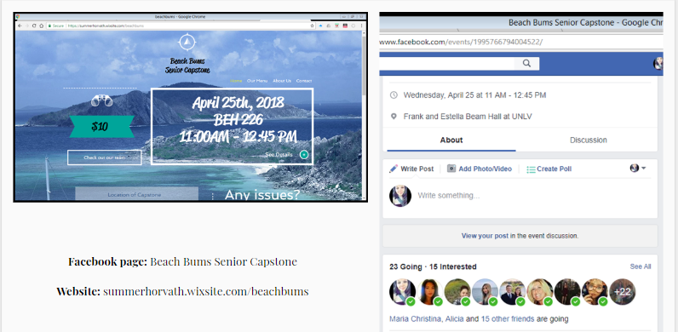

Food Description with Photos
Food Menu with Photos
Cobb Salad: fresh romaine lettuce topped with avocado, blue cheese, red onion, and tomatoes, served with a vinaigrette dressing on a medium circle plate. This takes 20 minutes to prep, cook, and plate.
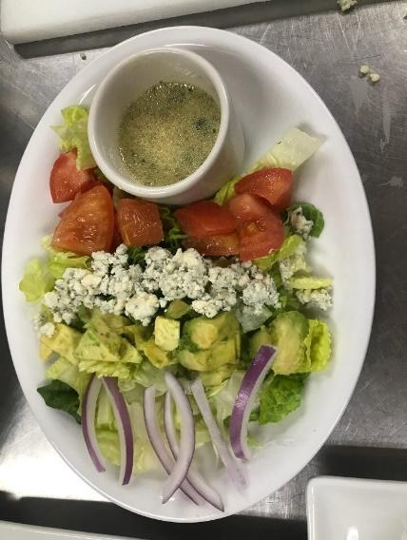

Spinach artichoke dip: creamy blend of mozzarella, parmesan, artichoke hearts, spinach, and garlic, served with tortilla chips on a rectangular plate with a deep oval shaped dish for dip. Takes an hour and a half to prep but will be prepped day before and 10 minutes to cook/plate.
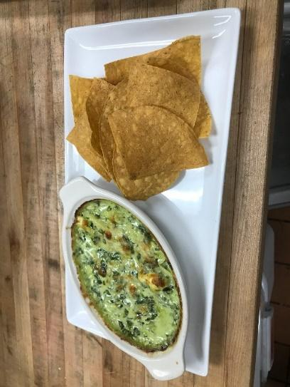
Shrimp tacos: sautéed shrimp on warm corn tortilla, garnished with cilantro, lime, and a sour cream avocado sauce on a deep clay circular plate. Takes 15 minutes to prep with 5 minutes to cook.
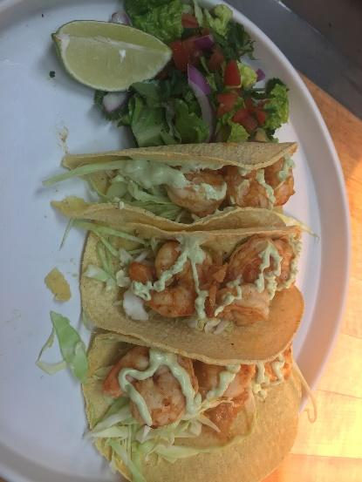

Chicken Avocado flatbread: Fried chicken flatbread topped with Applewood smoked bacon, avocado, red pepper, cilantro, and creamy chipotle ranch sauce on a large square plate. Takes 20 minutes to prep and 30 minutes to cook.
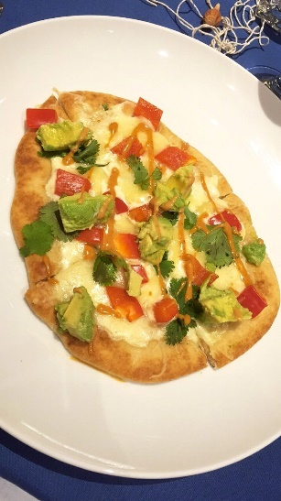

Churros: warm churro sticks drizzled with chocolate sauce in an oval small desert dish. Takes 5 minutes to cook and 5 minutes to plate.
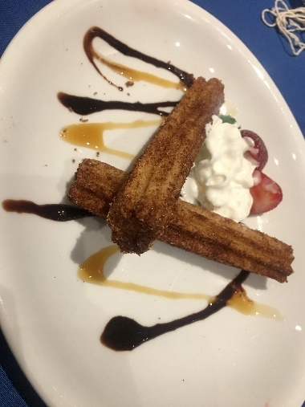

Fruit skewers with vanilla-honey yogurt dip: fresh kiwi, strawberry, cantaloupe, and grape on a skewer served with a vanilla-honey yogurt dip in a ramekin on top of a large rectangular plate. Takes 20 minutes to prepare and 5 minutes to plate.

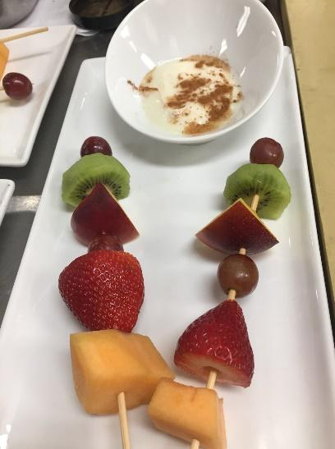

Beverage Menu with Photos
Blue Peach on a Beach
Ingredients
1 oz Peach Vodka
1 oz Cranberry Juice
1 oz Orange Juice
1 oz Peach schnapps
½ oz Blue Curacao
1 Wedge Peach
How to mix
Fill a shaker with ice cubes. Add all ingredients. Shake and strain into a chilled hurricane glass filled with ice cubes. Garnish with peach.
Time to prepare: 2 min
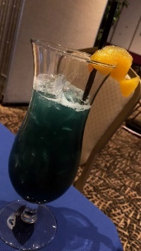

Strawberry lemonade
Ingredients
6 oz of minute maid strawberry lemonade
1-2 sliced strawberries
How to mix
Add all ingredients into a chilled Pilsner or Collins glass filled with ice cubes. Fill with club soda if necessary.
Time to prepare: 1 min

Photographs of Event
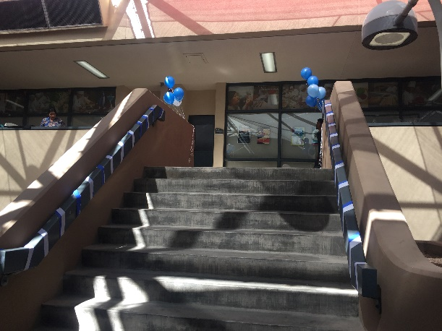
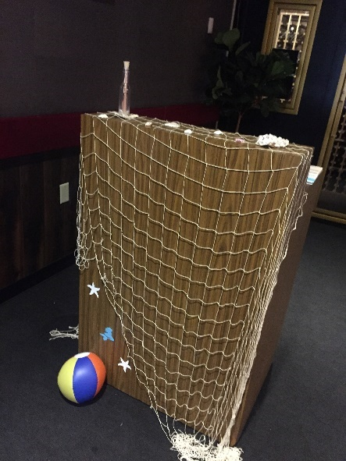
Decorations:
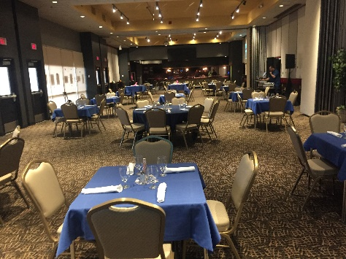
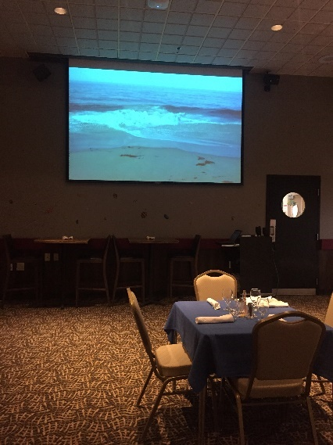
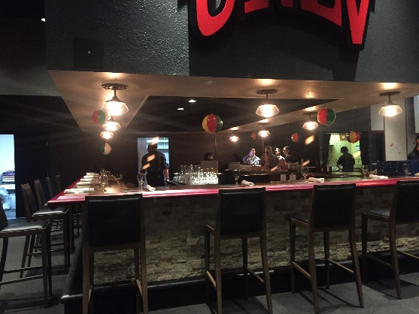
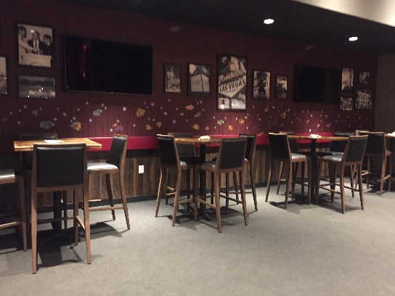

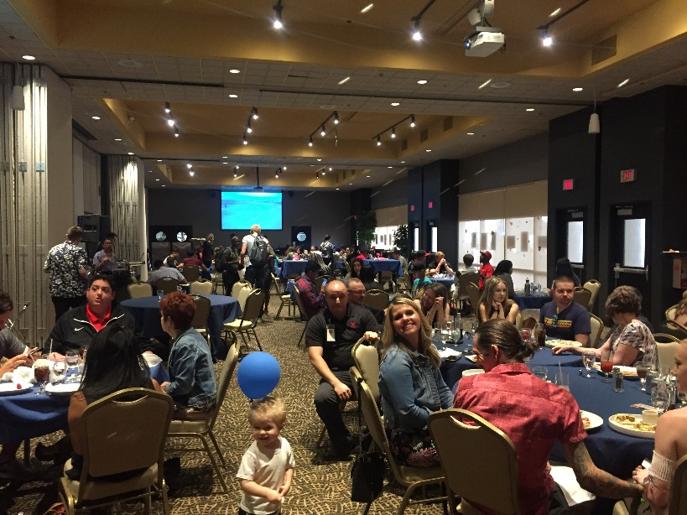
FOH:
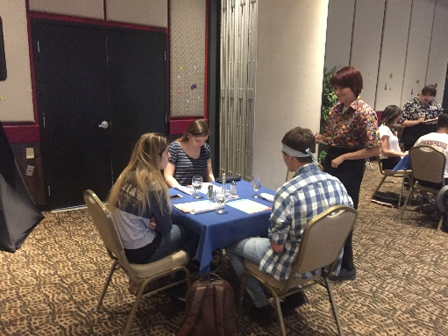

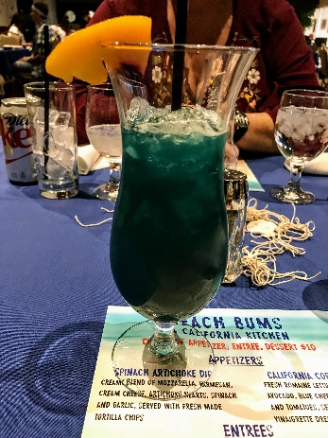
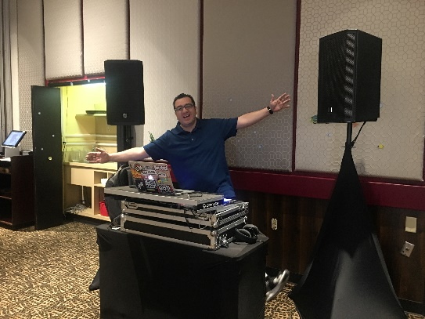

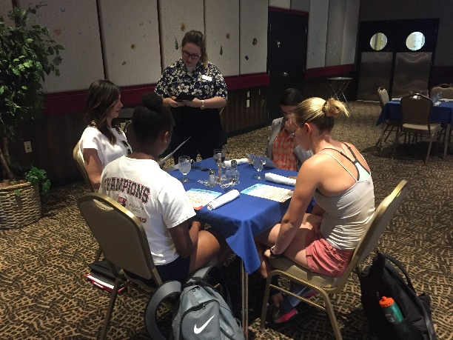

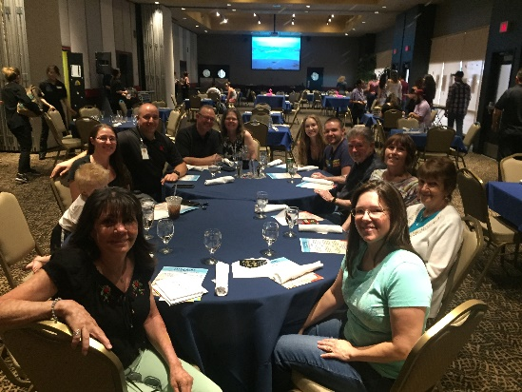

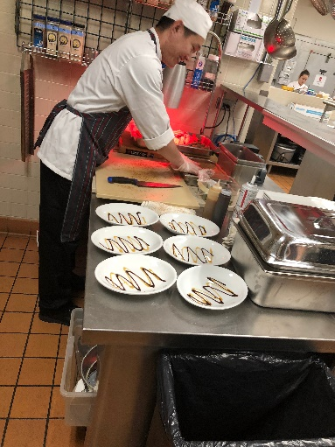

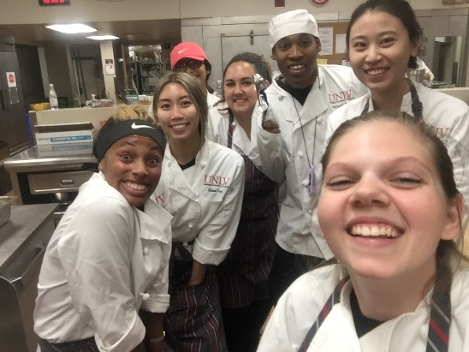
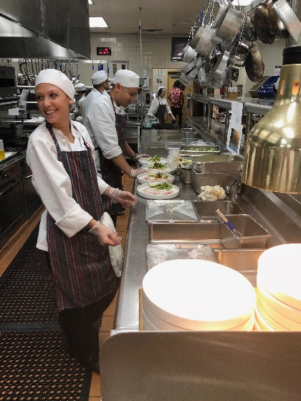
BOH:

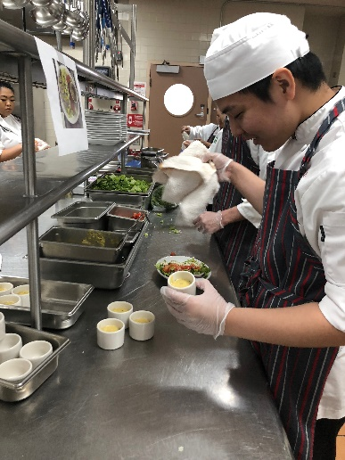
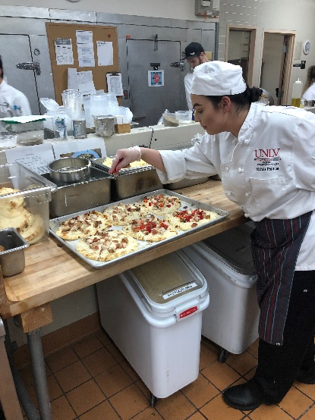

Final Diagrams

BOH: No changes were made.
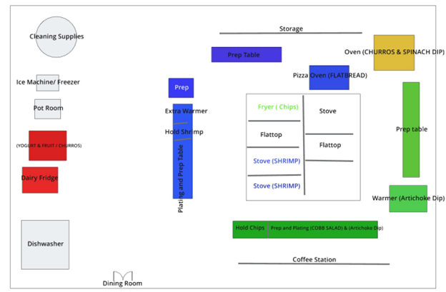

FOH: Our diagram changed slightly for big parties. We added a table in Section 1 and combined/ added a table in Section 6. We also switched the area of the DJ to be set up because he needed power. Lastly, Mitchell was absent, so Brittney took over Section 5.
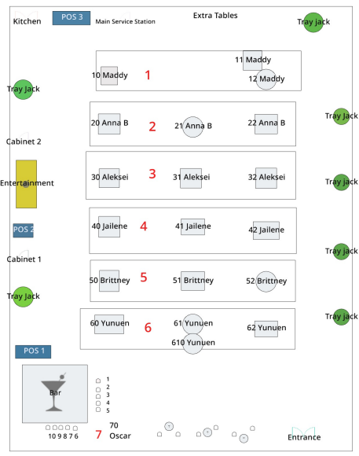

Employee Tasks
FOH:
Employee Tasks (Before meal)
Jessica Daum: Prep hostess table
o Have waiting list prepared
o Have map prepared
o Have menus prepared
Breakdown: Clean hostess table

Alex Webb: Vacuum morning of service
- Clean and put out serving trays and jacks
- Prepare hostess table with Jessica
- Breakdown: Bring trash cans back in and put away service trays

Oscar Lopez: Prep bar
o Polish glasses
o Number seats at bar 1-10
o Make sure all items are in well
o Have all glasses polished
o Ensure caddies, garnishes, and rags are present and prepped
o Ice well
Breakdown: Clean bar

Aleksei Reyes: Make sure there are comment cards, pens, and receipt holders at each POS station
o Refill Paper
Breakdown: Put POS stations away

Anna Burton: Store both cabinets with cups, linens, napkins, silverware
o Water glasses and silverware are all same size and polished)
o Napkins are rolled
o Refill condiments
Breakdown: Put Cabinet away

Yunuen Martinez: Setup centerpieces and help with other decor
Breakdown: Put centerpieces away and help take down decor

Jailene Vasquez: Store both cabinets with cups, linens, napkins, silverware
o Water glasses and silverware are all same size and polished)
o Napkins are rolled
o Refill condiments
Breakdown: Put Cabinet away

Madison Black: Prep main service station in kitchen
o Test soda/coffee
o Clean out trays
o Refill condiments
o Follow checklist
Breakdown: Put service station away

Michelle Chan: Polish Silverware and Glasses
Breakdown: Put away silverware and glasses

Anna Lei: Set up dining room and help with service stations
o Linen, napkins, silverware
Breakdown: Put tables and chairs away

Lei Fu: Polish Silverware and Glasses
Breakdown: Put away silverware and glasses

Brittney Chancellor: Set up dining room and help with service stations
o Linen, napkins, silverware
Breakdown: Put tables and chairs away

Nayeli Sosa: Blow up balloons, and pass out flyers outside of BEH
Breakdown: Take down decor

Allison Pipo: Blow up Balloons and pass out flyers outside of BEH
Breakdown: Take down decor
Positions of Front of House

Hostess: Jessica Daum
- Have dry erase map and waiting list form prepared
- Open doors at 11 AM
- Acknowledge all guests
- Greet
- Write down name of the Party
- Write down number in the Party
- Write down the time of their Arrival
- Make sure to smile, use guests name, and never leave post

Seater: Alex Webb
- Acknowledge all guests
- Track open tables & seats and inform main host
- Provide menus
- Memorize Table Numbers
- Promptly seat guests
- Assist bussers with set up
- Make sure to smile, use guests name, and inform head host of wait times

Bar Servers:
Oscar Lopez (7777)
Volunteer Haeden (8888)
Volunteer Roise (9999)
Volunteer Madi (0000)
SECTIONS: 70 POS 1 and Cabinet 1
***YOU ARE TAKING FOOD ORDERS AS WELL***
Example POS Table Number for Food Runners: 701 (70 is your section and 1 is the seat at bar)
- Wipe down bar chairs before service / number seats
- Must have Alcohol Awareness and Food Handler card at all times.
- Acknowledge all guests
- Check for proper ID’s
- Know the seat numbers at the bar for ordering
- Make sure the bar area is clean from spills
- Make sure the guests are satisfied
- Deliver drinks properly
- Present food bill with comment cards and pins
- Give payment to the cashier in the back of the house
- Give change back to customers/collect comment cards
- Follow all Sanitation guidelines
- Server food from customer’s left, serve beverage from customer’s right, and clear everything from the customer’s right.

Servers:
Madison Black (1111) SECTIONS: 10, 11 and 12 POS 3 and Main Service Station
Anna Burton (2222) SECTIONS: 20, 21 and 22 POS 3 and Main Service Station
Aleksei Reyes (3333) SECTIONS: 30,31, and 32 POS 2 and Cabinet Two
Jailene Vasquez (4444) SECTIONS: 40, 41 and 42 POS 2 and Cabinet Two
Brittney Chancellor (5555) SECTIONS: 50, 51, and 52 POS 1 and Cabinet 1
Yunuen Martinez (6666) SECTIONS: 60, 61, and 62 POS 1 OR 2 and Cabinet 1

- Acknowledge all guests
- Know tables numbers and your specific section
- Attend to customers when they arrive at their table
- Write down each seat number’s (clock way or starting with the ladies/kids) meal
- Deliver drinks properly / Check ID’s for alcoholic drinks
- Communicate with the kitchen for any allergies and all problems
- Ensure that customers are enjoying their meals periodically
- Present food bill with comment cards and pens
- Give payment to the cashier in the back of the house
- Give change back to customers/collect comment cards
- Follow all Sanitation guidelines
- Server food from customer’s left, serve beverage from customer’s right, and clear everything from the customer’s right.

Bussers: Michelle Chan
Lei Fu
- Acknowledge all guests
- Know tables numbers
- Always prepare dining room for guest arrival (cleaning table and its surrounding/ setting tables)
- Set up table decorations after the table is clean
- Make sure serving stations are stocked at all times
- Keep menus presentable
- Remove guest’s dirty dishes and cleaning all spills made as needed
- Maintain bar
- Serve water and refills to the guests
- Follow all Sanitation guidelines

Food runners:
Nayeli Sosa
Allison Pipo
Anna Lei

- Help organize food tickets for the cooks
- Deliver food to the customers in a timely manner
- Serve water or refills to the customers as needed
- Have communication with the front and back of the house
- Assist the teams with any additional help needed
- Follow all Sanitation guidelines

BOH:

Positions of Kitchen Staff

Salad station: Anthony Jamieson & Daiki Hayashi

- Slice avocados.
- Place sliced avocado on top.
- Sprinkle diced tomatoes and crumbled cheese.
- Follow all safety and sanitation guidelines.

Dip station: Marina Ruffo & Chaad Tam

- Place in warmer.
- Place on oval platter with handful tortilla chips.
- Follow all safety and sanitation guidelines.

Taco station: Miriam Sol Toraya & Olivia Barnaby

- Heat tortillas on flat-top.
- Place shrimp mixture in tortillas and sprinkle with cilantro.
- Place three tacos on platter with two lime slices and side salad.
- Follow all safety and sanitation guidelines.

Flatbread station: Taylor Phillips & Sara Sadaro

- Brush naan bread with olive oil.
- Spread tablespoon of alfredo sauce on bread.
- Sprinkle cheese, pre-cooked chicken, bacon, and peppers on top.
- Heat in oven.
- Dice avocado.
- Remove flatbread from oven and let cool.
- Sprinkle avocado and cilantro on top of flat bread and drizzle chipotle ranch mixture on top.
- Cut into four pieces.
- Place on platter.
- Follow all safety and sanitation guidelines.

Churro station: Tianze Yang & Daiki Hayashi

- Bake churros in oven.
- Roll in cinnamon sugar mixture.
- Place on platter, one crossing over the other.
- Drizzle chocolate sauce over the top.
- Spray small amount of whipped cream in the middle.
- Follow all safety and sanitation guidelines.

Yogurt station: Tanner Jackson

- Lightly sprinkle yogurt bowl with cinnamon.
- Place yogurt bowl on platter.
- Place two skewers on platter.
- Follow all safety and sanitation guidelines.

Dishes: Yedam Lee & Zixuan Wu

- Ensure all dishes are being cleaned, dried, and put away in a proper and timely manner.
- Make sure dishes are not piling up.
- Ensure bussers are organizing the dishes in a proper manner.

Decoration Analysis
Our decorations were themed with California beaches, the deep blue sea, and fun in the sun. As you walk up the stairs in BEH, you saw see dark blue, light blue, and white balloons so our guests know they are in the right place. Including streamers wrapped around the stairs. Approaching the hallway, you saw mermaids, seashells, and sea star cutouts in blue and white. When you walked into the dining room, and reached the hostess table, the first thing you saw was fish net hanging from the tip of the counter covered in seashells and beach balls. There was sea shells at the tables for those waiting to be seated. To your right, you saw the bar that had seashells in each corner and beach balls attached to fish line hooked by a tact hanging from the ceiling. As people walked to their table, they saw blue linen with our centerpiece and table setting. The center piece features a fish net with a message in the bottle and seashells surrounding the bottle. When the guests looked around the room, they saw fish located on the walls of the dining room. For our lunch, we had live entertainment and videos projected upon both sides of the dining hall. For live entertainment, we decided to go with a DJ. He came completely prepared for his two-hour shift. He played mellow music but also took music requests. His music was at just the right volume, not causing disruptions to people's conversations but also letting all of the guests get a hint of our theme. At the same time, we pulled up a video off of youtube: Relaxing California Beach Long Video, which gave people a feel of eating with the view of the ocean. The projector was displayed on both big screens of the dining room so it was accessible to both sides of the dining room. We believe our décor and theme took our restaurant to the next level.

Service Recovery
FOH:
A few of our servers had trouble staying on top of their tables. Not necessarily checking in between courses but more so putting in the correct food orders for the tables. The beginning of our lunch, our General Manager, Summer, had a party of 13 (her family) so Mr. Mohsen made accommodations and moved tables around. Instead of consistently following the flow of the numbers and sections, the server Brittney put the order under the wrong table number. This action caused for confusion for the food runners, who came to find a manager and we had to explain to Brittany her mistake. The table that did not get their food on time or staff members and we’re waiting for about 30 minutes before they got their main course. Another problem that happened, is that one of the service stations computer shut down we were unable to print tickets, so one of the managers had to go around to the servers that were using that POS system and tell them to write down all of the orders in great detail in great detail. The teacher’s assistant, Cherae worked for about 15 minutes to get the POS system back up and working, therefore we were able to resume our work.

BOH:
First of all, we are short of food runners when the restaurant just opened. However, 10 minutes later, volunteers arrived and came to help us. Also, we are a little bit mess when we start to taking order. The reason why is our food runners all wait on entrees station to pick up food. However, our guests need appetizers in that time, because the restaurant just opened. So, we change the plan, I gave the copy of order tickets to appetizers stations, and let them starting to make everything. Also, let food runners know pick up appetizers first and then came back to pick up entrées later. Moreover, during the event time, one of table ordered 7 chicken avocado flatbreads, and we did not give them on time. The reason why is the machine did not print out the ticket to notify us fire the chicken avocado flatbread for that table. When we find this problem, we started to made this order immediately, and one of our front manger came to help food runner carry food for that table. Also, one guest ordered for shrimp taco though with the exclusion of the shrimp. For this reason, we prepared it with only cabbages and avocado sauces. However, Chef Hekili saw this and thought that it was incorrect, so he went to talked with that guest and double check what they want. When Chef Hekili came back, he adds more ingredients in taco, like red peppers and avocados, and we made a special taco for that guest.

Staffing Analysis
FOH:
In the front of house, we were short staffed. We were short a server, so we changed a busser to be a server, which made us short a busser. We did have a volunteer as a food runner, but we were still understaffed. Altogether we had three food runners. We had two volunteers for the bar area and the manager, which was enough. If we could do this again, we would try to get more volunteers. Because we found out last minute that we would be short a server, we did not have time to find more volunteers. If we would have had the volunteers to begin with, it would not have been a problem. During the service the managers would also help out everyone, if they needed help running food or bussing tables. Another way to utilize what we had to work with would be to have the servers run some of their own food to help out the food runners.
BOH:
In our first set of assigning staff, we had a total of 13 people working in BOH. These people were all assigned to their set positions and each had a station which they would take over and work in. As somethings can change, on the day of our service day they did, but even though BOH wasn’t short staffed, these changed helped.
Before opening, when it came to gathering our staff member we realized that there would be a staff member missing. Which is something that is fairly common in the real F&B world. Many people call out due to personal reasons, and you can’t control what happens in someone life. Thankfully, we decided that it was possible to move staff members around. We also noticed that, this person was to be stationed in the dessert station, making it easier to move people around. Dessert station usually has a lot of people helping and able to help as well. Dessert is the last of the dishes, therefore being the last thing people need. Realizing that missing one member wouldn’t hurt us, we proceeded right away with delegating tasks and switching up who needed to go where, although it didn’t alter our set up in any extreme way.
Just like in the real world, sometimes there are on calls who can come in and pick up positions others can’t full-fil. On our service-day there were two additional volunteers who showed up, and we were able to excel more within our day. One was able to float and help where ever additional help was needed, especially helping out a lot in the dish washing station. The other volunteer also helped in being the one to thoroughly cook the shrimp, which all came out to good quality. Even though there was a loss in staff, there were people to replace and additionally help put even more.
Although we had enough staff, there were times when it became a bit stressful in the plating stations. In the shrimp, the tortillas had to be placed, a bed of cabbage, then the shrimp, an exact count of two, adding the side salad, and then topping it off with the sauce. Our staff stationed in that section got it down, and there were three people there. This was the same amount of people we had on the flat bread. This one needed all of its ingredients before being put in the oven, then put in the oven, and after 5 minutes, it needed to also have the sauce added on top. If both stations would have had an additional staff member, they would of most likely been less stressed, and would have gotten the plates out quicker. Although for the flatbread, it took a bit of time because of cooking time, which can’t be speeded up. An additional staff of two for us, would have helped. Yet, bringing in the real-life example again, many restaurants would probably only have two people per station, to lower labor costs. It can also increase a safety risk having many people in the kitchen and hit a company’s labor costs. Therefore, evaluating and analyzing as a whole, the staff member we had to put to work were very well enough people for us, to be put at full staff.
On service day while we did miss a staff member, there were volunteers that stepped in. This turned our service day from being considered short staffed, to working at full capacity. This allowed for guests to receive their food in a timely matter form the BOH point of view. It also helped clean-up go fast and efficient. Being able to finish cleaning the entire kitchen and utensils in a timely manner.

