Thank You CBS Radio: An Incentive Corporate Concert featuring Andy Grammar 

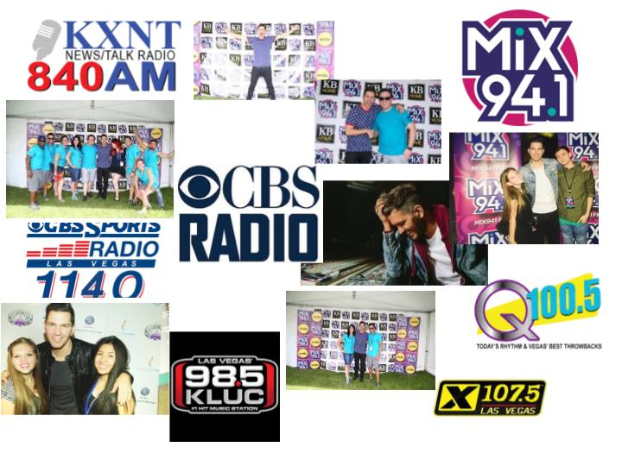

Summer Horvath, Tylere Adkins, Jordan Cunanan, Samantha Ranaudo

Presented by Party Patrol
Presented to Tony Perlongo General Sales Manager
On August 1st, 2017
Assignment due: November 15, 2017

Party Patrol
2000 Party Street
Las Vegas, NV 89147

August 1st, 2017

Tony Perlongo, General Sales Manager, CBS Radio
7255 S Tenaya Way
Las Vegas, NV 89103 Suite 100

Dear Mr. Perlongo,

Thank you for allowing Party Patrol to present a proposal for your incentive corporate concert for your staff on October 20th, 2017. Our event will be located at Brooklyn Bowl at the Linq Promenade. With a few tricks up our sleeves, we aim to impress your staff with a relaxing night out, filled with food, music, and drinks. Your staff will feel rejuvenated for the upcoming new year with this acoustic incentive concert.

In our proposal, we have included all the information regarding theme, floorplan, equipment, labor, sustainability, registration, location, check in, welcome reception, party favors, food and beverage options, tentative scheduling, as well as payment of featured artist. A timeline, budget and contingency plan will be enclosed to make certain no issues arise. Our budget is safely sitting at $15,000 to ensure a successful event. The artist, Andy Grammar, will come to $2,000, the chosen venue will be $10,000 and all other purchases will total to $2,000. Finally, we will have $1,000 set aside for contingency plans.

Thank you for the opportunity to present our proposal to you and your team. Party Patrol is looking to expand more in the music and media industry, and by working with CBS Radio, we know we can achieve that. If you have any questions, concerns or special requests, please do not hesitate to reach out. You can reach me at (702) 525-3064 or summerh@partypatrol.com We look forward to working with you and the amazing CBS team.

Sincerely,

Summer Horvath
Creative Director

Table of Contents

Cover Page 1

Confirmation Letter 2

Table of Contents 3

Specifications of Event 4

Creative Property 5

Description of Event 6-7

Timeline of Event Planning 8

SWOT 8

Theme 9

Food and Beverage 9

Entertainment 10

Event Schedule 10

Risk Management 11

Technology 12

Event Marketing 13

Event Equipment 14

Floor Plan 14

Investment 15

Human Resources 15

Sustainability 16

Event Team Page 16-17

Reference 18
Specifications of event

PRESENTED BY:
Party Patrol
2000 Party St.
Las Vegas, NV 89147
Phone: 1 (702) 777-1234

PRESENTED TO:
Tony Perlongo, General Sales Manager, CBS Radio
7255 S Tenaya Way
Las Vegas, NV 89103 Suite 100
Phone: 702-777-1234

DATE:
August 1st, 2017

EVENT:
FOR: CBS Radio
FUNCTION: Incentive Corporate Concert
DATE: October 20th, 2017
TIME: 6:00 to 8:00 PM
LOCATION: Brooklyn Bowl at Linq Promenade
IN ATTENDANCE: 200 total (100 employees, 100 guests)
THEME: Music

Creativity property

All ideas and concepts detailed in the enclosed proposal have been developed exclusively by Party Patrol for CBS Radio, and are considered by Party Patrol to be of a proprietary nature.

These ideas and concepts remain property of Party Patrol. In this respect, CBS Radio must honor our proprietary rights to the content of this proposal and refrain from disclosing its contents to our competitors or any third party.

Unauthorized use of these ideas and concepts is strictly prohibited. Should you wish to produce the ideas and concepts included in this proposal without retaining Party Patrol, a Design Consultation fee of $3,000.00 will be required.

All documents, written proposals, and other materials submitted by Party Patrol shall be returned to Party Patrol upon request.

Description of the Event
Location of Event: Brooklyn Bowl

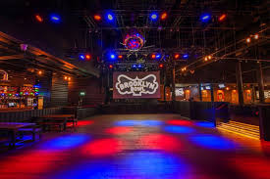
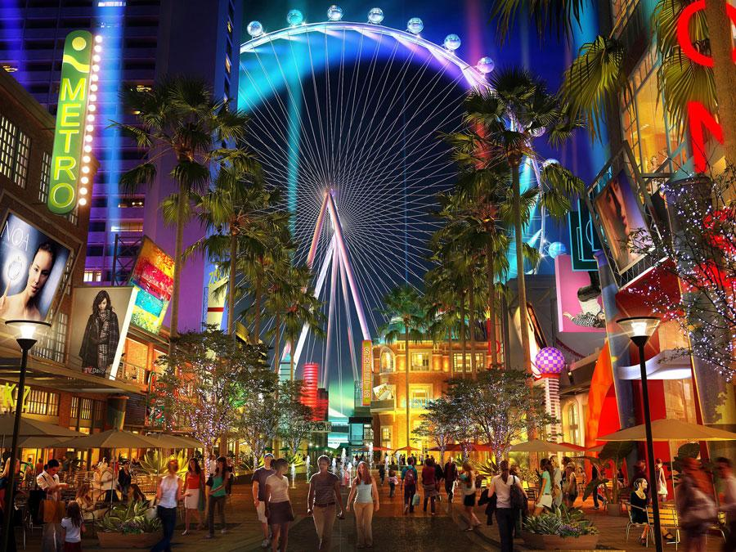
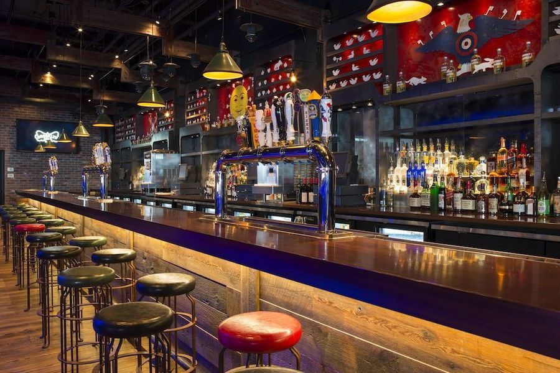
This venue is in the heart of the Linq Promenade. With neighboring businesses, such as In-N-Out, Sprinkles, Margaritaville, and Yard House, we were able to secure them as sponsors, who will supply discounts and party favors for our event. The Brooklyn Bowl offers a unique atmosphere that will welcome your team, as well as the performer, Andy Grammar. The rock n’ roll theme provides a dark and eerie vibe, making it perfect for an intimate and acoustic session. There is enough space to mingle, enjoy food and drinks, and to host a Q & A / meet and greet with the special guest. When the concert is over, the party does not necessarily have to end there. The Linq Promenade is perfect for the CBS Radio team members to enjoy a block party filled with live entertainment, picture opportunities, and food and drinks from our sponsors, using their discount cards.

Our Punch Card will look like:

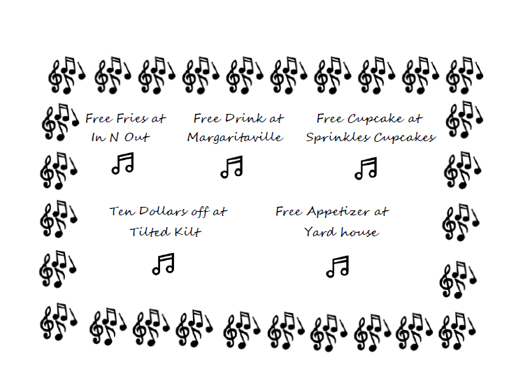

Our Light Up Party favors will be:

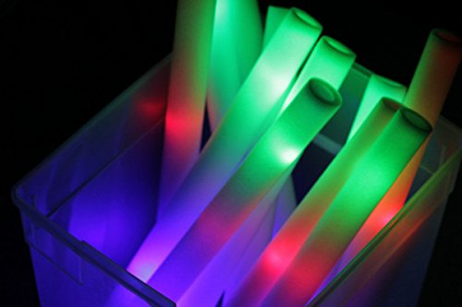

Proposed timeline of our event planning

June 5, 2017 -- Contacted Andy Grammar’s manager
June 19, 2017 -- Received confirmation for Andy Grammar
June 20, 2017 -- Visited prospective venues (including Brooklyn Bowl)
July 6, 2017 -- Contract signed with Brooklyn Bowl (pending acceptance by Tony Perlongo) July 19, 2017 -- Final site inspection of Brooklyn Bowl
July 23, 2017 -- Appetizer tasting / viewing of cocktail menu
July 30, 2017 -- Decor chosen
August 1, 2017 -- RFP submitted
August through October – Finish planning event

SWOT Analysis
Strengths
Event Team
No pay to park
Funding
Marketing
Weaknesses
Volunteers (where are we getting them and are they trained)
Long walk to venue
Too Loud

Opportunities
Threats
The event (Higher morale for CBS employees to want event again)
Holding other segments of a convention
Social media of celebrity
Gifts from sponsors

Running out of F & B or it not being liked
Employees not wanting to come
Celebrity cancelling
Food poisoning

Description of theme
The theme is based around music. Music being loud, upbeat, and fun. Sometimes working in the office can make you forget why you started working in radio; we would like to remind CBS employees the fun in radio and in the music industry. It will be a night all about them and their passions. This event will help increase employee morale. We do not need to decorate because Brooklyn Bowl has all sorts of rock n roll themed memorabilia that gives a great vibe for this show.

Food & beverage
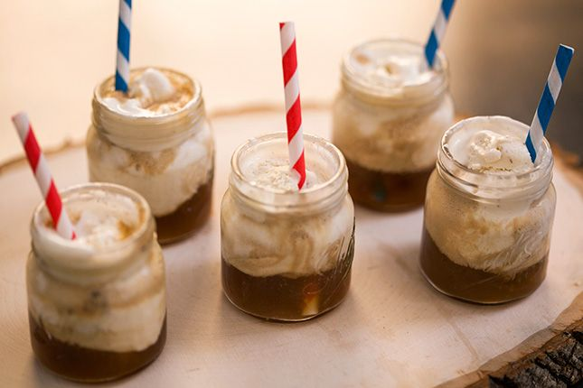
Hors d’ Oeuvres will be served in Brooklyn Bowl. They are $1000 which is included with the Venue. We will be serving 400 Hors Oeuvres throughout the night. Our Hors Oeuvres are from the Brooklyn Bowl Menu. They will be their Rock N Roll Fries with gravy, hummus and pita bread, fried calamari with lemon and cayenne mayo, BBQ pork sliders, wings, cake pops, and root beer floats. There will be an open bar for all employees over 21-year-old, and a full drink bar filled with soda, water, and tea. Limited high boy tables will be provided for eating and socializing. After the concert, we will have a block party that will have our sponsors involved.
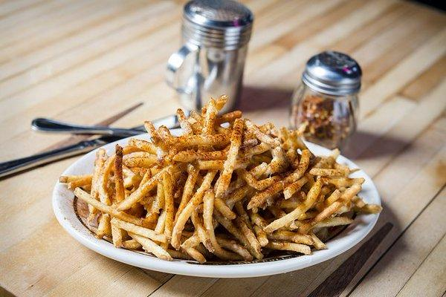
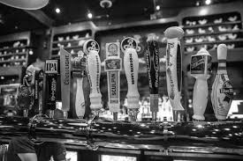
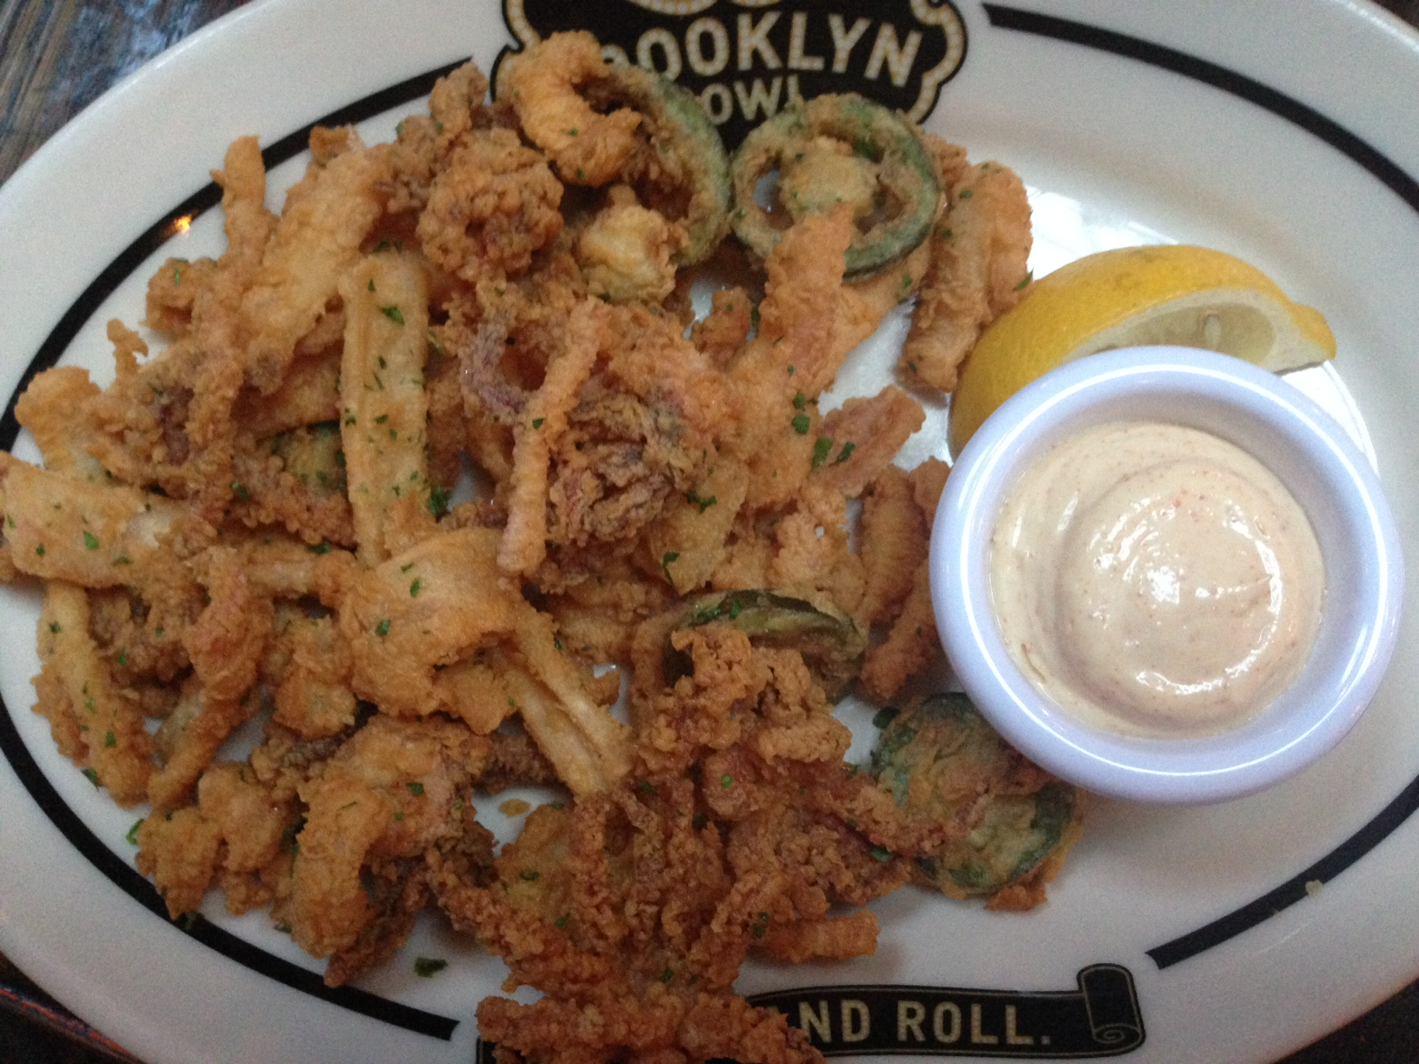
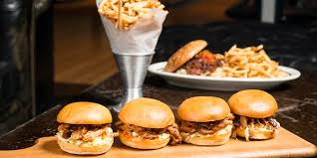
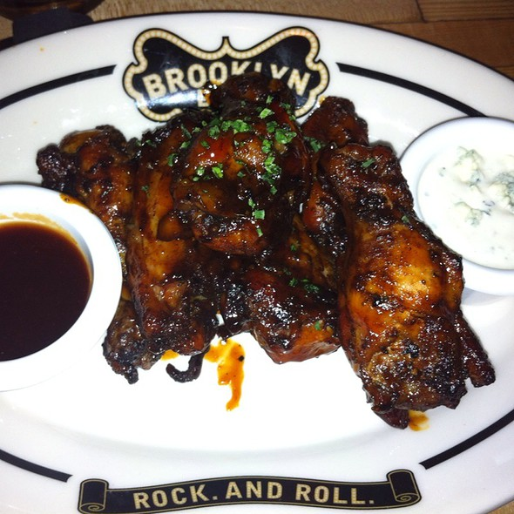

Entertainment
“It is a tale now well told about a street performer on the Santa Monica Promenade who has gone on to reach tens of millions of people worldwide. It was on that California street corner that New York-raised Andy Grammar earned his stripes as a pop star – truly shaping the rare and unique dimensions of the artist he is today. The crowds that gathered to hear him perform on the street are now millions of fans who attend his sold-out tours around the country. The work ethic, fortitude and generous spirit that took shape out there in a public space translated into his first body of work, an album ripe with optimism, encouragement and good vibes” (BIO, 2017). Andy Grammar will be the talent for CBS Radio’s incentive corporate show. He will be doing a 45-minute set, Q & A, and meet n’ greet. He will be paid for an hour and a half worth of his time. Party Patrol will oversee transportation, hotel room, and rider.

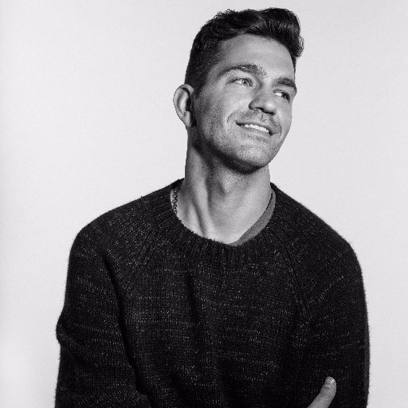

Event schedules

2PM: Load in
3PM: Set up high boy tables, registration table, and stage
4PM: Kitchen prepares Hors d’ Oeuvres
4:30PM: Band arrives from the Linq and goes to Green Room
5PM: Volunteers and staff arrives (they are told their job duties)
5:30PM: Soundcheck
6PM: Doors Open (Employees are given their punch card as well as light up party favor)
6:15PM: Andy Grammar Performs a 45-minute set
7PM: Q & A for 15 Minutes
7:15PM: Meet n Greet for 30 minutes
7:45PM: CBS Employees leave for block party outside

Risk Management (Health and Safety Issues)
Brooklyn Bowl has 3 emergency exits for easy access. We have $1000 in contingency just in case anyone gets hurt on the dance floor, while setting up, etc. The chart below details possible hazards that could occur at the event, who is at risk, the severity of the incident, and most importantly, the control measures Party Patrol has put in place to prevent such incidents.

HAZARD | AT RISK | RISK LEVEL | CONTROL MEASURES
Set Up/Tear Down | Brooklyn Bowl Staff | Minor | - Proper equipment will be used by venue staff  - Trolleys will be used for larger pieces of equipment  - Staff will be trained
Equipment | Party Patrol Staff / Brooklyn Bowl Staff | Minor | - Stage will not be overcrowded  - Equipment is to be used correctly  - Cables are taped down  - All staff will be trained on how to use the equipment
Transportation of Artist | Contractor | Minor | - Security will be provided  - Private entrance secured for artist
Fire/Electric | All on site | Serious | - All staff will be briefed on evacuation measures and procedures  - Fire exits will be identified in advance and accessible to all  - Power sockets will not be overloaded
Alcohol | All on site | Severe | - Bartenders will be trained and certified  - Wristbands provided to attendees 21+  - Security will be on site
Slips, trips, & falls | All on site | Major | - Suitable footwear worn by staff  - Cables are taped down  - First aid station on site  - Equipment will be used properly

Technology
The app that was created for the Thank you CBS Radio. On the home page, it has the map with the location of Brooklyn Bowl so that the attendees can find it if they get lost. The app also has the schedule of when Andy Grammar is going to perform, when the Q and A with him is and when the meet and greet starts. There is also a section that has the sponsors of the event and in that it says what they will receive from each sponsor.

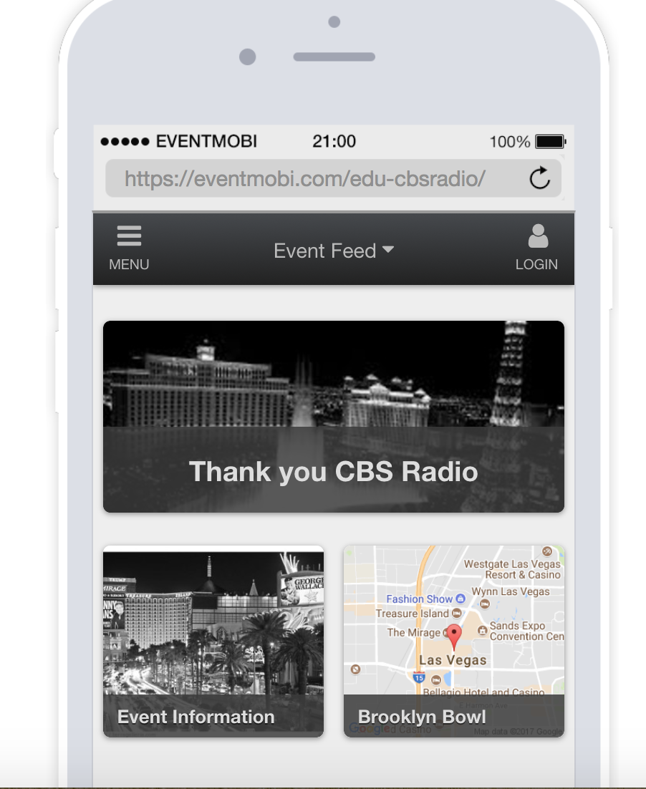
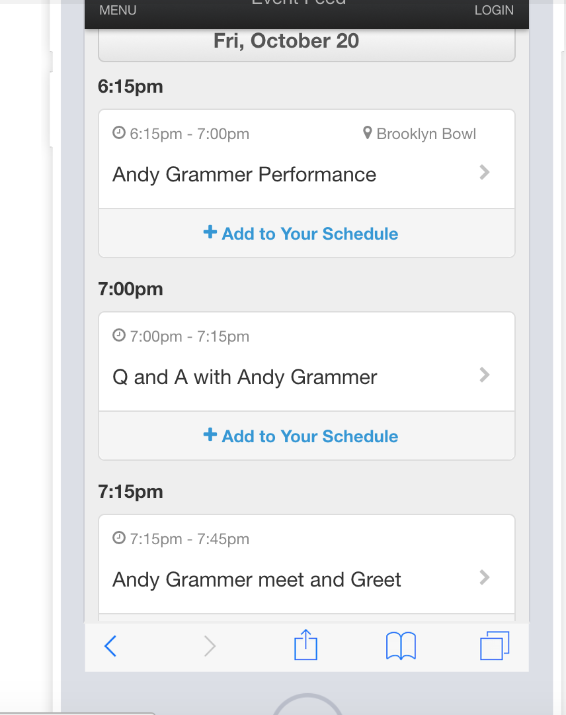
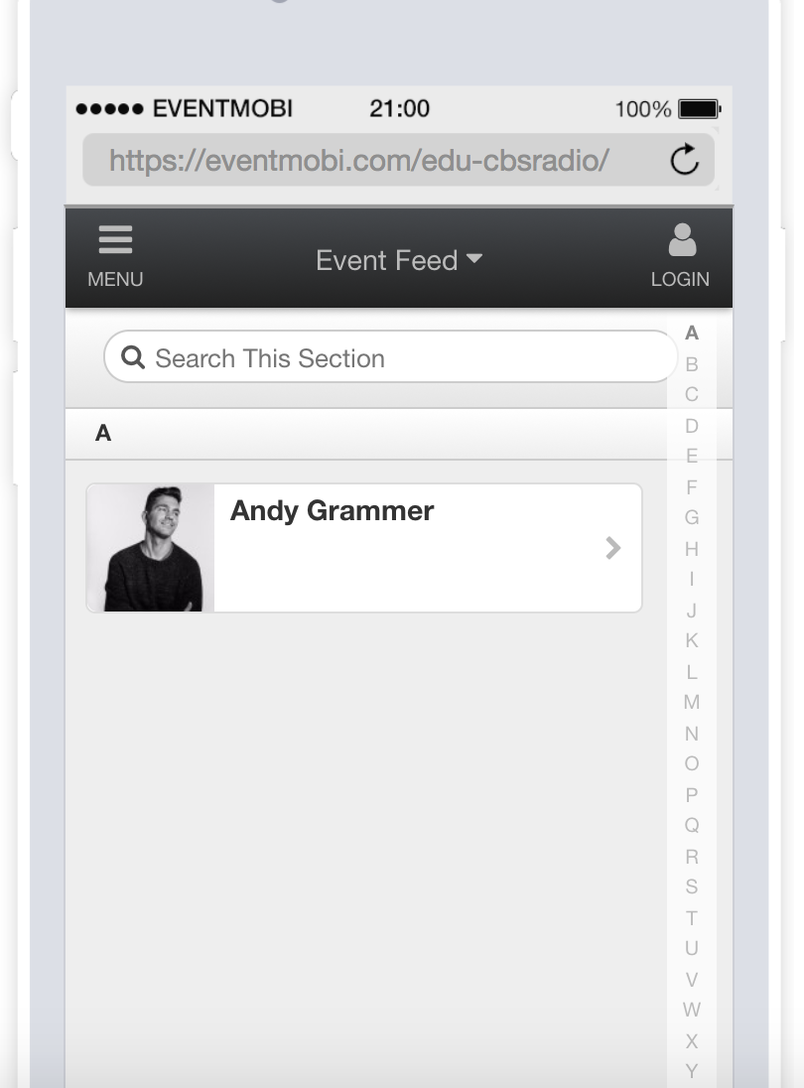

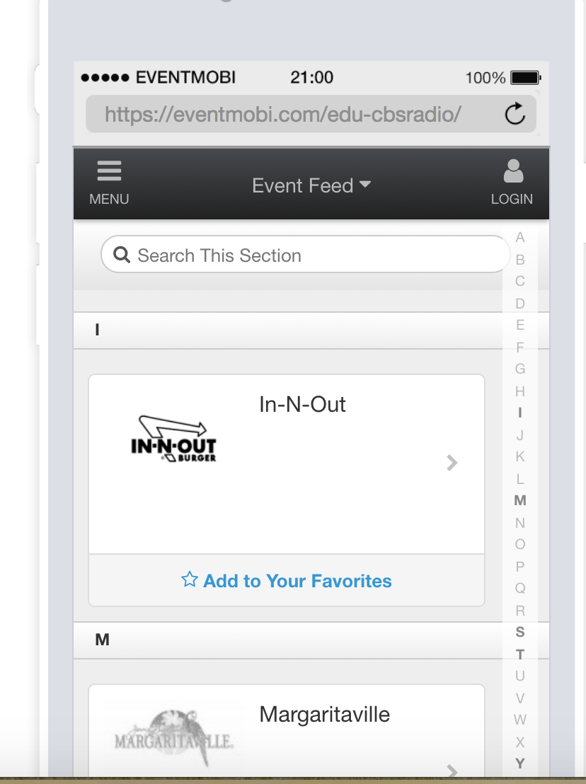
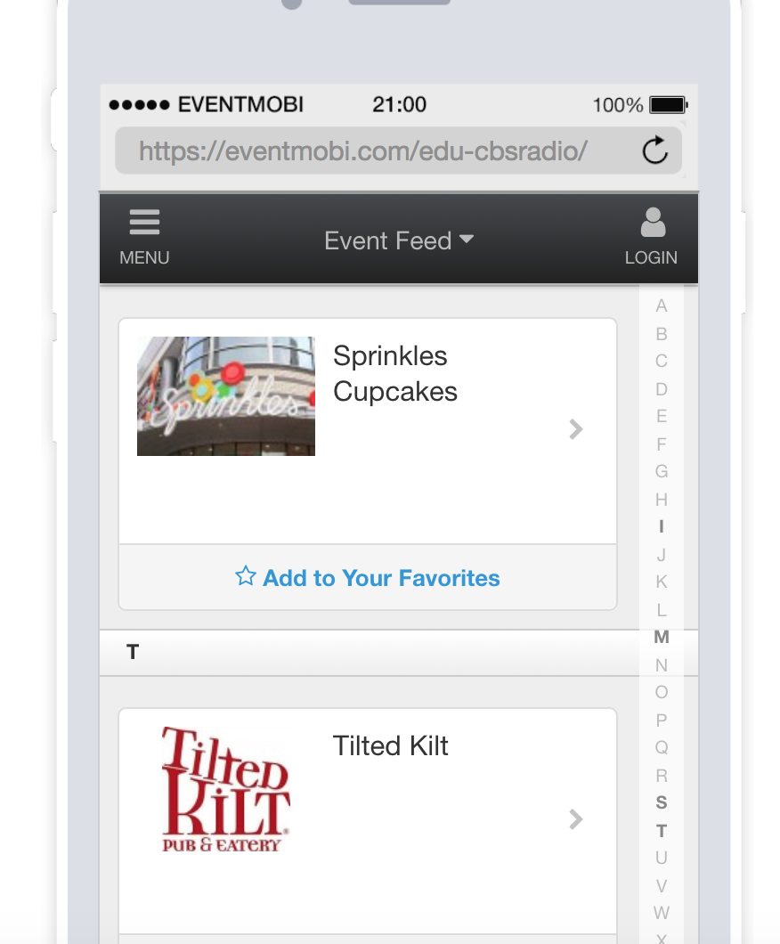

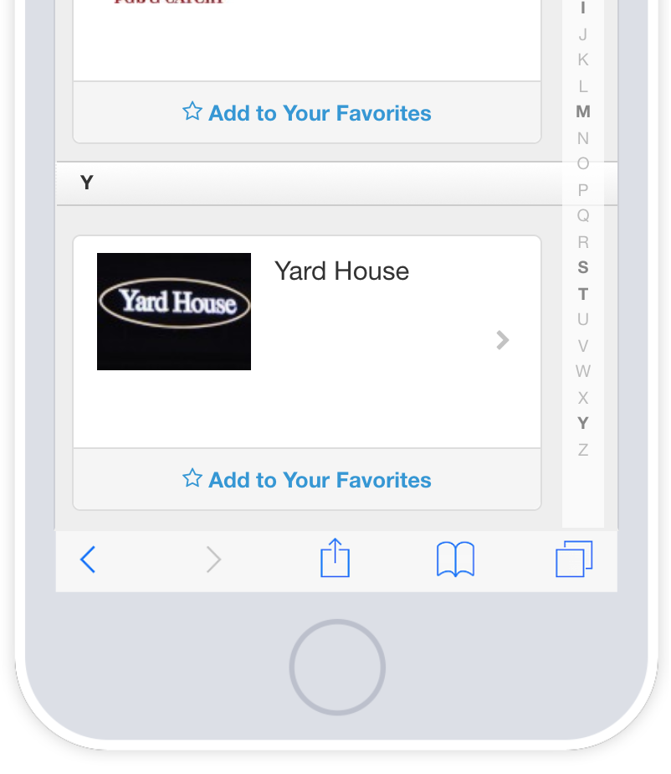

Event marketing
Event marketing will just be based within the office. This is just a small incentive show for the CBS employees so the only marketing that needs to be done is a mass email with a link regarding the registration tool such as Eventbrite as well as handmade invitations to each of the staff. From there, whoever RSVP’s will be added to the guest list and will present their ID at the venue upon arrival.

This is the handmade invitation: This is our Eventbrite Page:

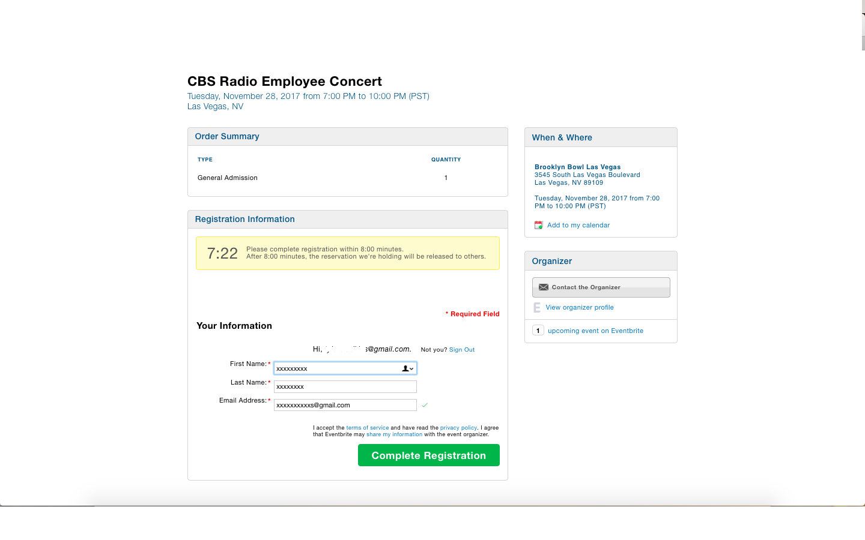
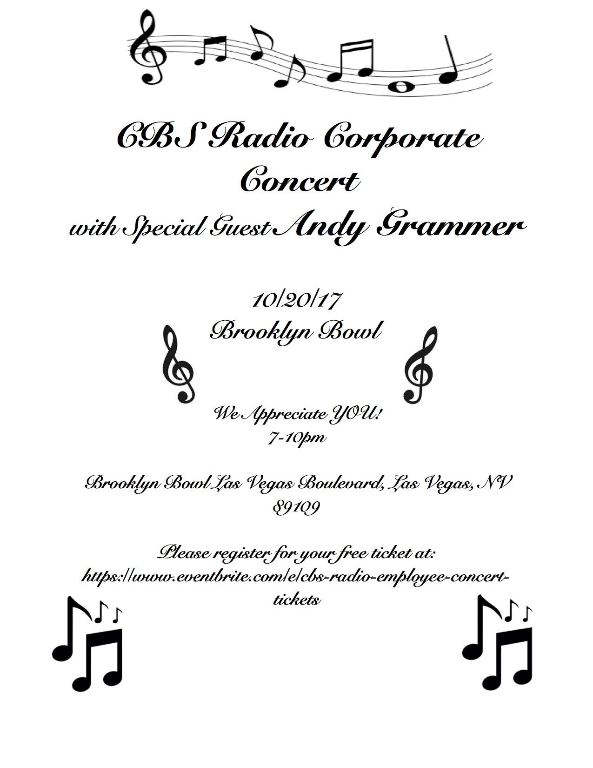

Event equipment

The equipment we will need is:
Brooklyn Bowl’s stage
Brooklyn Bowl’s Bar
Brooklyn Bowl’s audio/visual equipment
1 registration table
8 High boy tables
5 trash cans
2 Clipboards with the list of attendees
200 wristbands

Floor Plan
This is the floorplan of Brooklyn Bowl. In the lobby, we will just need a registration table in front of the escalators for check in. On the Mezzanine level, we have mapped out our event. We will have the stage in the front of the showroom. Around the bar which is located on the smaller upper level, we will have high boy tables and appetizers. Around the floor, we will also have 5 trash cans.
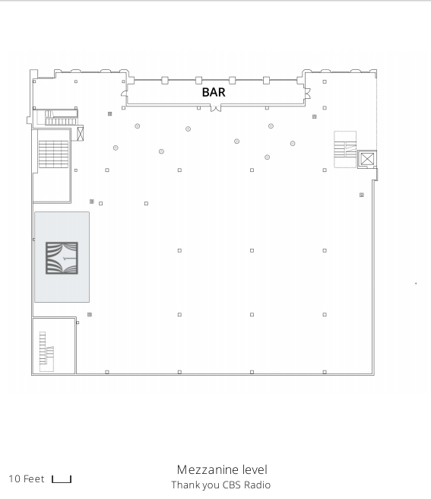
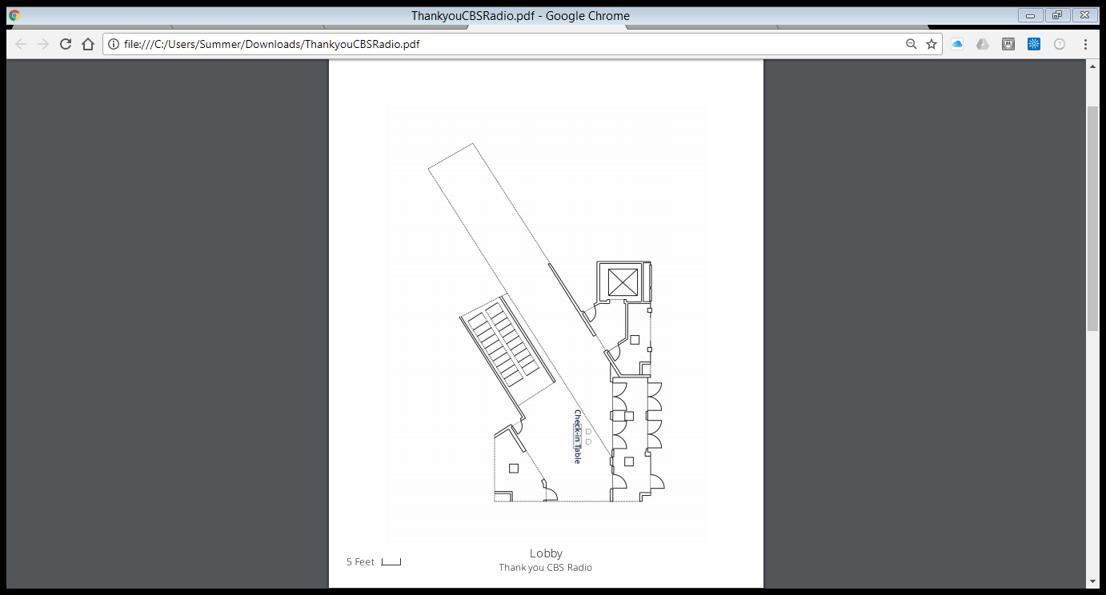

Investment page
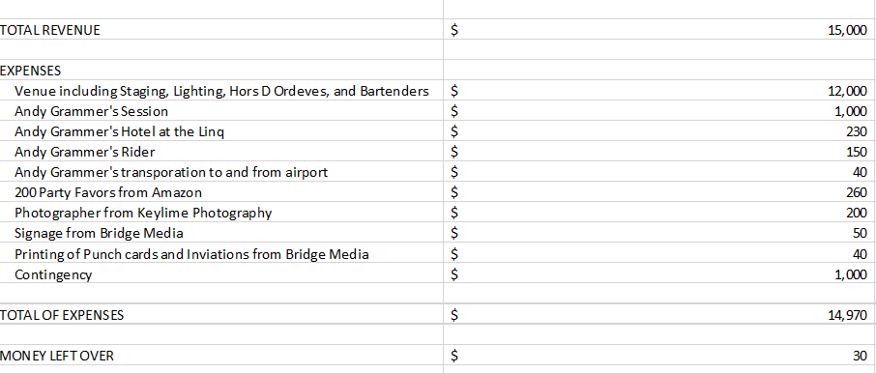

Human resource management
2 registration volunteers from UNLV events concentration; 2 Bartenders with Brooklyn Bowl; 5 servers who are volunteers in UNLV events concentration

Staff schedule:
Registration #1 5-9PM
Registration #2 5-9PM
Bartender #1 5-9PM
Bartender #2 5-9PM
Server #1 5-9PM
Server #2 5-9PM
Server #3 5-9PM
Server #4 5-9PM
Server #5 5-9PM

All employees will arrive an hour early to learn the event and job duties and start preparing. During event, bartenders will be at open bar. Servers will be walking around giving out premade Hors Oeuvres throughout the two hours. And we will have two students doing registration to check in the CBS employees and their guests. They will also give them their punch card for their snacks for the block party as well a light up party favor for the show. They will be dressed in all black. They will stay an hour after for cleanup.

Sustainability
We want the concert to be as sustainable as possible. Our venue supplies us with most of our equipment needed for the event, however we have found ways to make a positive impact on our planet. First, each invitation will be printed on recycled paper. Second, for all attendees to get to the corporate event, we will encourage employees to carpool and use ride sharing applications. All of the punch cards that will be given to employees to enjoy free and discounted items will also be printed with recycled paper. We are using Brooklyn Bowl’s silverware, plates and glasses which allows us to not waste paper products. Instead, we will be able to wash all the tableware at the end of the event. After the event is over we plan to keep all the left over materials, and reuse them within the community. This includes all registration materials.

Event team introduction page
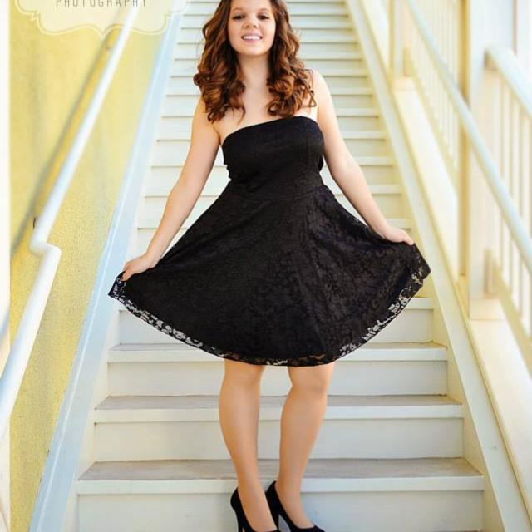
Summer Horvath has been within the events industry since she was 15 years old. She has a wide variety of talents that incorporate work ethic, use of resources, and creativity. She is eager to learn and willing to grow in the events industry. Her experience ranges from being a clown, being the main event coordinator at Southwest CTA, interning with Recycled Percussion, Onstage Talent Group, Andy Grammar, Cirque Du Soleil, and Southern Wine, and lastly working with CBS Radio, and Activity Planners to establish her career. Events is her passion and she is ready to rock n roll with Party Patrol.
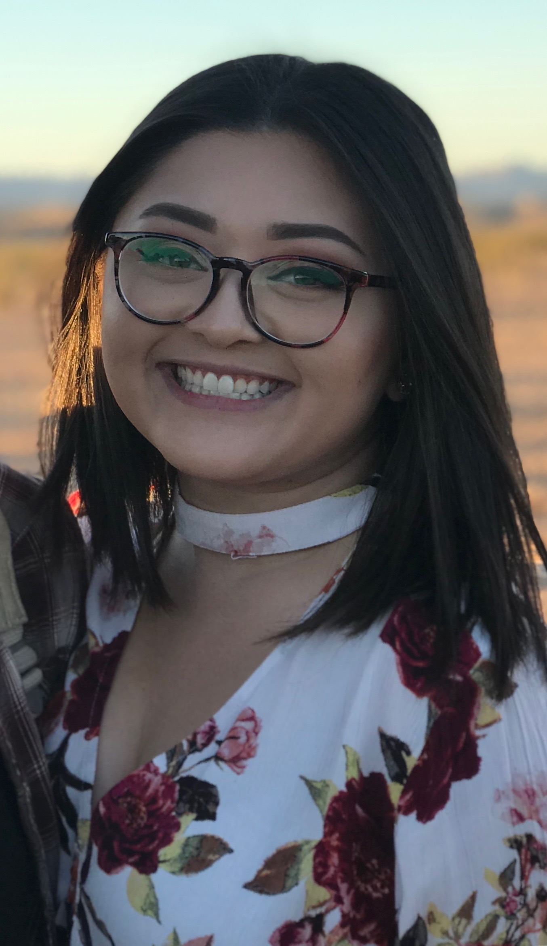
Jordan Cunanan never planned on entering the field of hospitality, she was heading down a more scientific path. It wasn’t until Jordan planned her own debut that she fell in love with the events world. Her work experience spans retail, food and beverage, and marketing. Each job has collectively provided her with vital skills to apply to the hospitality department; such as: excellent customer service, the ability to design and execute, and a keen eye with marketing strategies. Jordan’s thirst for knowledge and growth is what drives her passion with event planning, and she is grateful to be a member of the Party Patrol team.

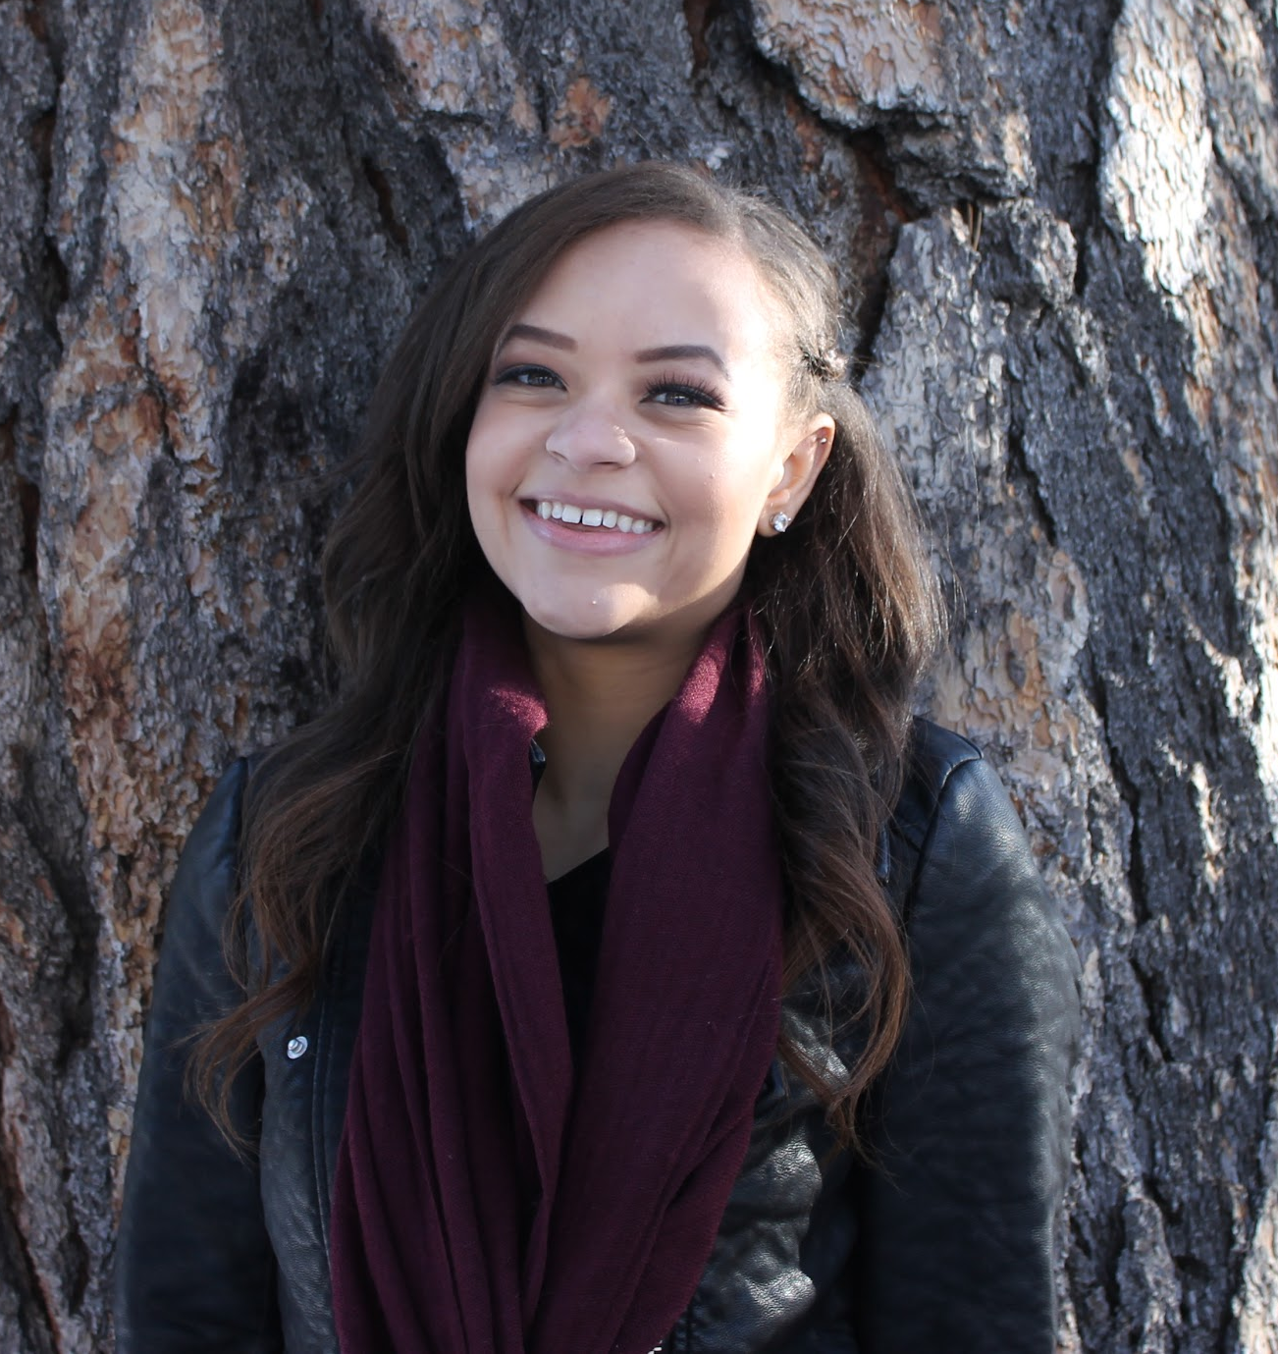
Tylere Adkins dreamed of being an event planner, and has been in the events industry for the past 5 years. She treats every new project with excitement and loves meeting with new clients. Tylere challenges herself to bring each of her client’s vision to life. She graduated from the University of Las Vegas, Nevada with a Hospitality Management degree with a concentration in Meetings and Events. She credits her education to helping her understand all parts of the industry. Outside of events she loves to travel to gain inspiration. Tylere loves being a part of the Party Patrol team, and is ready to have fun and knock your event out of the park.

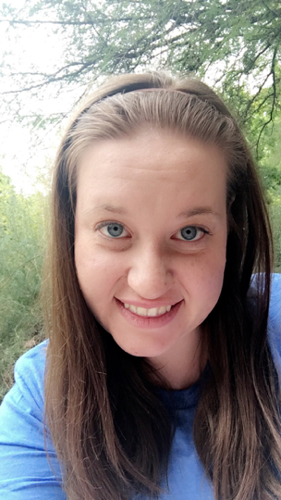
Samantha Ranaudo never thought about going into the event planning industry she wanted to be a teacher ever since she was four years old. After helping to plan parties and events when she was in high school she decided to go into the events industry. Samantha has volunteered to help put on many events in the Las Vegas community and is excited to be working full time with Party Patrol team.

Reference Materials

BIO. (2017, June 10). Retrieved September 26, 2017, from http://andygrammer.com/bio/

Eventbrite.com

Eventmobi.com

“Las Vegas.” Brooklyn Bowl, www.brooklynbowl.com/las-vegas/.

Socialtables.com

