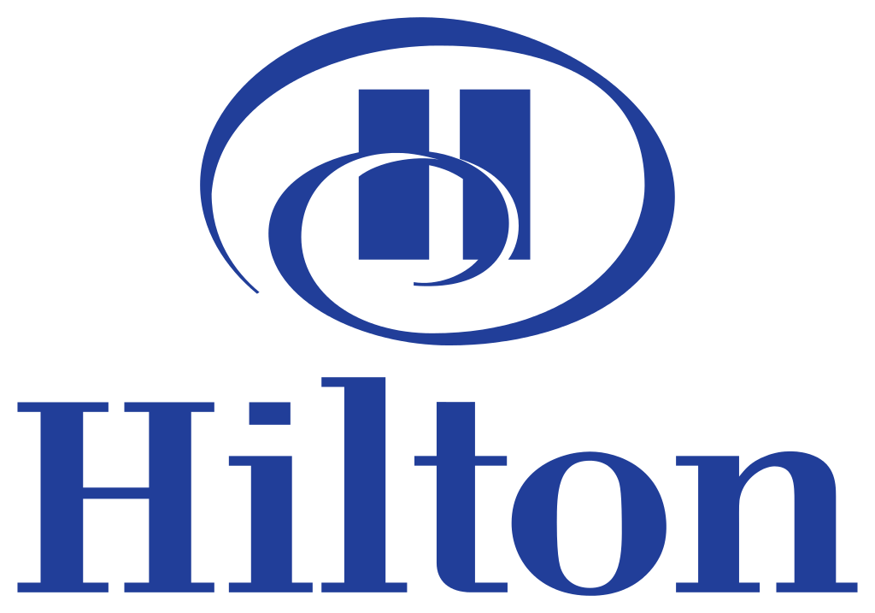

Business Plan
HMD 454
Denise Molintas

Managers:
Summer Horvath
Cherae Muije
Madison Black
Minji Kim
Jiwon Baek
Mariana Ruffo
Zixi Fu

Table of Contents

Part 1: Executive summary……………………………………………………………………...3
Part 2: Direction setting
Company overview………………………………………………………………………………..4
Vision, Mission, and Values…………………………………………………………………...4 - 5
Our Domain……………………………………………………………………………………….5
Stakeholders…………………………………………………………………………………....5 - 6
Part 3: Environmental Analysis……………………………………………………………..6 - 8
Porter’s 5 Forces..………………………………………………………………………………...9
Analysis of Porter’s 5 Forces…………………………………………………………………….10
SWOT Analysis……………………………………………………………………………..10 - 11
Part 4: Competitive/Resource Analysis
Competitors…………………………………………………………………………………12 - 13
Resource Evaluation………………………………………………………………………...13 - 16
Financial Analysis………………………………………………………………………………..17
Advantages and Vulnerabilities…………………………………………………………………………………....17
Part 5: Strategy Development
Brand Portfolio…………………………………………………………………………………...18
BCG Matrix……………………………………………………………………………………...18
Hilton Brands Strategies………………………………………………………………………....19
Corporate Level Strategies……………………………………………………………………….19
Strategic Recommendations……………………………………………………………………...19
Generic Business Level Strategy……………………………………………………………20 - 21
Interorganizational Relationships………………………………………………………………..22
Functional Strategy Audit…………………………………………………………………...23 - 24
Organizational Structure………………………………………………………………………....24
Organizational Chart……………………………………………………………………………..24
Part6: Implementation Plan………………………………………………………………25 - 27
SMART Measurements…………………………………………………………………………..27
Part7: Conclusion……………………………………………………………………………….28
Part8: References…………………………………………………………………………..29 - 31

Executive Summary

Problem
Currently, Hilton receives 80% of its profits from US properties and has a weak global presence.

Solution
In order to increase overall market share and Hilton’s global presence, all Canopy, Conrad and Tru properties need to be divested. These brands hold very little market share and are not significant enough to Hilton’s bottomline to warrant keeping and investing money into them. The profits earned from the divestiture will then be reinvested into the company to expand Hilton Garden Inn, DoubleTree, Hilton and Hampton into emerging global economies, such as Asia and South America, and to fund initiatives that will increase global occupancy rates.

Benefits/Financial Projections
By increasing our global market share and occupancy rates, Hilton will further establish ourselves as global leader with increased global brand recognition. If our goal of increasing our global occupancy rate by 5% and our global market share by 5%, our profits will change dramatically, allowing Hilton to decrease our high level of debt.

Call to Action
The first step in becoming more of a global leader is for the board to start divesting all of the Canopy, Conrad and Tru properties. The profits gained from the divestiture should be split between investing in technological and security advances and building new properties, from existing Hilton brands, in emerging economies such as Asia and South America. It is important that as Hilton expands, our values, vision, and mission are maintained across all brands and are reasonably adapted to cultural norms and values of other countries.

Company Overview

Hilton Hotels and Resorts is one of the most established hotel brands in the entire world with over 4,900 hotels and resorts in more than 100 countries. Since its name is recognized by everyone, Hilton considers themselves a global leader of hospitality and prides themselves on style, innovation, and genuine hospitableness. Hilton is considered one of the largest and greatest companies in the world. Hilton Hotel also manages Conrad, Doubletree, Embassy Suites, Hampton Inn, and Homewood Suites as well as its own brand name Hilton which is discussed on D & B Hoover under the company description of Hilton.

Under Financial Performance on D & B Hoover, Hilton consistently has a steady revenue growth for the past several years with $11.27 billion revenues in 2015 and $11.66 billion revenues in 2016. 80 percent of the revenue is from the United States.

Hilton’s mission and vision is to take care of their employees, give their guests an unforgettable experience, and strive to greatness as a hotel franchise. Hilton gives back to the community and tries to maintain a well known brand.

Vision, Mission, and Values

Mission

Hilton offers top quality customer service that reaches each guest on a personal level throughout each of our hotels across the globe. We will continue to improve and grow our reputation as one of the nation's most respected hospitality management companies. The needs of our guests and associates are the most important aspect of the business. While focusing on the guests and associates, Hilton has set high standards to inspire and motivate employees as well as to achieve outstanding financial results.

Vision

Deliver unforgettable experiences to our guests each and every day, one hotel at a time.

Values

Honesty: It is important to be honest with our service. As a service provider, we must serve with clear and conscientious service mind. Every guest will stay with our unbiased service and feel welcome in every property we operate.

International: As a world-wide global company, it is essential to understand global standards and culture diversity for each region. Our service and atmosphere in the workplace will be remarkable and set an example for the hospitality industry.

Leadership: We lead with innovation and creativity to become the best in the industry by building strong leaders and a team to strategic manage our brand.

Trustworthy: We take full responsibility over every action and decision we make with absolute integrity.

Openness: We will treat every guest and employee with genuine honesty by sharing our knowledge and information that affects them and their brand.

Neighborly: We will collaboratively work with employees, partners, and suppliers to give back to our community.

Our Domain

Market Area: Hilton being worldwide gives us a great position to have an advantage over our competitors because the accessibility and consistency keeps bringing our guests back to our properties. D & B Hoover states that Hilton has 4,900 hotels in over 100 countries. All the way from the United States, Asia, Western Europe, among others. Having this large number of hotels will allow us to have a substantial reach to every different clientele.

Segment of Business: Hilton Worldwide has worked towards different types of brands for positioning and targeting customers. Hilton has a list of 13 different brands that each brand takes a different position in luxury, lifestyle, full service, focused service, all suites, and vacation ownership.

Target Market: We believe our target market is:
1) Business professionals in their late 30s: We target business professionals because Hilton is highly involved with conventions.
2) Families: Families are targeted because Hilton offers a wide variety of amenities to accommodate a family of four which brings them back every year.
3) Guests wanting to stay long term: We target long term guests because Hilton can be a second home to most.

Stakeholders

Stakeholder | Importance | Performance | Weighted Score
Employees | 20% | 4 | .8
Guests | 20% | 3 | .6
Owners | 10% | 3 | .3
Suppliers | 10% | 3 | .3
Investors | 10% | 2 | .2
Government | 10% | 3 | .3
Media | 5% | 2 | .1
Community | 5% | 2 | .1
Shareholders | 10% | 3 | .3
 | 100% |  | 3

From our analysis, the main importance is our staff and our guests. Otherwise, all other stakeholders are around the same amount of importance because they all benefit the hotel equally except for the investors, media, and the community. Investors are having trouble being stable with the company, the media plays a role in every industry, and the community has not been too involved with Hilton recently. The importance and performance go together to create a weighted score of 3.

Environmental Analysis

Category | Opportunity | Threat | Source
Political 1  Immigration | Hilton worldwide benefits from guests traveling to other countries other than the U.S. to increase global revenue within those properties. | Stricter requirements for visa waiver program (VWP) could decrease the number of tourists coming into the U.S. as well as potential workers. | U.S. Department of State-Bureau of Consular Affairs
Political 2  Geopolitical Instability | Our brand recognition will allow Hilton to be there for our guests by giving them a safe place to stay in an environment that might not be safe. | Having geopolitical instability steers travelers away from traveling to unsafe areas and creates a negative impact on the property's profits. | U.S. Department of State--Bureau of Consular Affairs (travel.state.gov)
Economic 1  Corporate Tax Break | The income received from the tax break will encourage more personal and business travel. | With U.S. corporate tax rate dropping from 35% to 21%, Hilton may be affected by increased competition in the United States. | Internal Revenue Service (IRS)
Economic 2  Currency Exchange | The dollar is strong in other countries, resulting in inexpensive operating costs in other countries. | Customers who are from outside of country would have to put out more money for traveling when the currency of U.S dollar fluctuates. | www.hospitality.net
Sociocultural 1  Terrorism | Hilton properties will implement security procedures to increase to make a strong safety standard across all brands. | Terrorism across the world has led to a decrease in travel, due to fear. This can negatively affect Hilton’s profits. | CNN news  U.S. Department of State Country Reports on Terrorism (state.gov)  United Nations, Office of Counter-Terrorism
Sociocultural 2  Sustainability | Creating green initiatives can generate savings on electricity, water bills and cleaning materials. | As global warming becomes well known, guests are willing to pay more to stay in a hotel where sustainability takes place. | U.S. Green Building Council (USGBC)  The Guardian
Technological 1  Guest management system | Mobile check in helps customers to check in easily. People can save time instead of waiting to check in. | Ransomware, a virus, sends out personal information can be a hindrance to Hilton properties and dissatisfy our guests. | hospitalitytech.com
Technological 2  Concierge Services | Self-service technology will allow marketing opportunities for Hilton by allowing guests to access technologies with common devices such as smartphones and biometric technology. | New technology will decrease the need for human labor, minimizing human interaction which is what Hilton is all about. | Self-service Technology in hospitality & Tourism

Threat of New Entrants
1. Threat of new entrants is low when brand reputation of existing companies is high. This is because hotels can maintain their strong reputation to stop others from swaying the industry.
2. Threat of new entrants is low when existing companies control of distribution channel is high. This is because hotels can monopolize to where new entrants cannot get resources.
3. Threat of new entrants is low when existing company’s proprietary knowledge is high. This is because hotels have a lot more networks in the industry where a newcomer cannot find these contacts.
Threat of New Entrants is LOW

Suppliers
1. Supplier power is high when differentiation of suppliers products and services is high. This is because having a dynamic range of products makes hotels more accessible to things the guests wants.
2. Supplier power is high when knowledge about buyer industry is high. This is because both parties are working at their best to have great communication.
3.Supplier power is high when organization of suppliers is high. This is a because hotels need to ensure safety and sanitation in transportation and delivery.
Supplier Power is HIGH
Buyers

1. Buyer power is high when buyers knowledge about the company from which they buy is high.
This is because they understand the brand and who the hotel is as a company.
2. Buyer power is high when volume of purchase is high.
This is because the hotels compete to
market the brand so guests purchase for multiple nights.
3.Buyer Power is high when price sensitivity is high.
This is because hotels understand to not be outrageous with their room rates thus their buyers will purchase more when the price is sensitive.
Buyer power is HIGH

Rivalry
1. Rivalry is intense when the number of competitors in the industry is high.
This is because there are so many brands to compete with.
2. Rivalry is not intense when product differentiation is high. This is because every hotel has a different product, guests do not have to choose which they like better.
3. Rivalry is not intense when availability of substitutes is low. This is because substitutes are not able to compete with the brands of larger corporations.
Rivalry is INTENSE

Substitutes
1. Threat of substitutes is low when availability of alternatives is low This is because substitutes don’t have the resources to provide a hotel experience
2. Threat of substitutes is low when profitability of company producing substitutes is low. This is because substitutes do not have the money to be able to make a huge profit because of lack of marketing and resources.
3. Threat of substitutes is low when potential new substitutes is low. This is because the hotel industry has taken control of the clientele and provide them with an unforgettable experience.

Threat of Substitutes is LOW

Analysis of Porter's 5 Forces

Our buyer and supplier power is low for Hilton because they have so many suppliers and buyers so no one can have power over them. Hilton’s reputable brand and strong relationship with vendors lets them pick and choose who they want. Industry standards are high because hotels have to compete for suppliers and buyers thus they have the power and can pick where they want their service. However, Hilton specifically rose to the top of the leaderboard from keeping their power low.

Substitutes and new entrants are low in the industry and for Hilton because hotels have monopolized the industry and made their brands recognizable. Hilton is one of the most well known companies globally so they do not have smaller companies attacking their stance within the industry.

However, our rivalry is intense because of so many hotels in the industry. This shows Hilton that they must maintain a competitive edge to stay within the top five of the hospitality industry. Their biggest threat is Marriott and Accor and this will stay our most recent threat.

In the next five to ten years, new entrants and substitutes will be on the rise and it will be more common for those to stay at cheaper, home environments like Airbnb.

We will implement our strengths and opportunities to maintain a strong stance within the industry.

SWOT Analysis
 | Strengths  - Brand Recognition  - Company Knowledge & Resources  - Effective customer retention schemes by Hilton Honors Loyalty Program | Weaknesses  - Substantial Debt (6.5M end of 2017)  - 80% of the revenue is from the US market only. Over Dependent on US properties.  - Little global market share compared to brands portfolio
Opportunities  - Corporate Tax Breaks  - Emerging Economies (Asia & South America)  - Currency Exchange | Strengths/Opportunities  - As companies come into more money to spend on business travel, Hilton can create a corporate rewards program that will further entice companies to stay with Hilton while traveling  - Hilton already has so much experience building hotels and expanding their portfolio that it will be easy to break into emerging economies such as Asia or South America because they can copy what they have already done.  - Some companies are more profitable to operate in because of the currency exchange, by using our rewards program to attract new guests and encourage current members to travel more, the company can increase profits. | Weaknesses/Opportunities  - As companies gain money from tax breaks, there will be more business travel and individual leisure travel that can increase profits and revenues for Hilton.  - By expanding into emerging economies such as Asia and South America, Hilton will be increasing their portfolio and global market reach which will drive international profits.  - Some companies are more profitable to operate in because of the currency exchange, Hilton can cheaply expand into these markets to increase our global market share.
Threats  - Terrorism  - Geopolitical Instability  - Strict visa regulation which means less foreign visitors | Strengths/Threats  - Guests should not have to worry about the safety of where they are staying. Guests will want to turn to companies that have been around a long time and that they can trust, Hilton will be there for them just like they always have been.  - Hilton has been around for so long and gained so much knowledge and resources that will attract customers to our hotels because they will feel safe staying with us, even in unstable areas.  - Strict visa regulation can make it hard for international travelers to visit Hilton properties, however, the Hilton Honors program will encourage and reward travel to other properties where regulations are not as strict. | Weaknesses/Threats  - After terrorist attacks, travel often declines, resulting in lower profits which contributes to Hilton’s growing debt.  - Make customer feel safe in the property where geopolitical instability might happen such as Middle East and Asia around North Korea.  - People who are having trouble with issuing visa to travel to US, might change travel destination to countries around them. So increasing some properties besides US

Competitors
Marriott International, Inc.
After acquiring Starwood Hotels & Resorts Worldwide in 2016, Marriott International became the number one lodging company in the travel and tourism industry to have the most extensive brand portfolio. Marriott International currently owns 30 brands and operates 6,400+ properties in 126 countries and territories which include different market segments such as upper midscale, upscale, upper upscale and luxury. Marriott International is Hilton’s major competitor as it’s currently the leading global lodging company thanks to its extensive brand portfolio, service, and 90 years of experience. Like Hilton, Marriott International targets different market segments around the world as well as making it easy for it’s guests to become part of their rewards program, these two similar attributes between companies are the main reasons why Marriott International is Hilton’s #1 competitor.

Accor Hotels
Although Accor Hotels can be found in 100 countries worldwide they are known as the market leader in Europe. With 4,283 hotels around the world, Accor Hotels counts with over 20 brands ranging from economy all the way to luxury. Accor Hotels differentiates from other lodging companies at it has a brand for each guests’ personality, from luxurious boutique hotels to nature focused properties. Accor Hotels not only provides lodging experiences but hospitality experiences which consists of Private Rental, Coworking, Concierge, Dining & Events and Digital Solutions. One unique aspect about Accor Hotels is their private rental segment, with it’s “one fine stay” brand, guest can now enjoy longer-stay hospitality by renting luxury private houses and apartments. Each one fine stay rental is accompanied by concierge services in order to meet guest’s needs at all time during their stay.

Choice Hotels
Choice International is another leading hotel franchisor with more than 6,500 locations in US and in 35 other countries. Their listed revenues for 2016 was $924 million(D&B hoovers). 88 percent of the revenues are from US properties. Ranging from limited services to full service hotels in the midscale and upscale segments. It was targeted for both business and leisure travelers.

Resource Evaluation
Being one of the largest hotels with an international presence, Hilton hotel has a wide capital base that has influenced its entry into new markets. Entering a new market in the hospitality industry is a costly prospect and requires a significant amount of financial investment. This has been achieved by the hotel due to its strong capital bases and considerate investment decisions. Secondly, Hilton has a huge operational financial power to run its activities. in 2016 financial report, the hotel about 1.26 billion USD (HILTON, 2016). This is a strength since it can be used to propel the development of other product lines or improve the existing ones. The management of the hotel and the entire staff are made up of competent individuals with exceptional qualifications in their respective operational areas. The table below illustrates the strengths of Hilton and that of its main competitors:

 | Hilton | Marriott | Accor | Choice
Financial  - Net income  - Shareholder’s equity | 1.3rd Net income $364M in 2016  2. Hilton has 2.1 billion number of shares calculated in 2017. Which means diverse people has involved in this company. | 1. 1st Net income $780M  2. Marriott has 3.7 billion number of shares which rank Marriotts the first of numbers of shareholder’s equity. | 1.2nd Net income $494M  2. Accor has 293 million number of shares calculated in 2017. | 1.4th Net income $138.4M  2.Choice has negative 212 million of shares which means has high liabilities that company owe.
Human Resources  - Strong employee numbers  - Employee training program | 1.Hilton has approximately 163,000 employees worldwide calculated in 2017.  2.Focus on ensuring the highest level of services to the guests | 1.Marriott has approximately 226,500 employees worldwide calculated in 2016.  2. Ensure the new staff have the skills needed to perform effectively | 1.Accor has approximately 240,000 employees worldwide calculated in 2017.  2. They promise to make their talents feels valued and has opportunities for lifelong learning. | 1.Choice has approximately 215,000 employees worldwide.  2. Ranked in top 100 training organizations with to have excelled in developing innovative and diverse programs that produce measurable results.
 | Hilton | Marriott | Accor | Choice
Technology  - Online services  - Guest management services | 1.Easily navigable website. Ranks second among the competitors.  2.Have smartphone check in and unlock door system. And was first hotel with air conditioning and TVs in guests room. | 1.The website is the best in the industry because of the design that coincides with the hotel’s brand.  2. Mobile check in is also available, and have prototype which will let guests control everything from temperature of shower, lights, sounds and etc. | 1.Developed an app that make it easier for the customers to make their bookings. The website is ranked third best among the industry players.  2.Instead of launching check in kiosk Accor thinks interacting with customers face to face is more important. | 1.Ranked fourth due to the website presence of fluffs that are yet to be rid from the website.  2. Does not have much technology launched for guests but have nice mobile app where they can book rooms and check in rooms with.
Organization  - Brand reputation  - Global presence | 1.Ranks second with three major awards in the hospitality industry.  2. Hilton has 4,900 hotels and resorts in more than 100 countries | Ranked the strongest brand in 2017/2018 ranking. Has a global presence and has received two Fortune awards.  2. Marriott has over 6,000 hotels worldwide with in over 122 countries. | Ranks 4th with no global brand reputation award.  2.Accor has over 3,700 hotels in 92 countries throughout the world. | Ranks 3rd with the best hotel of the year award.  2. Choice has 6,500 hotels worldwide with in 35 countries.
Reward Programs  - Loyalty Program  - Employee rewards program | Through the Hilton Honors program, Hilton Hotel is ranked first in the industry (Zuo, Xiong & Iida, 2017). This program offers the customers free nights and a package the perfectly coincides with the lifestyle of the customers.  2. Have choice of employee stock purchase, performance bonus, equity incentive plan, stock options and etc given to hilton employees. | Marriott does not offer any free nights for the customer and instead ventures in influencing customer loyalty through offering bonus points and flyer miles.  2. Have various options towards employees such as stay awards where you can stay wherever they want, experience awards when you can experience golf, dining and spa. And more others. | Accor is ranked 3rd in this category. Through the Le Club Program, the hotel offers the customers free nights and a free access to airport longue when the customers are using the hotel’s air miles.  2. Have choice of getting bonus, collective retirement savings plan, and six months discount cards valids at all of accor hotel brands. | Choice is ranked Second. It offers privilege and free room nights (Zuo, Xiong & Iida, 2017). It calculates the dollars spent by the customers and gives 10 pints for each dollar.  2. Does not have much options than others but have bonus, hotel discounts, paid family leave and others.

Critical Success Factor | Your Company  Hilton | Marriott | Accor | Choice
1 International Global Presence | 2nd: Hilton is second for having 4,900 hotels and resorts in more than 100 countries | 1st: Marriott is first for having over 6,000 properties worldwide with being in over 122 countries. | 4th: Accor is fourth for having over 3,700 hotels in 92 different countries. | 3rd: Choice is third for having 6,500 hotels worldwide with being in 35 countries
2 Rewards Program | 1st: Hilton has a rewards program by the name of Hilton Honors that offers free room nights as well as packages that fits to your lifestyle the best. | 2nd: Marriott is second for their generous ways to to earn points and flyer miles. | 3rd: Accor Le Club Program offers free nights, presale room nights, and airport lounge when you use air miles. | 4th: Choice Privileges gives free room nights, 10 points per dollar spent, and extra rewards for midweek stays.
3 Safety Rank | 1st: Hilton is first for their safety rank by having a well written manuals for each property as well as a recognition matters program that recognitions departments for following guidelines and being safe. | 3rd: Marriott is third for having a safety review system for their employees to go back and get a refresher on safety guidelines. | 2nd: Accor is second for having a hotline for their employees to get 24/7 advice on safety within their scope of practice. | 4th: Choice does not have any safety programs but they do have resource groups for their employees.
4 Accessible Online Services | 2nd: Hilton’s website could be look more like the brand but it is easy to navigate as well as the app. | 1st: Marriott’s website and app are both very organized and corresponds with Marriott’s brand. | 3rd: The website is hard to navigate but the app was so detail oriented and easy to book. | 4th: Choice’s website and app correspond with the brand but have a lot of fluff that could be taken out.
 | Hilton | Marriott | Accor | Choice
5 Brand Reputation | 2nd: Hilton has a strong running up to Marriott with rewards and recognition with already having three awards this year. | 1st: Marriott’s brand reputation sweeps the world with having two awards from Fortune this year. | 4th: Since Accor is privately owned, there are no established awards for the company. | 3rd: Choice has won best hotel of the year and tries to stay on the leaderboard worldwide.
6 Green Initiatives | 1st: Hilton takes the prize for having the best green initiatives with all of their programs like Home 2 Home which recycles their amenity products, LightStay which cuts 15%-20% of energy consumption, Earth Hour competition, Global Service month of dedicating 291,000 volunteers to over 4,000 hours of service. | 2nd: Marriott comes in second with having Serve 360 which is a plan of goals to be completed by 2025. There goals are nurture (volunteer to help at risk youth), empower( spending 5 million in programs, sustain (which is reducing carbon footprint by 5%), and welcome (human rights training). | 4th: Accor has Planet 21 which is based of planting, gardens, and eco friendly items as well as eco design for their hotel rooms. | 3rd: Choice’s program is Room to be Green which is a 3 level program of renewable energy, stopping water consumption, eco friendly light bulbs, and volunteering.

Analysis of Critical Success Factors
The above information describes how Hilton has the highest weighted score in the areas being evaluated over Marriott, Accor, and Choice. Although Marriott is now the number one hotel in the world, the areas being evaluated show that they are slightly lacking in some areas when compared to Hilton. It also shows that Hilton is keeping up with Marriott very well by surpassing them. Hilton is clearly doing something right in these areas and should keep up their good work. With Hilton leading with rewards programs, safety, and green initiatives, they are climbing up the leaderboard on online services, global presence, and brand reputation. These factors are displaying Hilton’s drive in being the best. Overall, Hilton is a strong competitor against strong competition.

Financial Analysis

 | Hilton | Marriott | Accor | Choice
Liquidity - Current Ratio | .9 | .46 | .99 | 1.37
Activity - Asset Turnover | .64 | .96 | .08 | 1.09
Profitability - Net Profit Margin | 13.83% | 5.99% | 10.3% | 11.41%

Advantages and Vulnerabilities

Advantages:
- Hilton has the most effective rewards program that offers a wide range of rewards
- Hilton has a highest ranking of safety which ensures guests with reliable security
- Hilton has established a consistent brand image trust
- Hilton has a high strength in human resources for providing great services
- Hilton has a top green initiative for implementing variety of green practices

Vulnerabilities:
- Hilton is in 22 countries less than Marriott, this hinders our global presence and brand recognition
- Hilton’s website does not accurately represent the Hilton brands which gives our guests a skewed outlook on our company.
- Hilton’s website is not as easy to use as other hotel websites, which could deter guests from booking with us
- Hilton’s battle with Marriott for the number one ranking has been a vulnerability because they are lacking additional recognition by not acquiring a joint venture with another company
- Multiple Hilton have low market share

Brand portfolio

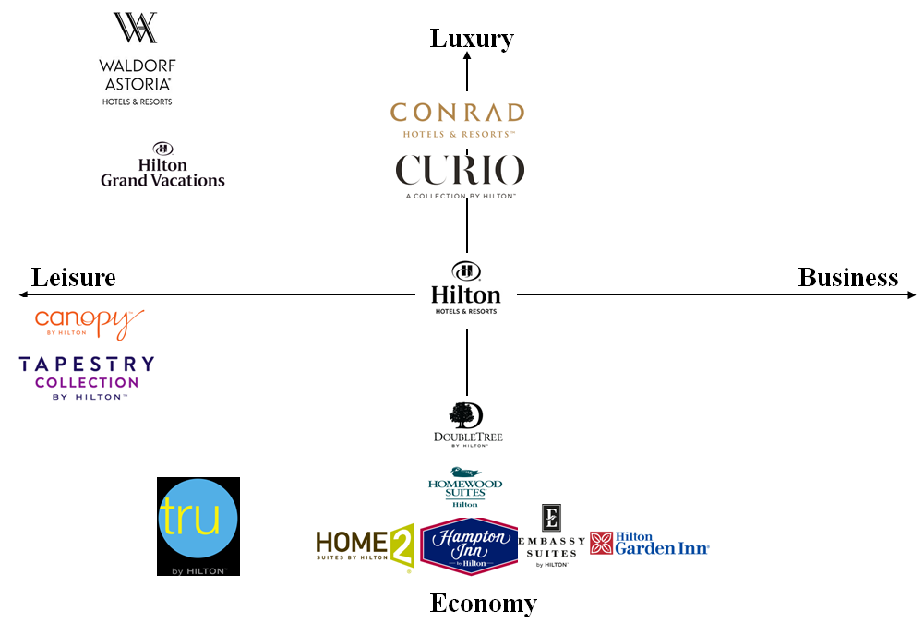
BCG Matrix
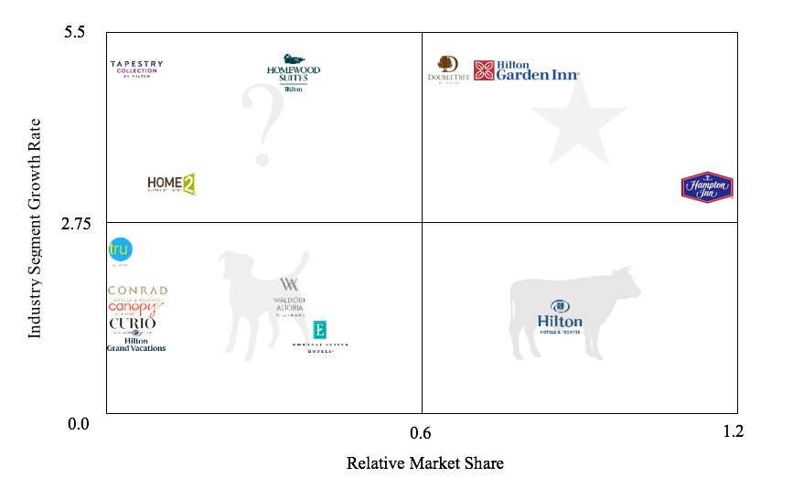
Hilton Brands Strategies

Dog(Waldorf Astoria,Conrad,Canopy,Curio,Embassy Suites,Hilton Grand Vacations,,Tru)
Hilton owns a large amount of hotel brands. Those brands list above are in the Dog department with low market share and low ROA. We will decide to divest some brands like Canopy, Conrad and Tru and use the money to support other business in our Company. For example, our flagship and most famous brand Waldorf Astoria need to expand more to get more market share.
Cash cows(Hilton)
The only cash cow in our company is our Hilton brand. We get a lot of revenues from Hilton every year and do not need to invest a lot of money to it because the market of these type of hotel is really fixed and saturated. We need to improve our service and hardware of our Hilton brand to keep the high market share and our group of guests.
Star(Hilton Garden Inn,Hampton,DoubleTree)
These two brands of Star is in a increased market right now. We are expecting these brand become our cash cows in the future. To achieve this goal and keep leader position, we need to put money in these brands and expand more and more hotels of them.
Question marks(Tapestry, Homewood Suites, Home2 Suites)
These brands also in a high increased market right now but we have a low market share of these brands. Our company need to evaluate the situations of these brand and chose which one to invest money. We need to be really careful on these brand when we want invest them. However, they can become Stars even Cash cows in the future. On the other hand, we can also become the Dogs.

Corporate Level Strategies
In the past, Hilton has had the strategy to saturate the United States market with a variety of brands to attract all different types of guests. Hilton has fourteen brands to accomplish this, however, seven of the fourteen brands are located in the ‘dog’ quadrant of the BCG Matrix. Hilton has focused too much on diversification and has lost sight of other goals such as holding an increase in market share or becoming more of a global leader. To accomplish these goals, Hilton needs to divest Canopy, Conrad and Tru brands and use the profits to restructure the company to focus more on global expansion.

Strategic Recommendations
Business Level Strategies
- Some companies are more profitable to operate in because of the currency exchange, by creating promotions towards other countries using our rewards program to attract new guests and encourage current members to travel more, the company can increase profits.
- Partner with well known security company and give the guest feel safe staying in the hotel. Guests will want to turn to companies that have been around a long time and that they can trust, Hilton will be there for them just like they always have been.
- Hilton has been around for so long and gained so much knowledge and resources that will attract customers to our hotels because they will feel safe staying with us, even in unstable areas.
- As companies gain money from tax breaks, there will be more business travel and individual leisure travel that can increase profits and revenues for Hilton.

Corporate Level Strategies
- Joint venture with technology companies (luxury and upper upscale)
  - Partnerships with LG Electronics (AI) technology companies make guests feel that luxury feeling and comfortability. Also attracts more business travelers. By joint venture with LG, can also advertise their electronic product for a guest, so customers get attracted and will like to purchase for their own comfort abilities.
- Diversify Hilton Grand Vacation with some promotions and tour packages.
- Divesting Tru, Conrad and Canopy hotels.
  - Have not much hotel properties globally and small market share. Divesting these hotels and concentrating in other hotels.
- Expand core business to make more bigger and globally.
  - Increasing core business into major geographic location will benefit Hilton to grow and other segments of hotel will follow also.

Generic Business Level Strategy

Low-cost Leadership
Homewood Suites | Homewood Suites provides every guests a spacious living room, a kitchen and a comfortable bedroom to ensure guests to feel like home

Focus Through Low-cost Leadership
Tru | Tru hotel provides affordable price and value for each stay. Within 24 hours in advance, guests can choose their room, check in, and customize their rooms from their mobile device.

Differentiation
Hilton Hotels & Resorts | Hilton Hotels & Resorts provide guests with innovative amenities, services and restaurant concepts. Hilton Hotels & Resorts are known for hosting Hollywood award galas all the way to business events. Hilton tailors to every guest’s needs no matter how unique the requests are, by doing this Hilton helps guests make traveling easier.
Conrad Hotels & Resorts | Conrad Hotels & Resorts provide guests with luxurious properties as well as top of the line amenities. Conrad Hotels & Resorts focus on giving its guests exclusive access to local culture based on each hotel’s location, from cities like Singapore all the way to the Maldive islands.
DoubleTree | DoubleTree believes that small actions can have big impact on guests, that being said DoubleTree is characterized for their signature warm welcome chocolate chip cookies. By handing out freshly baked chocolate chip cookies during guest check-in, DoubleTree ensures and reminds it’s guests that they are constantly dedicated in making them feel special throughout their entire stay by creating meaningful experiences.

Focus Through Differentiation
Curio Collection | Curio Collection is a collection of hand-picked independent hotel with distinct character and authenticity that represents each location’s unique character.
Waldorf Astoria Hotels & Resorts | Waldorf Astoria Hotel & Resorts are very high end luxurious hotels which provide guests with their own personal concierge in order to ensure every request is met in order to go above and beyond guest expectations. The personal concierge is there to make the guest’s stay as easy as possible by tailoring to the guests preferences from assisting them with culinary preferences all the way to complimentary bag-packing service.
Canopy | Canopy is known for their hip boutique hotel vibe which provides guests with modern hotel amenities, for example their Breakfast amenity, this amenity delivers guests a breakfast bag which includes items made with local and fresh ingredients to their room in order to provide guests with breakfast on the go. Canopy is also known for its paws in the neighborhood program which consists of providing pet-friendly rooms. Another unique amenity offered by Canopy is their welcome gifts, these include locally made products such as pastries. To top it all off, Canopy opens its bar for complimentary evening tastings which provide guest an opportunity to sample local wines, beers and spirits. Canopy’s main focus is to immerse it’s guests on local products, talent and culture.

Best Value
Home 2 suites | Clean and comfortable accommodation  Practice sustainability by purifying and recycling.  Give soap to impoverished people, keep soap to prevent disease world wide.
Hilton Garden Inn | Offers guests with comfort throughout quality rooms.  Fresh coffee by the cup from own personal coffee maker.
Tapestry | Provide guests with an original hotel experience, with the expected reliability of Hilton.

Focus Through Best Value
Hampton | Offers basic needs for guests whether they are on a leisure or business trips. Friendly and helpful service with high quality accommodation and amenities. Free wifi and breakfast for guests every morning.
Embassy suites | Free made-to-order breakfast each morning, complimentary drinks and snacks for two hours every night as well as complimentary 24/7 access to fitness centrs and business centers.

Hilton Grand Vacations | Hilton Grand Vacations’ properties consist of resorts with exclusive amenities for guests to enjoy during vacation, from typical mountain and beach adventures all the way to big city adventures. Hilton Grand Vacations has different locations around the world to best accommodate and fit guest’s different vacation styles for the best price.

Interorganizational Relationships

Strategy | Interorganizational Relationships
Improving our promotion and reward programs to attract more guest to come to our hotels especially focus on some travel destinations which affected by currency exchange. | Guests:Some brands like Curio should embrace a stronger marketing campaign to inform travelers and guests in our reward program about the locations of the unique collection of resorts and hotels. State of the art facilities, when well marketed through the social media, will attract more customers to the luxury resorts.
Develop technology in hotels and partnerships with some top level technology company to upgrade our hardware in our room to make our guest more comfortable and satisfied. | Suppliers:Partnerships with the LG Electronics to introduce new technology like AI in our hotel to make us upscale and make guest feel luxury and comfortable. To gain a competitive advantage over Marriot, Hilton Brand needs to delve into innovation through tech hotel room designs and digitized services that yield more accuracy and customer satisfaction.
Reset some dogs brand in our company, divest those hotels in bad situation or helping some of those brands to improve themselves and make them diversification. | Owner:Divesting those brand with less amount and low market shares like the Tru and Canopy in our company. Brand like Hilton Grand Vacations should increase its high-quality resorts to cover more celebrated destinations. Perhaps, it should expand to more than its three current countries through the acquisition of competitors.

Functional Strategy Audit
Business Functional Strategy Audit:
- Marketing Strategy:
  - Target customers: Review targeting strategies and focus on international travelers and business travelers.
  - Product/Service Image: As expansion occurs, ensure properties/brands align with different cultural values and norms.
- Operations Strategy:
  - Quality Assurance: Create controls and standards across all brands to ensure quality of product & performance.
  - Facility Location: Expand into areas that will entice travel and will benefit the company in terms of suppliers and labor.
- Information Systems Strategy:
  - Personnel: subcontract with a well-known security company to keep up to date with security systems and software to ensure guests feel safe on property.
  - Information Security: Ensure checks and balances are in place to protect guest information.
- Innovation Strategy:
  - Knowledge Creation: Offer tuition reimbursement to employees taking management courses.
  - Incentives for Innovation: Ensure that a continued stream of ideas from employees are being brought to management for evaluation and possible creation.
- Human Resources Strategy:
  - Selection: Create a consistent selection process across all brands to ensure quality across all brands and to create transferability between employees.
  - Training: Consistent training throughout an employee’s career with additional training for all department changes or promotions.
- Financial Strategy:
  - Overhead Costs: Focus on expansion to countries with low currency exchange rate and low costs of labor to reduce overhead costs.
  - Financial Targets: Set specific and attainable goals for each Hilton brand to aid in measuring brand success.

Corporate Functional Strategy Audit:
- Marketing Strategy:
  - Product positioning: Position Hilton with LG to become a highly rated tech company
  - Promotion Practices: Promote Hilton Grand Vacations on various platforms to enhance sales globally.
- Operations Strategy:
  - Workforce Policies: Train and equip employees of new policies for expansion and new ventures.
  - Technology and Equipment Choices: Joint venture with tech companies to expose our customers to modern way of stay.
- Information Systems Strategy:
  - Social Media: Promote Hilton’s expansion, joint venture, promotion of Grand Vacations through social media platforms to give exposure.
  - Disaster recovery: Have a disaster recovery plan for those properties expanded into other countries
- Innovation Strategy:
  - Innovation focus: Focus on working with tech companies and companies to benefit our diversification strategies to make a smooth transition for our customers.
  - Project priorities: Create a detailed timeline and plan for upcoming projects within the Hilton brand.
- Human Resources Strategy:
  - Management compensation: Give compensation to those who prepare to move their career in a different direction within the company.
  - Recruitment: Recruit locals in expanded areas who can cater to locals.
- Financial Strategy:
  - Financial Control: Receive back control of bottom line when divesting from chosen properties.
  - Budgeting: Recreate budget for new global projects.

Organizational Structure:

Corporate Level Organizational Structure: Multidivisional Structure
This structure is appropriate for Hilton for many reasons. The first is that all of their businesses would be existing as separate units. Hilton could come up with multiple different divisions in which one person is in charge of. These divisions could have their own functions and services. Corporate headquarters would monitor the divisional activities and financial control. International strategies are also another part of the multidivisional structure in which Hilton can create yet another division for all their International properties to house those activities.

Since each business would be existing as separate units, each one is able to concentrate more on the needs of their certain stakeholders. Also, the multidivisional structure allows the focus to be on long term goals. Financial synergy is another thing that comes from having a multidivisional structure. Hilton dividing into different regions would be the best idea. That way, all hotels in certain regions are using the same structure for what is working in that particular region. This way, all hotels are going to achieve the maximum amount of success.

Organizational Chart

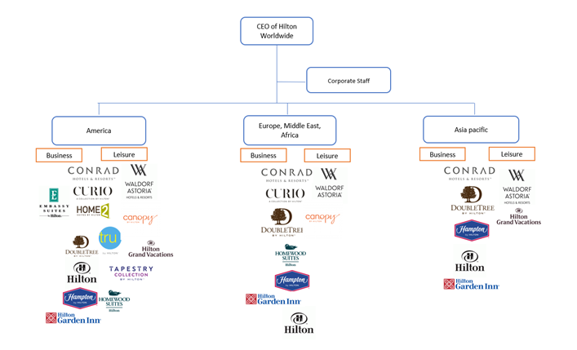

Implementation Plan

Major Tasks |  | Timeline | Responsibilities | Resources
Goal 1: Divest Tru, Conrad and Canopy hotels in order to invest in more successful properties to increase Hilton’s bottomline and global presence
A. Evaluate current properties and contracts with management companies  B. Sell properties that are not successful or negotiate contract terms with property current owner  C. Evaluate and select international markets for new properties  D. Open new hotels that come from the current brand portfolio |  | Q3 2018  Q1 2019  Q4 2019  Q1 2022 | Finance, Research & Development | Capital, Infrastructure, Contractors, Designers, Suppliers.
SMART: Global expansion by 5%
Goal 2: Promote global destinations without visa restrictions
A. Research and determine which properties within our portfolio do not carry strict visa regulations  B. Plan and develop travel rewards program within these properties to increase profits and revenues  C. Implement travel rewards program in order to encourage travelers to visit other destinations |  | Q2 2018  Q2 2018  Q3 2018 | Finance, Research & Development | Capital, Infrastructure
SMART: Increase global occupancy rate by 5% with travel rewards program
Goal 3: Joint venture with technology companies
A. Evaluate joint venture with technology companies  B. Select desired technology company  C. Develop strategies for advertising  D. Implement advertising their electronic product to guests |  | Q2 2018  Q2 2018  Q3 2018  Q4 2018 | Finance, Research, Development & Marketing | Capital, Infrastructure, Partnership
SMART: Increase occupancy rate by 5% with partnering programs.
Goal 4: Promote Hilton Grand Vacations
A. Plan and develop promotion and tour packages.  B. Select desired partnering strategies  C. Implement packages |  | Q2 2018  Q4 2018  Q1 2019 | Marketing & Operations | Advertisement
SMART: Increase ADR by $5 with Hilton Grand Vacation packages
Goal 5: Expand to low currency exchange countries to increase global market share
A. Evaluate global currency exchange  B. Select desired countries for expansion  C. Plan and develop strategies for new properties  D. Implement developed strategies and open properties in new locations  E. Advertise new properties to public |  | Q2 2022  Q3 2022  Q4 2022  Q1 2026  Q1 2026 | Finance, Research and Development, Marketing | Capital, Infrastructure, Contractors, Designers, Suppliers, Advertisement
SMART: Increase global market share by 5%
Goal 6: Create corporate rewards program
A. Organize the Hilton’s reward program  B. Specify the benefits using the reward program  C. Develop reward program strategy  D. Implement developed strategies and advertise them |  | Q2 2018  Q2 2018  Q3 2018  Q1 2019 | Marketing & Operation | Advertisement
SMART: Annual ADR increase by 10%
Goal 7: Expand Hilton Garden Inn, DoubleTree, Hilton and Hampton into emerging economies such as Asia and South America to increase brand awareness and revenue.
A. Evaluate emerging economies  B. Determine location for new properties  C. Plan and develop strategies for new properties  D. Implement developed strategies and open new properties |  | Q4 2019  Q2 2020  Q1 2021  Q1 2022 | Finance, Research & Development | Capital, Infrastructure, Contractors, Designers, Suppliers
SMART: Increase incoming revenue by 5%
Goal 8: Enhance security to maintain safety within the Hilton brand by partnering with third party security companies.
A. Develop training security program  B. Implement the training programs  C. Evaluate the results |  | Q3 2018  Q4 2018  Q2 2019 | Operation | Training
SMART: Safer property increases by 5%

SMART Measurements
- Maximize relevance of existing brands by 5%
- Increase global occupancy rate by 5% with travel rewards program
- Increase occupancy rate by 5% with partnering programs.
- Increase ADR by $5 with Hilton Grand Vacation packages
- Increase global market share by 5%
- Annual guest count increase by 10%
- Increase incoming revenue by 5%
- Safer property increases by 5%

Conclusion

Hilton Worldwide Inc. has been around for many years, throughout these years Hilton has gained critical knowledge and resources which have allowed Hilton to be one of the top companies in the hospitality industry year after year. In order for Hilton to regain the number one position in the hospitality industry the strategies we are recommending are both specific and attainable for each Hilton brand in order to strengthen our global presence and expand our market share as a whole. By successfully completing all of our strategies we will be able to expand our market share, attract new guests in order to increase profit and yield customer satisfaction by digitizing many of our services. Divesting Tru, Conrad and Canopy and investing in Hilton Garden Inn, DoubleTree, Hilton and Hampton, being one of our main strategies, will allow us to increase in global market share and focus on global expansion, to lead Hilton to become recognized as a world wide leader in those countries.

References

Accor SA (2018). AccorHotels Overview. Retrieved March 13, 2018 from
http://www.accorhotels.group/en/group/who-we-are/accorhotels-in-brief

Andone, D. (2018, January 06). Hotel staff interacted with Las Vegas shooter more than 10 times before massacre. Retrieved March 02, 2018, from https://www.cnn.com/2018/01/06/us/las-vegas-shooting-mandalay-bay-paddock/index.html

Braw, E. (2013, July 22). News, sport and opinion from the Guardian's US edition | The
Guardian. Sustainable tourism: the rise of the eco-boutique hotels | Guardian Sustainable Business | The Guardian. Retrieved October 13, 2017, from http://www.theguardian.com/sustainable-business/blog/sustainable-tourism-eco-boutique-hotels

Burr, B. (2015). Global turmoil creates strategic opportunity. Pensions & Investments, 43(6)

Carmichael, S. (2017, December 26). Breaking Down the New U.S. Corporate Tax Law. Retrieved March 02, 2018, from https://hbr.org/ideacast/2017/12/breaking-down-the-new-u-s-corporate-tax-law

D&B Bradstreet, Inc. (2017). Hilton Worldwide [Company Description]. Retrieved March 13, 2018 from D&B Hoovers database.

D&B Bradstreet, Inc. (2017). Hilton Worldwide [SEC Filings]. Retrieved March 13,
2018 from D&B Hoovers database.

D&B Bradstreet, Inc. (2017). Marriott International [SEC Filings]. Retrieved March 13,
2018 from D&B Hoovers database.

D&B Bradstreet, Inc. (2017). Choice Hotels International [SEC Filings]. Retrieved March 13,
2018 from D&B Hoovers database.

D&B Bradstreet, Inc. (2017). Hilton Worldwide [Company Summary]. Retrieved February 8, 2018 from D&B Hoovers database.

D&B Bradstreet, Inc. (2017). Hilton Worldwide [Competitors report]. Retrieved February 8, 2018 from D&B Hoovers database.

D&B Bradstreet, Inc. (2017). Hilton Worldwide [Products and Operations]. Retrieved February 8, 2018 from D&B Hoovers database.

D&B Bradstreet, Inc. (2017). Hilton Worldwide [Geographic Segments]. Retrieved February 26,
2018 from D&B Hoovers database

Enz, C. A. (2010). Hospitality strategic management: concepts and cases (2nd ed.). Hoboken, NJ: John Wiley.

Hilon. (2016). Hilton Hospitality 2016 Annual Report. Ir.hilton.com. Retrieved 12 March 2018, from http://ir.hilton.com/~/media/Files/H/Hilton-Worldwide-IR-V3/annual-report/2016-annual-report.pdf
Hilton Honors. (2017). Discover our vision, mission, and values. Retrieved February 14, 2018, http://hiltonworldwide.com/about/mission/

Hotel Online. (2017). Hilton Worldwide Reports a Q4 2016 Loss of $382 Million; Net Income for Full Year was $364 Million. Retrieved February 17, 2018, http://www.hotel-online.com/press_releases/release/hilton-worldwide-reports-a-q4-2016-loss-of-382-million-net-income-for-full

Higgins, S. (2017, May 25). Democrats officially introduce $15 minimum wage bill. Retrieved
February 25, 2018, from http://www.washingtonexaminer.com/democrats-officially-introduce-15-minimum-wage-bill/article/2624158

Hilton Worldwide. (2018). SEC Filings. Retrieved February 25, 2018, http://otp.investis.com/clients/us/hilton_worldwide2/SEC/sec-show.aspx?Type=page&FilingId=12549972-299877-585439&CIK=0001585689&Index=15500

Hospitality & Tourism: How immigration plays a critical role. (2017). Retrieved February 25, 2018, from http://www.newamericaneconomy.org/issues/hospitality-tourism/

Hotels, C. (2013, March 28). Currency Exchange Rates Have Differential Impacts On U.S. Lodging Demand | PKF Reports – Hospitality Net. Retrieved March 02, 2018, from https://www.hospitalitynet.org/performance/4060079.html

IBISWorld Industry Report. (2017). Global Hotels and Resorts. Retrieved February 24, 2018 from IBISWorld Database.

Kudialis, C. (2017, January 03). Las Vegas marijuana laws: Answers to questions on recreational weed in Nevada. Retrieved February 25, 2018, from https://lasvegassun.com/news/2017/jan/03/some-answers-for-your-questions-on-recreational-ma/

Muller, C. (2010). Hospitality technology: A review and reflection. Worldwide Hospitality and Tourism Themes, 2(1), 9-19.

Our Brands. (n.d.). Retrieved May 29, 2018, from http://hiltonhonors3.hilton.com/en/explore/brands/index.html

Peterkin, O. (2018, March 01). Kauai hotel now accepting Bitcoin as payment. Retrieved March 02, 2018, from http://www.hawaiinewsnow.com/story/37628361/kauai-hotel-now-accepting-bitcoin-as-payment

Porter, M. E. (2008). The five competitive forces that shape strategy. Harvard Business Review,
86(1), 25-40.

Ransomware: One of Hospitality's Biggest Threats in 2017. (n.d.). Retrieved March 02, 2018,
from https://hospitalitytech.com/ransomware-one-hospitalitys-biggest-threats-2017

