Group I
Summer Horvath, Tylere Adkins, Minerva Ramirez, Adriane Nevarez, Kiera Cannella, and Evelyn Bowen
Blaze Pizza Marketing Plan
TCA 380-1003 Professor Jeffrey Hoss

- Executive Summary
Blaze Pizza is changing the pizza industry by fulfilling the customer's needs in a new, eco, and vibrant way. Our goal is to double attendance by marketing the pizza shop in all forms of media that they do not already do, which would be television, radio and online ads. This brand has already expanded to over one hundred locations worldwide but many do not know Blaze’s brand. They have so much to offer because they have room to be able to grow and expand. The four P’s are promotion, place, price, and product. Blaze Pizza covers all four and is still expanding all four. However, promotion needs to be more consistent because they are slowly growing as a company. The four C’s of marketing is a customer driven model which are commodity, cost, channel, and communication. For Blaze Pizza, they already have three C’s to perfection, which is commodity (the product satisfies customers wants and needs), cost (which is not high or too low), and channel (which is having over 132 locations). The one C that needs improvement is communication with their customers to build more of a customer base. By creating a marketing plan to enhance attendance, this will improve the fourth C. Professor Hoss states that, “Ansoff suggested that business owner’s ability to grow their businesses comes down to how they market new or existing products in new or existing markets. He outlines four distinct strategies which are market penetration, which is selling more of the same things to more of the same customers, market development which is selling more of the same things to different customers, product development, which is selling new products or services to the same customers and diversification that is selling new products or services to different customers”. (Hoss PPT) Blaze Pizza has a strong lead on market penetration and market development. However, the two strategies that we would like to work on is product development and diversification so we create some new products to entice our customers, but then work on diversification to use those new products to market to new customers that we will use our new marketing strategies toward like media.
To strengthen the brand, we need to advertise. Our group plans on using different forms of media that they do not already use being Facebook and Instagram advertisements, TV and YouTube commercials, and radio remotes. Facebook advertisements is $3.99 per 1000 CPM (cost per impression). We would like to do 10,000 impressions to equally out to $39.90 while Instagram advertisements are $6.58 per 1000 CPM of a sponsored post not video; So 15,000 impressions would be $98.70. TV Commercials are about $150 for a 30 second ad and YouTube commercial at 5,000 views costing .20 cents equal out to $1,000. Radio will be $3850, which includes 30 second commercials, 15 remote announcements, and 4 live call ins. Our marketing plan will be costing $5,138.60 cents in advertising.

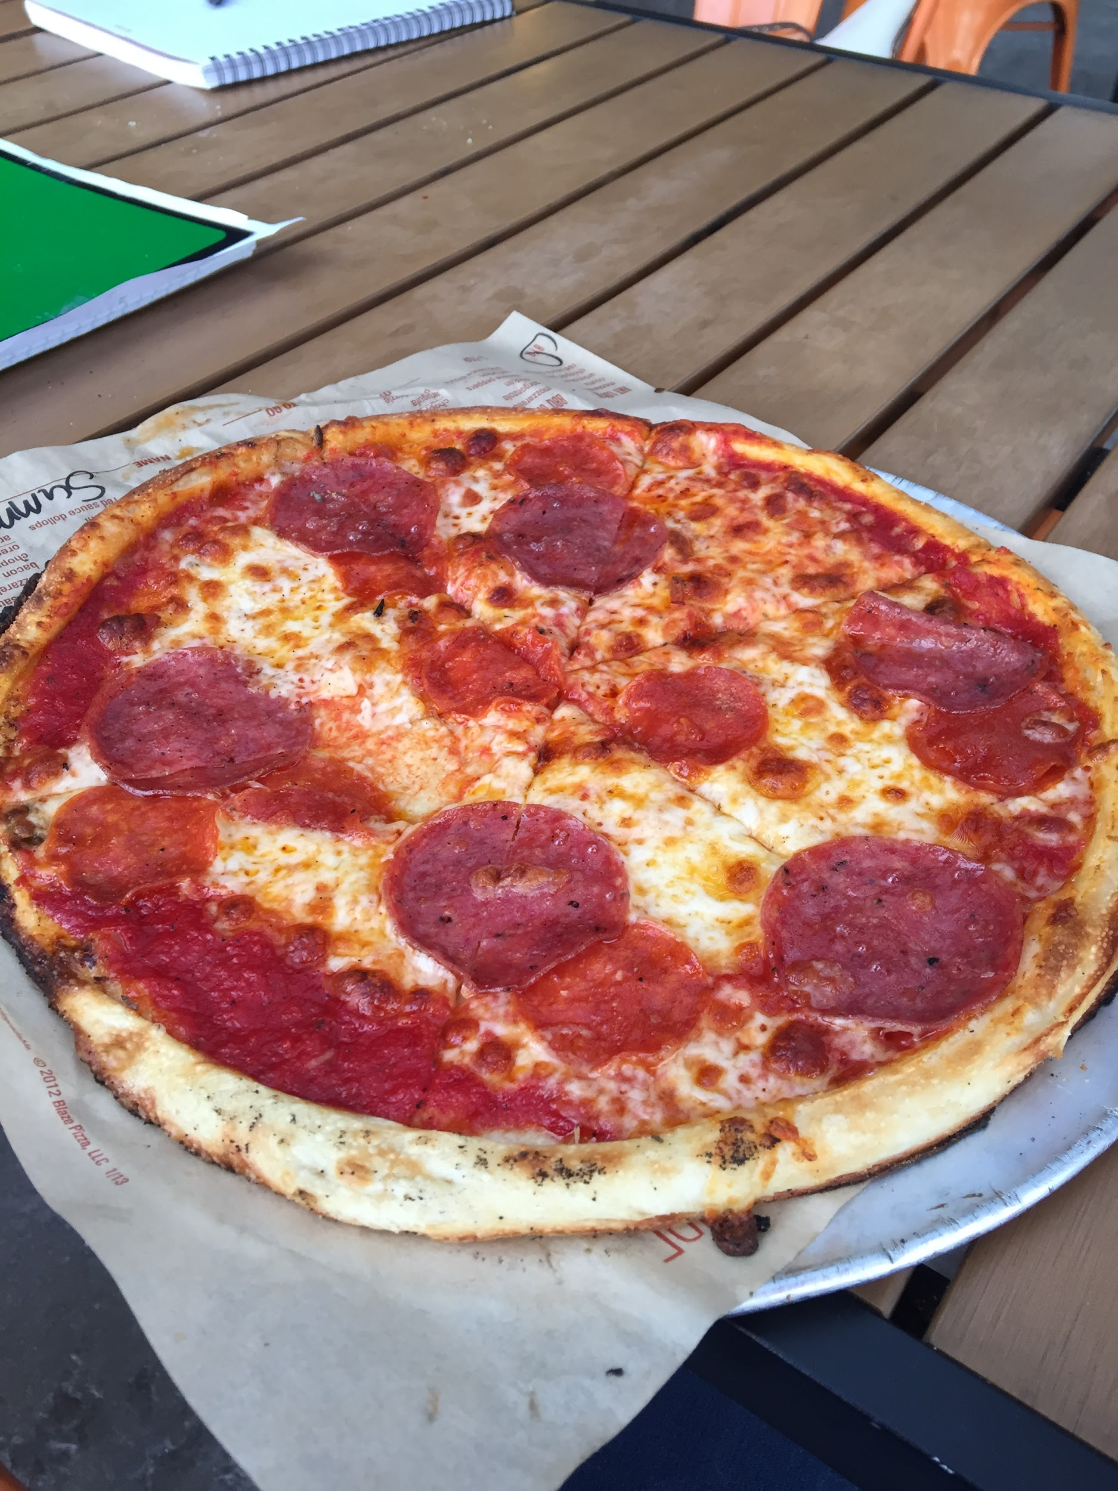
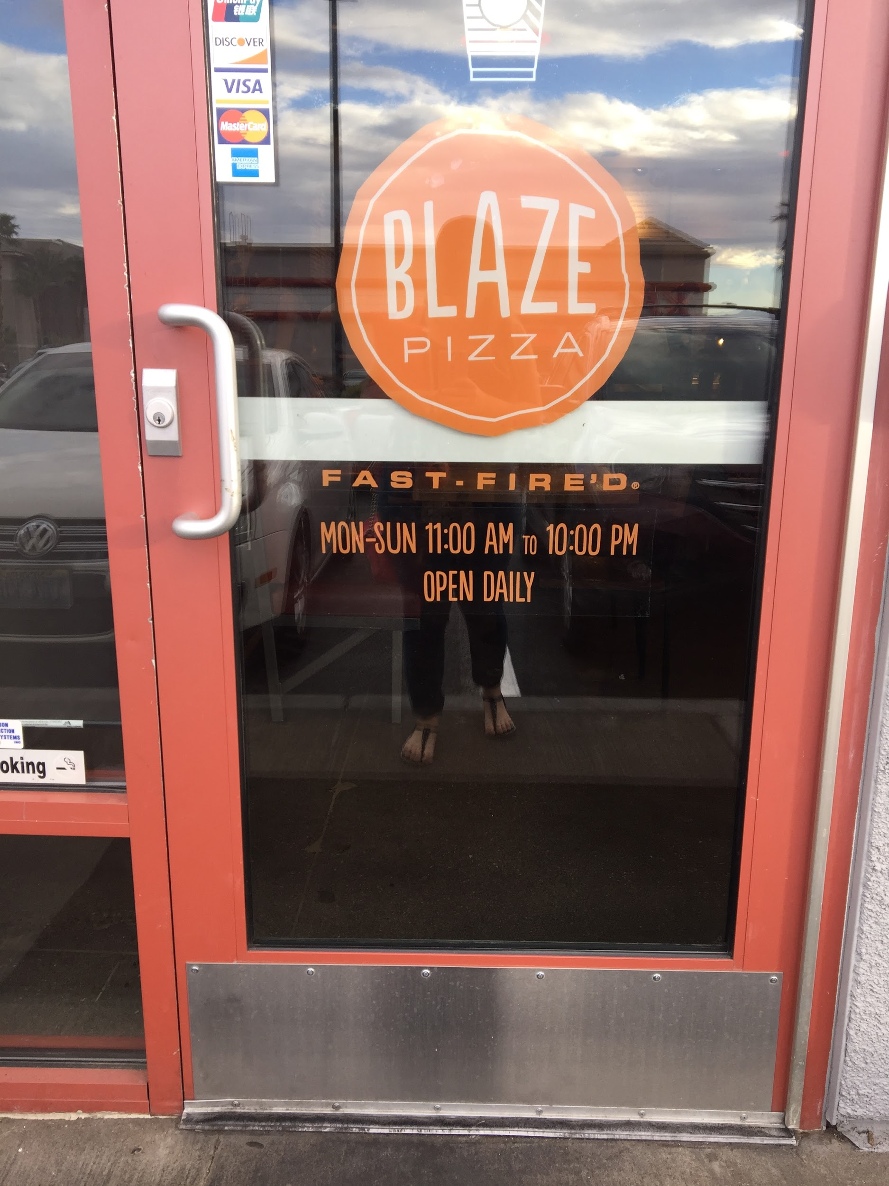
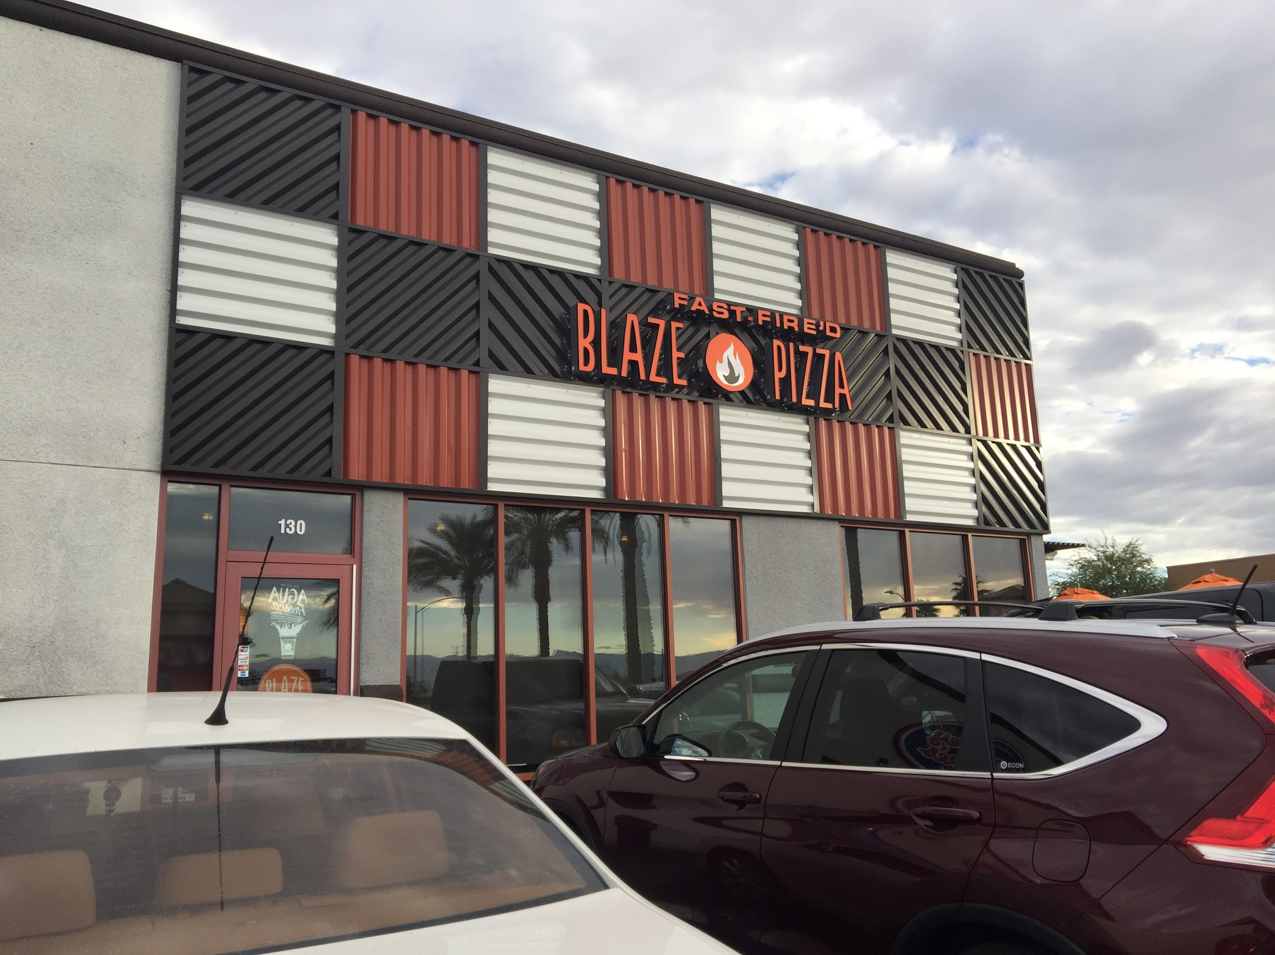

- Corporate Connection/Company Overview
Chloe from Blaze Pizza states, “We are changing the way that people think about and eat pizza. And I am happy to be a part of that” (About Us, 2016). Jennifer from Blaze Pizza says, “It's cool that we have that kind of brand or that kind of ora to where people are immediately attracted and I think it's cool to be a part of that” (About Us, 2016). Rene states, “The culture here, I feel like is different than the outside world. People come in here, interact with guests, and enjoy a really happy environment.” (About Us, 2016). This shows Blaze Pizza's goal is customer satisfaction, embracing their culture, and changing the pizza industry.
Their mission statement is “Ok, we're gonna keep this quick. Because exceptional quality at lightning fast speed is what we're all about. Blaze Pizza. Head food guy, Executive Chef Bradford Kent (aka "The Pizza Whisperer"). Fresh, made-from-scratch dough. Healthful, artisanal ingredients on the assembly line. Inventive to classic. You decide. Blazing hot oven + dedicated pizzasmith + 180 seconds = fast-fire’d, perfectly crisp perfection. Sound good? Enjoy the rest of your day” (About Us, 2016). Now, not the typical mission statement, but it shows how Blaze Pizza goals are to be fast, food is made fresh, and it will be perfect for their customers.

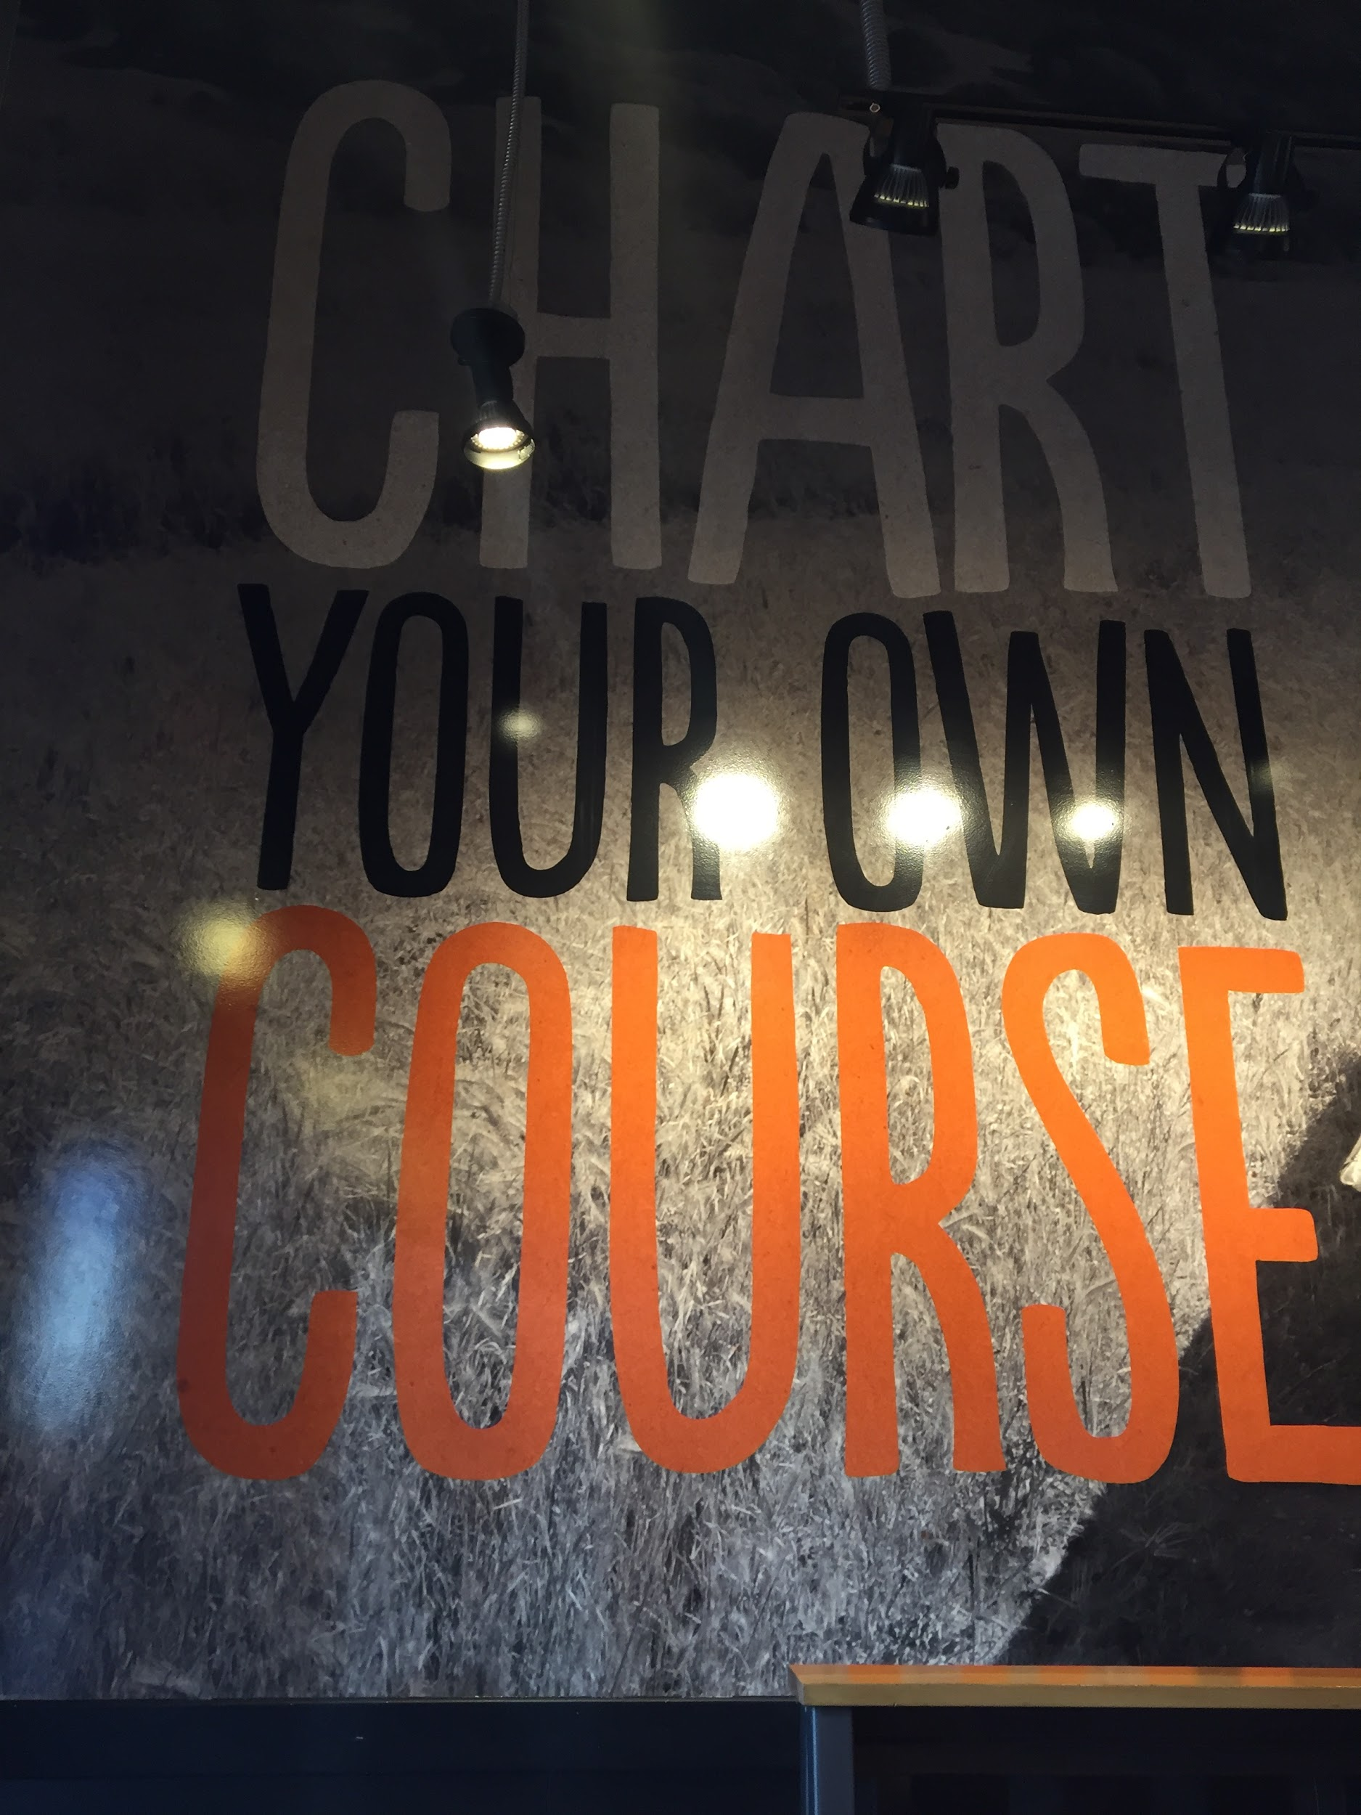

- Environmental Analysis and Forecasting
Blaze is different than their competitors already by having a community of people who love their brand and have the same values as them. However, Pieology and Pizzarev have the same concept as Blaze, but Blaze Pizza will surpass them by marketing through different sources of media to be able to dive deeper into the wants and needs of their customers. To do this, we must analyze the competition with the Porters Five Forces model. Porters five forces really helps us understand how to understand our competitors. Starting with threats to entrants, the pizza industry is something easy to get into. Other companies are starting to pop up and compete against Blaze Pizza. Pizza is something that is easy to start up because a majority of the population likes pizza, so there is a better chance it will be profitable. There is a competitive rivalry within the industry because there are so many different types of pizza places. They all sell the same types of pizza, but have a different strategy. The ingredients to make up pizza are all easy to get a hold of. Because of this, a company can buy all these ingredients in bulk. The bargaining power of suppliers is mostly low depending on the quality of ingredients they provide. Because the ingredients of a pizza are so easy to find from many different suppliers, the bargain itself is low. The only exception is that when a company does expect to have ingredients that are organic and higher quality, there are less suppliers to choose from which means that the bargaining power for the supplier is higher. The bargaining power of the customer is very high since there is a huge part of the population that likes to eat pizza. Because of this, people are very knowledgeable about the pizza product itself. Since there are so many different types of pizza restaurants, buyers have lots of options of where they can buy their pizza from. There is always a threat of substitutes because pizza can be considered so simplistic. Places like Pieology and Pizza Rev are already in the pizza market and similar to Blaze’s style. Since places like these already exist, there is a possibility others will follow and copy that same model. Now we know Porters Five Forces affects Blaze, we can also look at the macro environmental factors that affect them as well. The macro environment helps us understand how we can be different than our competitors. Now, macroenvironment affects microenvironment by competitive, demographic, economic, natural, technological, political and cultural factors. Blaze Pizza has a strong stance on all these factors except when dealing with our marketing plan, the obstacles will be competitive, technological, and demographic. First, Blaze is strong in being competitive in the pizza industry by satisfying their customers wants and needs. However, when we start to market to other medias that they do not already have, we need to accommodate to a new market which is where product development and diversification will come into play. We will overcome this by learning our new demographic to accommodate to our customers which handles the competitive factor and we shall use technological to get feedback to grow from our continuous stride to expand and strengthen our brand. Blaze’s strengths are economic, political, natural, and cultural. Blaze is economically prepared because when we went to the Henderson location, they looked pretty steady which helps them understand their spending patterns. Next, would be natural by having fresh and organic ingredients to be able to pick from. Politically, Blaze is all set since they are a franchise, they already have a book of laws and regulations to abide by and our marketing plan will not change any of that since this is a corporate plan to market the brand. Lastly, Blaze Pizza is culturally inclined by having a strong mission statement, values, and positive behavior toward their guests.
Now attached below is our SWOT analysis to better understand Blaze Pizza as a whole. We were able to get some ideas from the manager at the Henderson location.
Strengths  - Price  - Choices of toppings  - Locations  - App  - Demographic being everyone  - Company being new  - Great customer Service  - Organic  - Restaurants is orange which is a happy color to make guests happy  - Yelp Reviews  - Pizza lovers | Weaknesses  - No Delivery  - No different doughs for pizzas  - No other products (Example: No wings, pastas, or various deserts)  - Bathroom was not cleaned/ No toilet seat covers  - No various forms of marketing (Example: TV, radio, etc)  - Price  - App imperfections  - Stock Holders  - Elders  - Families
Opportunities  - More locations  - Marketing the brand  - Fundraisers  - Education programs  - Product  - Merger (Example: Uber Eats, Post Mates)  - Different sizes of pizzas  - Franchise  - Training  - Internal Promotions  - Eco Friendly Program (Example: If Blaze Pizza prints paper products, they will plant a new tree)  - 18-30 year olds  - College students | Threats  - Competitors (Example: Pieology and Pizza Rev)  - Suppliers (Example: If supplies is bad, then it will reflect company)  - Merger (Example: If they merged with Pizza Hut, it would hurt their uniqueness)  - Trend Reverse (Example: If people just wanted regular, not customized pizza)  - Franchise (Example: If all franchises were not ran the same)  - Customers loyal to other competitors

Nowadays everyone is on the go and wanting things fast and ready to eat. Overall, this industry trend of getting good quality food quickly is something everyone looks for when deciding what to pick up for their meal. This seems to be a trend for everyone and is not limited to a certain age or demographic. Whether people are out for work, school or leisure purposes, they still do not want to wait a long time for their meals. Having options for our customers, creates a more appealing approach as well. Within the last 10 years or so, there have been scandals within food companies that raise the question on where certain ingredients come from and how well they are being prepared. Food establishments are now constantly looked at under a microscope because people want to make sure their food is quality and will pay extra to get just that.
To ensure this company is going strong and continually being marketable, Blaze must be able to conduct surveys to their customers and to outside groups. These surveys should be distributed through their own app, online, through social media, and even local events around their franchises. The surveys should be given to all demographics to see who they are reaching out to the best and continually making them stronger and who they still need to work on. Also, there have been competitors in surrounding areas; because of these competitors, Blaze should research how well they are doing and who they are reaching out to. This way they will be able to compare and contrast their own business strategies and see if there is room for making changes to compete and rise above.
Since we are considering better marketing strategies for Blaze, there should be research done on the fast food industry as a whole. There, we can research who is providing the best marketing and benefiting the most through profits and popularity. Also, researching to see which marketing channels work the best for those companies and mirroring those to fit our company.
Another research method to utilize is going to the stores themselves and watching how they function and interact with the customers. By being at the location, one can get that feel of who they really are and how they are bringing their values and company vision to life. While getting food there, one can interact with other customers and interview them to see how they like the establishment and determine if they will be a returning customer.
The size of our potential market would be a quarter of Las Vegas, Summerlin as well as Henderson valley. We would expect most customers to be students or young adults. With current population growth in Clark County, it is feasible to have an estimated 27,000 people in our potential market. Given, we have proper advertisement to reach the potential market, we can expect our revenues to increase drastically.

- Segmentation and Targeting Your Market
Our desired target market is consumers who enjoy pizza. Our desired market segment is differentiated. Blaze is undifferentiated because our target market is very vague. Differentiated is our specific clients we want to target which will be the demographic of 18-30 year olds and college students. Our plan to target them will be to make sure every customer is special because they are getting a pizza just for them, the way they want it. This will be a huge selling point in our marketing strategies to strengthen our brand. Our positioning is to offer specials to customers new or returning by giving a free specialized birthday pizza, or half off during “happy hour”. For new customers we would encourage them to refer a friend for a free pizza after their referrals first pizza purchase.
The four requirements for effective segmentation are the following: Measurability, Accessibility, substantiality, and actionability. Measurability is measuring segment size and purchasing power. This relates to Blaze because we know that Las Vegas has a lot of people between our target age range group of 18 - 30. This city is constantly growing and this age range has good purchasing power in this affordable city. Accessibility is where segments can be assessed and served. Our target segment is mostly college students and people of that age range. With Las Vegas being somewhat of a college town, it will be easier to access Blaze when build near campus. Blaze can be assessed by customer counts, revenue changes, word of mouth, and social media exchanges. Substantiality is where a segment is large or profitable enough to serve as a market. Blaze has a very wide market to market to because there is not really anyone who does not like pizza. They meet special dietary needs with being able to make the pizza vegetarian, vegan, or gluten free. It is served quickly and is at a reasonable price range for most customers. College students and people between 18-30 would be a profitable market for Blaze to serve. Lastly, actionability is where effective programs are designed to attract and serve the segments. The locations and marketing tools we implement will attract our market segment. By making locations close to downtown or UNLV and making the brand well known among people of that age group, our plan will directly attract our segment. Our plan is differentiated. Now, after understanding our segment, we must determine how we will be competing in industry. Blaze Pizza will be competing by image because we are expanding our brand. We want Blaze Pizza to be the strongest and most well-known brand for custom pizza. The factor to help us get to that point will be location because the areas we build Blaze will attract our demographic. For example, since we want to attract students, Blaze should build a location right next to UNLV. Thus, if we have events at UNLV, that will help Blaze Pizza build their image. Their image is the most important to market because loyalty comes with a strong brand. Once the students or demographic of 18-30 year olds are loyal, we can expand to other markets. We will achieve positioning by adding locations in areas around college campuses, social media, tv ads, and word of mouth. Putting locations in downtown and near UNLV campus will attract the customer segment we want. Having ads on YouTube before videos, Instagram ads, and tv ads; we will make ourselves available to a customer base that heavily uses social media. Using tv ads will be effective as well. Although many people in this age range are cutting cable, many people of this age range also live at home or are moving back home after graduation. Therefore, this generation is being called the boomerang generation. By moving back in with parents or already living at home, they will have cable. These ads will run on channels like MTV, Comedy Central, Spike tv, ESPN. We will reach intended customers by displaying our brand in a way that we want to reach them. Another way we will do this is by doing radio remotes on campus to generate awareness,

- Objectives and Sales
The overall corporate objective Blaze Pizza is trying to accomplish is that they want pizza that is fast and fresh and ready to eat. Using this, we need to be able boost communication and promotion to expand the threshold of how many consumers know about this brand. To make this happen, Blaze Pizza needs to market better to the age group of 18-30 years olds because they have been shown to be the most profitable for this restaurant style.
Last year we saw a percentage of sales jump from 3 to 5%. Within 4 quarters of 2017, we would like to see anywhere from a 5-7% increase in sales. In order to achieve this, we will need to be able to market through tv commercials, YouTube commercials, radio ads and social media ads.
Through these market strategies, we will be able to inform this age group about our brand which will in turn increase our revenues. When we launch these ads in 2017, we will carefully watch each quarter and see how this affects our overall sales. By the end of the year, we would like to see this projected increase achieved.
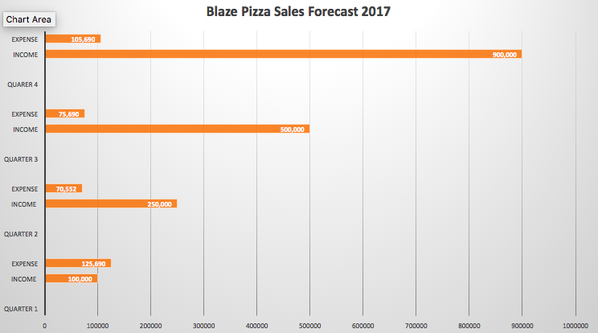

- Strategies and Tactics
Our main sales strategy to promote Blaze Pizza is social selling. Social selling is the use of social media or any online or mobile avenue to increase sales performance. Now in society, the internet and social sites online are the most valuable channels for a business to connect with their customers. We want to reach young adults and create awareness of our brand by using online sources on major social media websites such as Facebook and YouTube. This is where our target demographic spends a lot of their free time. Blaze Pizza was lacking a major presence on both of these major social media websites along with Instagram, and we believe the larger the presence on these websites will lead to improved sales percentages.
The advertising vehicles we plan to promote Blaze Pizza as a brand with are radio remotes, TV ads, search engine optimization, and social media including Facebook, Instagram, and YouTube. In order to reach our intended customers, we need to promote on the platforms they use and connect with the most. We will use radio remotes as a personal communication channel by going straight to future customers to create awareness and knowledge. There is a lot of opportunity for Blaze Pizza to make their brand well known to college students, and by creating a good first impression in person at the schools with the radio remotes, we believe it will generate more interest for the company within student communities. We also want to utilize a non-personal communication channel through TV ads. Not only will we be able to use our commercial for television, but we will also use it online through social media. To further establish more interest in Blaze Pizza for 18 to 30 year olds, we will use search engine optimization to advertise on the internet and more specifically Facebook and Instagram. Simple pop up ads for Blaze Pizza using the brand’s philosophy of quality food fast in each ad matches the need of our desired market. Young adults use most of their free time on the internet because it gives them information fast. Blaze Pizza is all about being fast with quality ingredients custom to its guests. The top websites our desired market uses are Facebook, YouTube, and Instagram. By using our commercial and ads on these platforms, we can promote the brand generating attention to our desired market.
To strengthen the brand, we need to advertise. Our group plans on using different forms of media that they do not already use being Facebook and Instagram advertisements, TV and YouTube commercials, and radio remotes. Facebook advertisements cost $3.99 per 1000 CPM (cost per impression). We would like to do 10,000 impressions to equal out to $39.90. Instagram advertisements are $6.58 per 1000 CPM of a sponsored post, so 15,000 impressions would cost us $98.70. TV Commercials will cost us $150 for a 30 second ad, and a YouTube commercial allowing 5,000 views costs .20 cents equal to $1,000. Our radio promotion will cost $3850 which includes 30 second commercials, 15 remote announcements, and 4 live call ins. Our marketing plan will be costing $5,138.60 cents in advertising.
Our goal for our sales strategy is to reach as many people within the 18 to 30-year-old age demographic to bring awareness of our brand. By advertising through social media, TV, and radio we will be more connected to this market. We want to start with 25,000 impressions through social media. We feel that this is a significant number to start measuring our results of increased promotion on Facebook and Instagram. We also would choose to spend the most money on radio ads and radio remotes because this allows us to create the personal communication and connection to young college students. The radio ad price was acquired through CBS radio, specifically local radio stations 98.5 KLUC and MIX 94.1.

- Necessary Resources 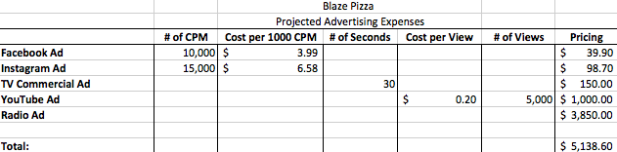

- Evaluation Metrics and Marketing Control
Finding out if we are successful or not will be based off our revenue expense, knowing if our metrics are profitable, and meeting our strategic goals. In reference to our chart in Blaze’s pizza sales, we have profoundly made an increase in each our quarters, expenses were low, yet we had an uprising increase in income, which is profitable for us. The more we can do to reach out towards our market segment, the more successful of a franchise we will be. We will also know if we are successful by looking at our evaluation metrics, which are how many people have downloaded our app, or how many times have our ads been clicked on. We find this to be successful because we are targeting the most top used applications in this generation, hoping to succeed our direct target towards our demographic market segment. We strongly believe in this objective of becoming a successful restaurant.
If this objective fails, then we will reorganize our market ideas and create a S.W.O.T. analysis to conclude a strong backup plan. According to our team, if all fails, we will come back stronger and better with newer innovative market ideas to promote Blaze Pizza. With that being said, we will establish other forms of media, such as billboards, coupon books at universities, and our best one yet, will be from our loyal customers, marketing by word of mouth. These are classic market strategies, that luckily, usually always work. We will be able to fall back on this backup plan, and hope for the very best. Billboards are always great, especially if they are by the campus. This can direct students to where they could get a great pizza option. This will help endorse our establishment to be known and hopefully more popular than your regular small shop pizzeria. We want to become the next big spot to hang out with friends after class or even in between times from your busy schedule. We are a fast-paced pizzeria that will fulfill your hunger and social needs.

- Planning for the Future
If we hit our goal, we plan on focusing on other market segments, dive into product development, and merge with another company like Uber Eats. Once diversification is completed for college students and 18-30 years old, we can move to another segment to market like families or elders. Maintaining a strong customer base is an objective to continuously have. Marketing is ongoing so as long we do not stop marketing, we will maintain business. Then we can focus on adding more products to the menu to increase options at Blaze Pizza. This is how our objectives will change from diversification to product development. At the moment, all they have is salad, two desserts, and pizza. They could slowly move into pastas and more desserts. This is how our marketing mix will change to product from promotion. Lastly, merging with another company like Uber Eats is a great way to market the brand and start a delivery service for Blaze Pizza. Blaze Pizza is a great franchise who is slowly climbing the ladder to success. With our marketing plan, Blaze will be able to increase revenue to beat their competitors and give awareness to their customers on their custom pizza.

WORKS CITED

About Us. (2016). Retrieved October 05, 2016, from http://blazepizza.com/about-us/

