Front of the House Training Manual

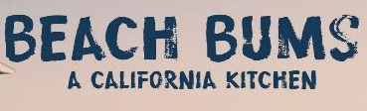

Training Manual

Our restaurant is Beach Bums California Cuisine on April 25th, 2018. Our theme is California style food with some beachy vibes surrounding the restaurant. We want to bring the beach to the desert.
Hours of Operation:
11:00 AM to 12:45 PM

Mission Statement:
Beach bums will provide a one-of-a-kind experience that brings people together for tasteful food, amazing service, and beachy fun.

Our Team:
Summer Horvath, General Manager, 702.525.3064, horvas1@unlv.nevada.edu

Taylor Pegram, Dining Room Manager, 972.814.8802, pegram@unlv.nevada.edu

Devonte Smith, Bar Manager, 702.807.9887, smithd18@unlv.nevada.edu

Emma Tom, Marketing Manager, 702.417.9969, tome2@unlv.nevada.edu

Positions
On our meal day, everyone will have specific job duties. Summer will be overseeing all of front of house and assisting with the flow of the restaurant. Taylor will be responsible for training and overseeing layout in the dining room. Emma will be relaying meal logistics and making sure guests arrive safely. Devonte will prep bar and have overall responsibility for the running of the bar and ensures that the operations run smoothly.

Managers per station
Summer: Summer will oversee making sure everything is running smoothly throughout the meal. She will act as a floater and will be moving around the floor for additional help and mainly helping back half of dining room.

Taylor: Taylor will oversee the host stand and giving additional help to maintain traffic with front half of dining room.
.
Emma: Emma will oversee helping all bussers and food runners in all sections.

Devonte: Devonte will oversee the bar area. Maintaining a clean work station and helping the bartenders.
Marketing
Our marketing proposal is to bring around 120 people to our event on April 25th. We plan on using many strategies and methods to draw our clientele into our restaurant. Our target market is faculty, students, student athletes, and outside guests. Each team member will be responsible for 5 presale tickets. We would like a diverse mix of people to mirror the California experience. Our menu is diverse ranging from vegetarian to meat lovers, fountain drinks to specialized cocktails, and sweet to sugary desserts. The 3-course menu will be low budget to attract more guests for example, the student population. Our implementation of marketing will be word of mouth, flyers, Facebook, and website. We will be passing out flyers around campus and around the city to give exposure of the event. We will start 3 months prior to event to give awareness and towards the meal day, we shall market heavy around campus. For the student athletes, our Marketing director will be speaking out during the gathering of the University’s captains to spread by word of mouth. We shall also have a radio spot aired the week of the event and remind those with flyers of the day of the event. We will make a “Beach Bums’ Facebook page to have people involved in the process and have information of our restaurant. Guests will be able to check in if they are attending or not, so we can get a forecast on how many people are attending. Lastly, our website is summerhorvath.wixsite.com/beachbums. Our website has all information needed to know the ins and outs of the event. The link will be located on all flyers and posters to give guests additional information.
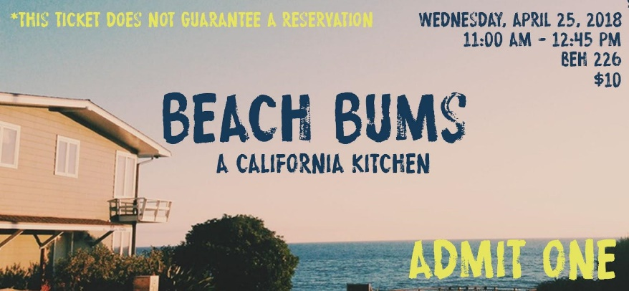

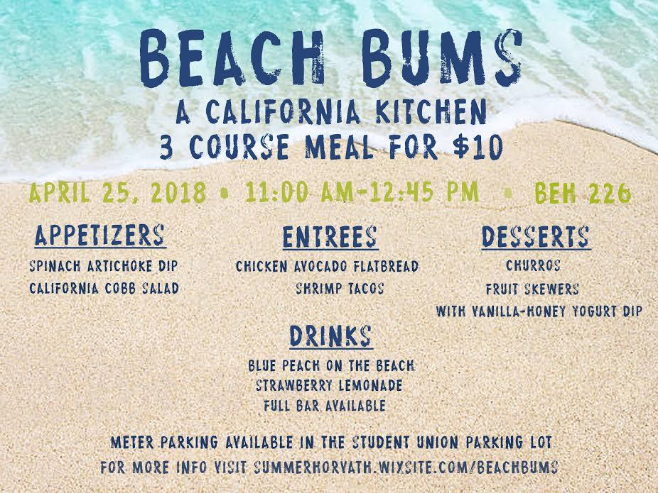

Profit and Loss Statement Format (Forecast)
Revenue: $ %
---------------------------------------------------------------------------------------------------------------------
Food Sales $1200 80% of Total Sales
Beverage Sales $ 82.50 20 % of Total Sales

Total Sales $ 1,282.50 100%

Cost of Goods Sold
-------------------------------------------------------------------------------------------------------------
Food Costs $ 950.22 79.2% of Food Sales
Beverage Costs $ 73.83 89.4 % of Beverage Sales

Total Food and Beverage Costs $ 1,024.05 79.8% of Total Sales

Gross Profit $ 258.45 19.8 % of Total Sales
(Revenue – COGS)
===================================================================
Labor Cost and Benefits Expenses $0.00 0 % of Total Sales
=====================================================================
Other Expenses (Controllable Expenses) % of Total Sales
Linen $46.92 3.6%
Decoration $193.99 15.1%
Music & Entertainment $0 0%
Supplies and maintenance $50.00 3.8%
(fixed Costs for our purposes)
Cost of Comps $ 10 .08%
Printing $ 62.75 4.8%
Cost of Promotion, Marketing, $ 0 0%
and Advertising
Employee Meal $ 80 6.2%
R&D (research and development) $ 321.07 25%

Total Other Expenses $ 764.73 59.6%
=====================================================================
Non-Controllable Expenses $0.00 0% of Total Sales
==========================================================
Grand Total Expenses $1,788.78 139% of Total Sales
==========================================================
Profit / Loss (Revenue – Costs) $-506.28 -39.5% of Total Sales

Timeline of Dining Room Set Up/Break Down Schedule

DAY BEFORE
Set Up:
2pm - Set up decorations, set tables in layout, assign tables for morning prep, check linens, and roll napkins

DAY OF
Set Up:
7AM - Managers arrive to begin setup for service
8AM - Workers arrive to join setup for service and managers check uniform while distributing shirts
8-8:15 AM - Pre-shift Meeting
8:15- 8:30AM- Assign pre-shift tasks
8:30-10AM- Vacuum (Hostess)
Finish prepping tables, bar, silverware, and service station (Servers)
Polish silverware and glasses and stock POS Stations (Bussers)
Blow up balloons, and finish decor (Food Runners FOH)
10:15AM- Check dining room for proper setup (Managers)
Check POS with Mohsen(Managers)
Pass out flyers outside (Food Runners FOH)
10:30AM- Check in with kitchen
Entertainment arrives
10:45AM – Start playing music
11AM - Doors open

Break Down:
1pm - Break down of front of house of cleaning, putting away items, and organizing storage closet
1:45pm - Help back of house clean kitchen

Front of House Checklist for Meal Day

Day Before Meal:
- Decorate
- Check Linen
- Roll Napkins
- Set up tables

Day of Meal Before Opening (Check - In):
- Attendance and Uniform Check (Shoes, Socks, Pants, Top, and Name Tag)
- Check TAM and Health Cards
- Vacuum Carpets
- Step up dining room tables according to layout
  - Checking linens (seam down, centered, no stains)
  - Centerpieces are placed according to photo
- Finish decorations
- Store both cabinets with ice and water
- Clean and put out serving trays and jacks
- Store both cabinets with cups, linens, napkins, silverware
  - Water glasses and silverware are all same size and polished)
  - Napkins are rolled
- Take out trash cans of dining rooms
- Clean and refill condiments
- Make sure there are comment cards, pens, and receipt holders at each service station
  - Refill Paper
- Check service station for setup and cleanliness.
  - Test soda/coffee
  - Clean out trays
  - Set up back station with glasses, ice bucket, sugar, straws, creamers and lemons
- Clean the entry of the classroom by the host stand
- Check ice machines
- Clean all seats (including the bar seats)
- Check/Program POS System with Mohsen
- Check bar for setup and cleanliness
  - Make sure all items are in well
  - Have all glasses polished
  - Ensure caddies, garnishes, and rags are present and prepped
  - Ice well
- Check - In with kitchen staff
- Assign additional help (HMD 253 students)
- Make sure entertainment is ready (music, live band, and projectors)
- Check the lighting in the room

Day of Meal Closing Procedure (Check - Out):
- Clean the entry of the classroom by the host stand
- Turn off ice machines
- Clean all cabinets with ice and water
- Place trash cans back in the dining rooms
- Refill paper in POS
- Clean all seats (including the bar seats)
- Vacuum Carpets
- Ensure all checks are closed
- Make sure we clean/collect all comment cards, pens, and receipt holders at each service station
- Make sure all tables are placed back in the proper closets
- Bring all dirty dishes to dishwasher
- Check service station for cleanliness.
  - Clean floor mats
  - Clean coffee and soda trays
- Check bar for cleanliness
  - Return all items
  - Wipe down bar and wells
  - Label left over garnishes and put in fridge
  - Make sure all glasses appear back in bar
- Return all workers attire for the next class if necessary.
- Make sure take down all decorations in the dining room and bar area if necessary.
- Make sure all glasses and silverware are stored in kitchen
- Make sure all dishes are washed.
- Make sure entertainment is shut down (music, live band, and projectors)
- Return lighting to normal

Employee Tasks (Before meal)
Jessica Daum: Prep hostess table
o Have waiting list prepared
o Have map prepared
o Have menus prepared
Breakdown: Clean hostess table

Alex Webb: Vacuum morning of service
o Clean and put out serving trays and jacks
o Prepare hostess table with Jessica
Breakdown: Bring trash cans back in and put away service trays

Oscar Lopez: Prep bar
o Polish glasses
o Number seats at bar 1-10
o Make sure all items are in well
o Have all glasses polished
o Ensure caddies, garnishes, and rags are present and prepped
o Ice well
Breakdown: Clean bar

Mitchell Garcia: Set up dining room
o Linen, napkins, silverware
Breakdown: Put tables and chairs away

Aleksei Reyes: Make sure there are comment cards, pens, and receipt holders at each POS station
o Refill Paper
Breakdown: Put POS stations away

Anna Burton: Store both cabinets with cups, linens, napkins, silverware
o Water glasses and silverware are all same size and polished)
o Napkins are rolled
o Refill condiments
Breakdown: Put Cabinet away

Yunuen Martinez: Setup centerpieces and help with other decor
Breakdown: Put centerpieces away and help take down decor

Jailene Vasquez: Store both cabinets with cups, linens, napkins, silverware
o Water glasses and silverware are all same size and polished)
o Napkins are rolled
o Refill condiments
Breakdown: Put Cabinet away

Madison Black: Prep main service station in kitchen
o Test soda/coffee
o Clean out trays
o Refill condiments
o Follow checklist
Breakdown: Put service station away

Michelle Chan: Polish Silverware and Glasses
Breakdown: Put away silverware and glasses

Anna Lei: Set up dining room and help with service stations
o Linen, napkins, silverware
Breakdown: Put tables and chairs away

Lei Fu: Polish Silverware and Glasses
Breakdown: Put away silverware and glasses

Brittney Chancellor: Set up dining room and help with service stations
o Linen, napkins, silverware
Breakdown: Put tables and chairs away

Nayeli Sosa: Blow up balloons, and pass out flyers outside of BEH
Breakdown: Take down decor

Allison Pipo: Blow up Balloons and pass out flyers outside of BEH
Breakdown: Take down decor

Positions of Front of House

Hostess: Jessica Daum
- Have dry erase map and waiting list form prepared
- Open doors at 11 AM
- Acknowledge all guests
- Greet
- Write down name of the Party
- Write down number in the Party
- Write down the time of their Arrival
- Make sure to smile, use guests name, and never leave post

Seater: Alex Webb
- Acknowledge all guests
- Track open tables & seats and inform main host
- Provide menus
- Memorize Table Numbers
- Promptly seat guests
- Assist bussers with set up
- Make sure to smile, use guests name, and inform head host of wait times

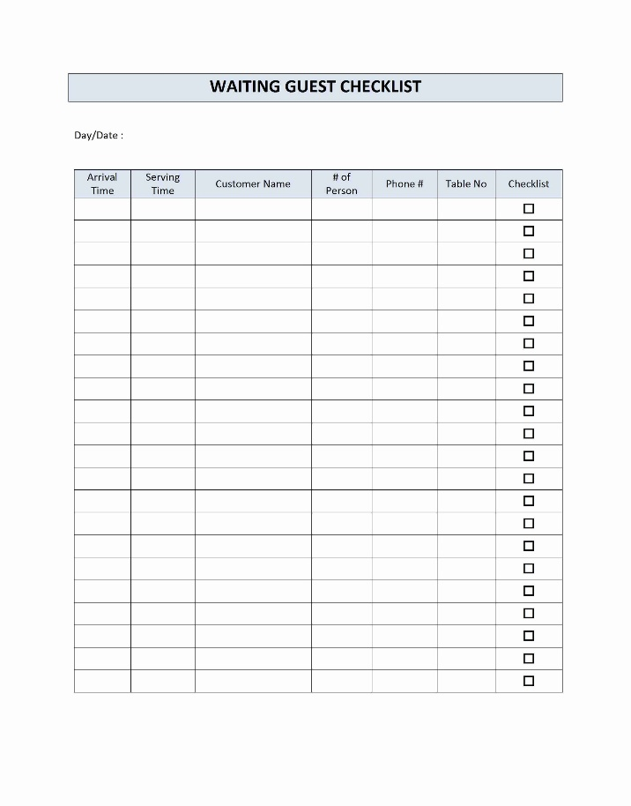

Bar Servers:

Oscar Lopez (7777)
Volunteer Haeden (8888)
Volunteer Rosie (9999)
Volunteer Madi (0000)

SECTIONS: 70 POS 1 and Cabinet 1
***YOU ARE TAKING FOOD ORDERS AS WELL***
Example POS Table Number for Food Runners: 701 (70 is your section and 1 is the seat at bar)

- Wipe down bar chairs before service / number seats
- Must have Alcohol Awareness and Food Handler card at all times.
- Acknowledge all guests
- Check for proper ID’s
- Know the seat numbers at the bar for ordering
- Make sure the bar area is clean from spills
- Make sure the guests are satisfied
- Deliver drinks properly
- Present food bill with comment cards and pins
- Give payment to the cashier in the back of the house
- Give change back to customers/collect comment cards
- Follow all Sanitation guidelines
- Server food from customer’s left, serve beverage from customer’s right, and clear everything from the customer’s right.

Servers:
Madison Black (1111) SECTIONS: 10, 11 and 12 POS 3 and Main Service Station
Anna Burton (2222) SECTIONS: 20, 21 and 22 POS 3 and Main Service Station
Aleksei Reyes (3333) SECTIONS: 30,31, and 32 POS 2 and Cabinet Two
Jailene Vasquez (4444) SECTIONS: 40, 41 and 42 POS 2 and Cabinet Two
Mitchell Garcia (5555) SECTIONS: 50, 51, and 52 POS 1 and Cabinet 1
Yunuen Martinez (6666) SECTIONS: 60, 61, and 62 POS 1 OR 2 and Cabinet 1

- Acknowledge all guests
- Know tables numbers and your specific section
- Attend to customers when they arrive at their table
- Write down each seat number’s (clock way or starting with the ladies/kids) meal
- Deliver drinks properly / Check ID’s for alcoholic drinks
- Communicate with the kitchen for any allergies and all problems
- Ensure that customers are enjoying their meals periodically
- Present food bill with comment cards and pens
- Give payment to the cashier in the back of the house
- Give change back to customers/collect comment cards
- Follow all Sanitation guidelines
- Server food from customer’s left, serve beverage from customer’s right, and clear everything from the customer’s right.

All Servers will have this cheat sheet with their server supplies to be able to explain to guests how the food and beverage items are prepared. Also, at POS station there will comment cards to rate our success.

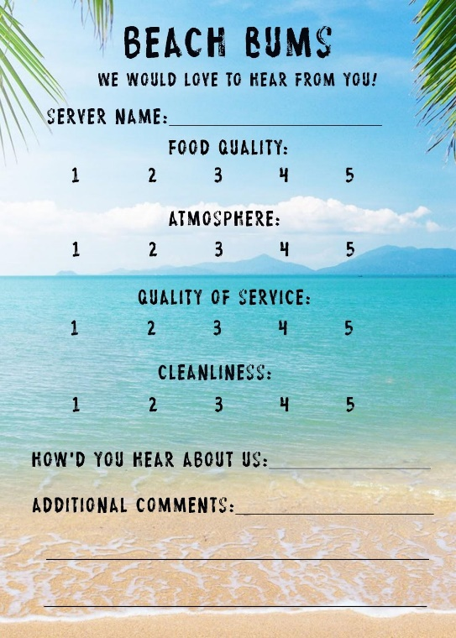
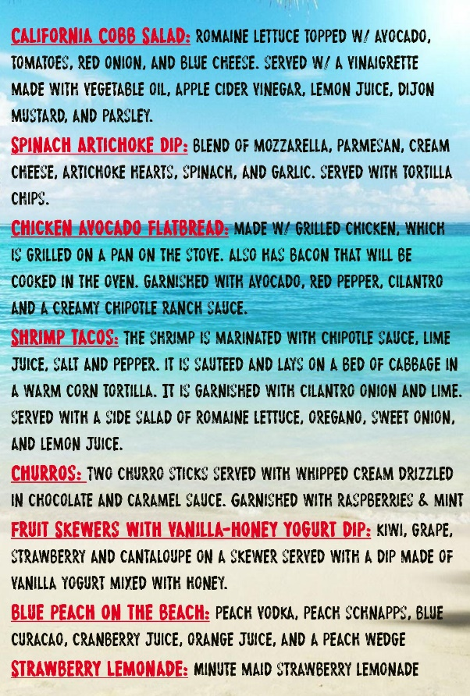

Bussers: Michelle Chan
Brittney Chancellor
Lei Fu
- Acknowledge all guests
- Know tables numbers
- Always prepare dining room for guest arrival (cleaning table and its surrounding/ setting tables)
- Set up table decorations after the table is clean
- Make sure serving stations are stocked at all times
- Keep menus presentable
- Remove guest’s dirty dishes and cleaning all spills made as needed
- Maintain bar
- Serve water and refills to the guests
- Follow all Sanitation guidelines

Food runners:
Nayeli Sosa
Allison Pipo
Anna Lei

- Help organize food tickets for the cooks
- Deliver food to the customers in a timely manner
- Serve water or refills to the customers as needed
- Have communication with the front and back of the house
- Assist the teams with any additional help needed
- Follow all Sanitation guidelines

POS instructions

- Employee Numbers for the servers have been listed above by their names.
Directions:
- You must type in your number and press OK to access the POS system
- After you enter your employee number, go to the bottom left and touch the tab New Table
- Enter the table number, the size of the party
- Get the entire order (including drinks, appetizers, meal, dessert, and wine/beers/cocktails) from your table
- Main screen will come on and it will show (Will be programed the day of by Summer and Mohsen):
- N/A Beverage
- First Course
- Entrees
- Dessert
- Spirit
- Beer
- Wine
- And you enter the above for each seat number (bottom left of the screen - push plus to add seats and arrows to maneuver)
5. After you enter all the information, press send and exit which is towards the top of the screen
- DO NOT FORGET TO LOG OUT EACH TIME YOU ARE DONE
6. Keep your eyes on your guests and track where they are at throughout the meal
7. After the guests are finished with each part of their meal, follow these steps…
Close to done with their appetizer ----> Fire Course Meal (Send and exit for each seat number)
Close to done with their meal ----> Fire Desert (Send and Exit for each seat number)
- DO NOT FORGET TO LOG OUT EACH TIME YOU ARE DONE
8. After their entire meal is completed, start getting ready for checks…
- Comment Cards
- Pen
- Receipt Holder
9. If the group is paying together, you will go back to the main screen and click print
10. If the group wants separate checks, go to functions and split checks by seat number
11. Present each Receipt Holder with the receipt, comment card, and pen to the correct seat number (do not remove any drinks people are still working on)
12. Give the Receipt Holder to the Cashier in the back and once change has been given or credit cards have been charged, return to the table.
13. After the cashier closes out your table, it will disappear from your main screen (you will not be able to open another tab on the table until the cashier closes it)
14. Repeat steps 1 - 13 for the next guests.

Uniform

Servers: You must wear Hawaiian shirt given to you, white shirt under Hawaiian shirt, black pants, black socks, and closed toe black shoes.

Bartenders: Bartenders will wear black shirts underneath Hawaiian shirts, black pants, black socks, and closed toe black shoes.

Bussers and food runners: FOH polo, Black Pants, Black Socks, and Black non-slip shoes.
All employees must look business professional and be groomed by maintaining their personal hygiene and having clean clothes. Please smile and be ready to have a fun beachy day in the desert!

Also, no cell phones. We would like a professional environment to maintain a great restaurant.
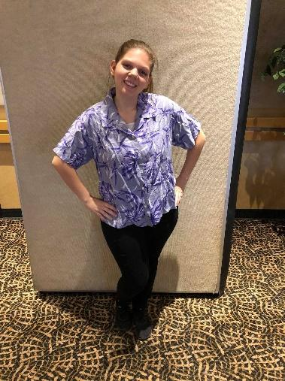
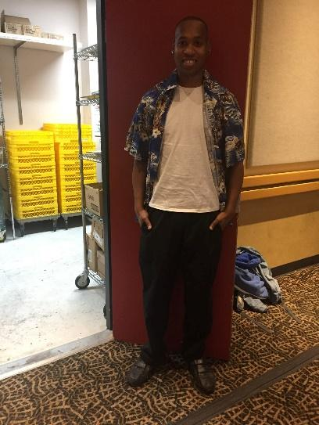

Dining Room Layout

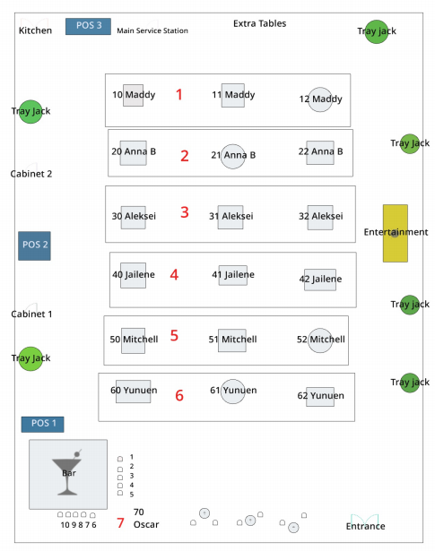

This will be printed and located in kitchen and at every POS station.

Sizes of tables: We will have three types of tables. We will have sixteen 52” by 52” square tables, four 85” by 85” round tables, and three highboy tables.

Tables and chairs: We have a total of 18 tables with 98 chairs because we are also serving at the bar and have talent coming.

Tablecloths: Our tablecloths will be light and royal blue. For our square 52” by 52” and the highboy tables, we will have royal blue and for the 85” by 85” we will have light blue.

Napkins: Our napkins will be white, and we will be rolling the silverware within the napkins. We will spend the day prior rolling and finish before our meal day.
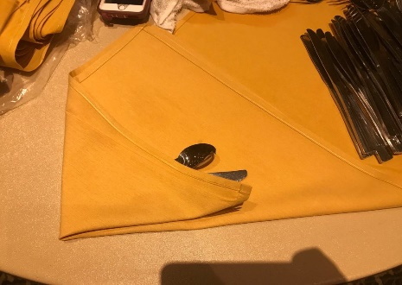
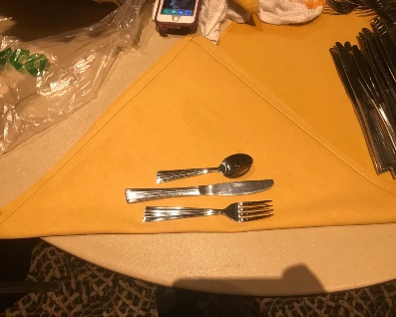

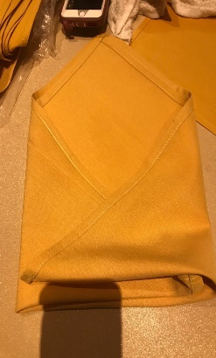

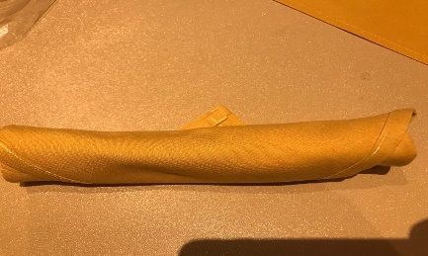

Service Stations (Cabinet 1 and Cabinet 2)
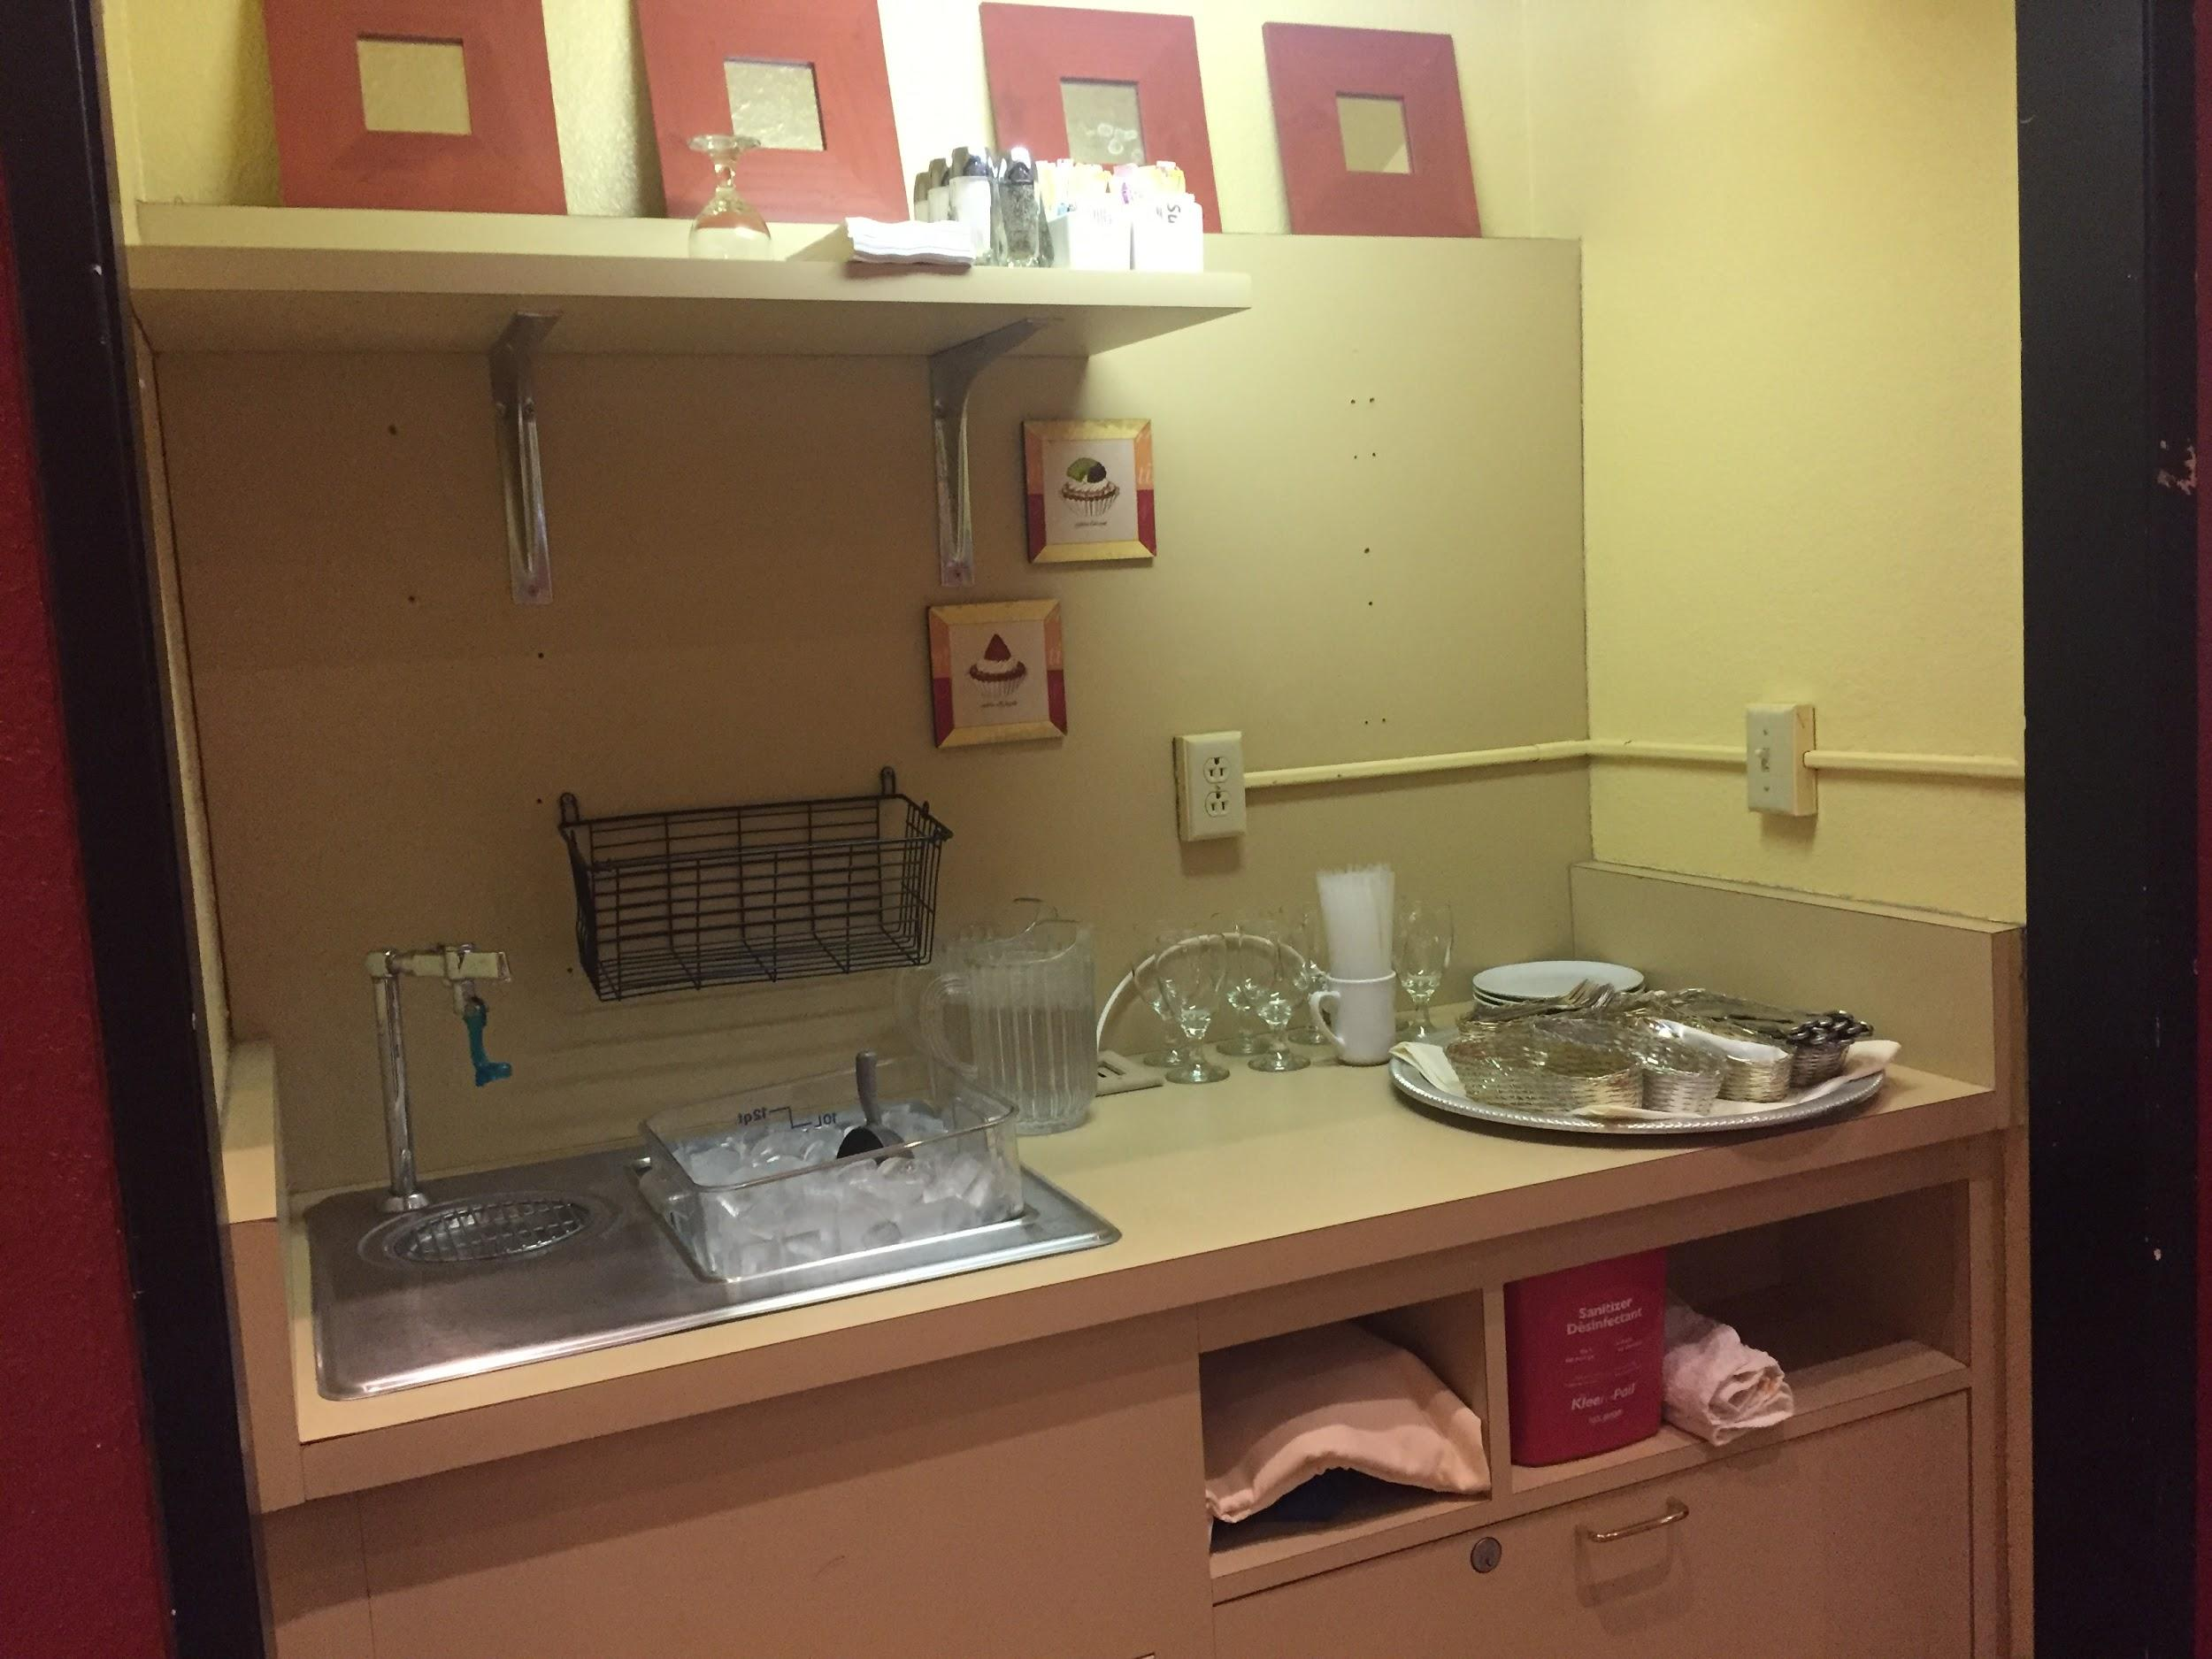

The service stations are stocked with multiple pitchers filled with water, a bucket of ice and ice scoop in sink, water glasses, condiments/salt and pepper shakers, sugar caddies, extra silverware organized separately, beverage trays, rolled up napkins, straws and extra linens. POS 1 and POS 2 will be using these stations.

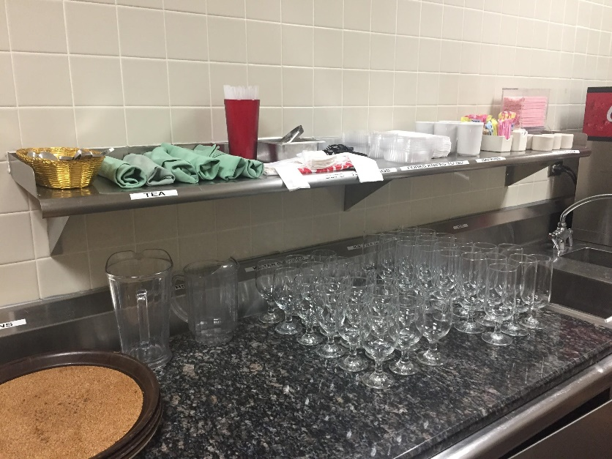
Main Service Station

The main service station needs pitchers filled with ice water, drink trays, lemon wedges with tongs, napkins, water glasses, iced tea glasses, ice in bucket with scoop, sugar caddies, straws, stirring straws, condiments, coffee cups, and creamer. As well as to go items like to go trays, plastic knives, plastic forks, and plastic bags. POS 3 will be using these stations.

Decoration
Our decorations are going to be themed with California beaches, the deep blue sea, and fun in the sun. As you walk up the stairs in BEH, you will see dark blue, light blue, and white balloons so our guests know they are in the right place. When you walk into the dining room, you will reach the hostess table, the first thing you will see is our team banner and fish net hanging from the tip of the counter. There will be sea shells as you are waited to be seated. To your right, you will see the bar that will have seashells in each corner and beach balls attached to fish line hooked by a tact hanging from the ceiling. As you are walking to your table, you will see a blue linen with our centerpiece and table setting. The center piece features a fish net with a message in the bottle and seashells surrounding the bottle. The guests will look around the room and see rafts, surfboards, beach balls, and fish located on the walls of the dining room. The price of decorations will be around $193.99, and we will purchase off Amazon except for the rafts which we will use our own materials. To enhance the level of entertainment for the guests, we will be having live entertainment (a DJ) as well a projection of the ocean/surf videos.
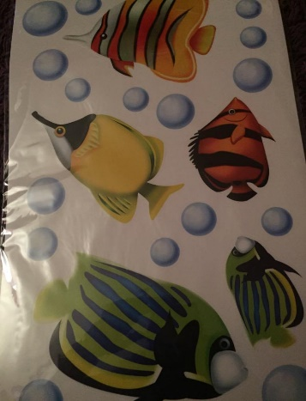
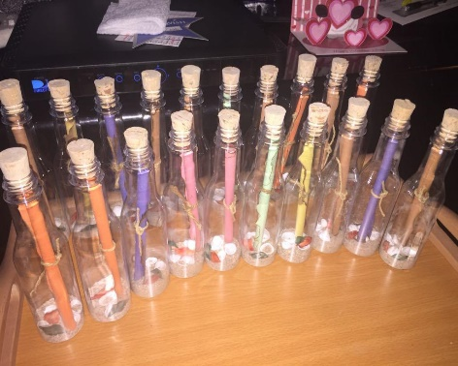
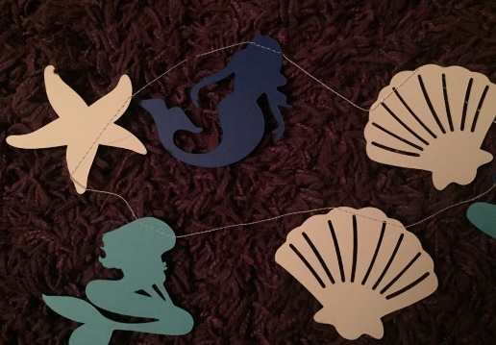

Plating

Plates: Plates will vary depending on our menu items. We have about 5 different types of plates we are using for our dishes.
Utensils: Utensils will be wrapped in linen in front of the guest. However, the table will still have the centerpiece, salt and pepper shakers, and water glasses. We will wrap utensils the day before and morning of our meal day.
Centerpiece: Our centerpiece consists of a message in the bottle, seashells, and fish net to make our guest feel by the ocean.

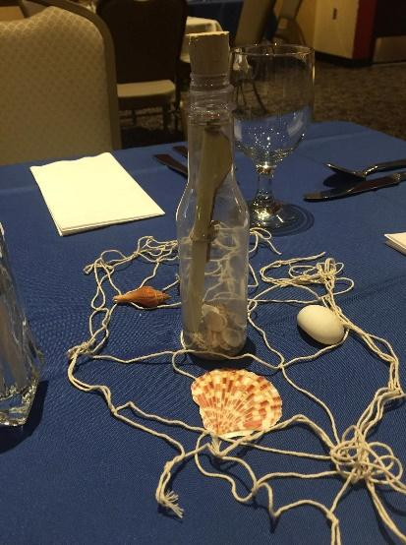

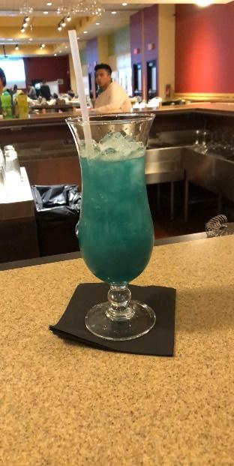
Beverage Menu with Photos
Blue Peach on a Beach
Ingredients
1 oz Peach Vodka
1 oz Cranberry Juice
1 oz Orange Juice
1 oz Peach schnapps
½ oz Blue Curacao
1 Wedge Peach
How to mix
Fill a shaker with ice cubes. Add all ingredients. Shake and strain into a chilled hurricane glass filled with ice cubes. Garnish with peach.
Time to prepare: 2 min

Strawberry lemonade
Ingredients
6 oz of minute maid strawberry lemonade
1-2 sliced strawberries
How to mix
Add all ingredients into a chilled Pilsner or Collins glass filled with ice cubes. Fill with club soda if necessary.
Time to prepare: 1 min
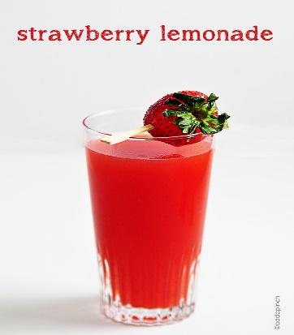
As well as full bar available: Assorted Beers, Wines, Soda, and Coffee
Bar Execution
Bartender – Volunteers and Oscar
- Must have Alcohol Awareness and Food Handler card at all times.
- Stock ice behind bar
- Cut peaches
- Stock straw, cocktail napkins, stir straws and coasters.
- Ensure glasses are polished and prepared
- Setup blenders and mixers at the service areas
- Stock utensils and supplies (strainer, shakers, jigger, wine opener, bottle openers pour spouts, etc.
- Set up speed rail according to manual
- Ice down and stock garnish.

Set-up bar station according to checklist.
● Prepare alcoholic and non-alcoholic beverages for bar and guests.
● Interact with customers, take orders, serve drinks.
● Prepare cocktails.
● Upsell specialty drinks (Strawberry Lemonade, Blue Peach on a Beach).
● Check customers’ identification and check if they meet legal drinking age.
● Restock and replenish bar inventory and supplies when necessary.
● Comply with food and beverage regulations.
● Clean glassware.
● Communicate with Bar Manager if in need of assistance.
● Break down bar station according to checklist.
Bar Ticket Execution
When servers need drinks at the bar they will simply ask the bartender to make their drinks. If the volume is too high and all bartenders are busy, the servers will then print a sheet of paper from the POS and write the order down; then they will lay it next to the POS system. Once the order is fulfilled the bartender will cross out the order and lay the drink on the paper. The bartenders will be split between well drinks and specialty drinks to increase efficiency. The bar manager will assist when necessary.
Food Menu with Photos
Cobb Salad: fresh romaine lettuce topped with avocado, blue cheese, red onion, and tomatoes, served with a vinaigrette dressing on a medium circle plate. This takes 20 minutes to prep, cook, and plate.
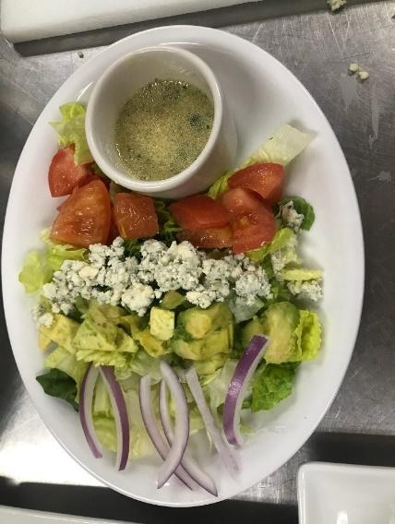

Spinach artichoke dip: creamy blend of mozzarella, parmesan, artichoke hearts, spinach, and garlic, served with tortilla chips on a rectangular plate with a deep oval shaped dish for dip. Takes an hour and a half to prep but will be prepped day before and 10 minutes to cook/plate.
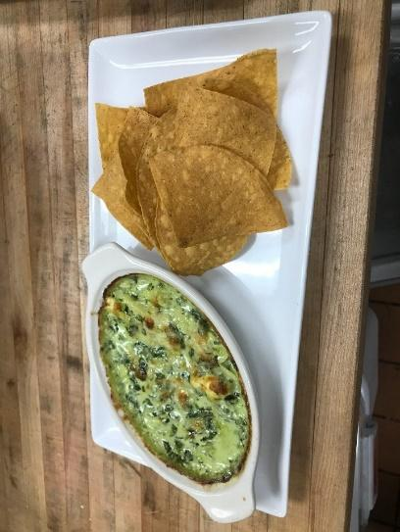

Shrimp tacos: sautéed shrimp on warm corn tortilla, garnished with cilantro, lime, and a sour cream avocado sauce on a deep clay circular plate. Takes 15 minutes to prep with 5 minutes to cook.

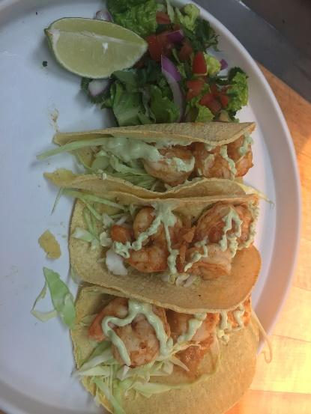

Chicken Avocado flatbread: Fried chicken flatbread topped with Applewood smoked bacon, avocado, red pepper, cilantro, and creamy chipotle ranch sauce on a large square plate. Takes 20 minutes to prep and 30 minutes to cook.

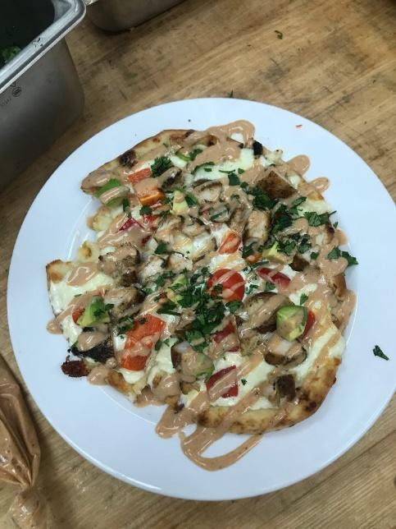

Churros: warm churro sticks drizzled with chocolate sauce in an oval small desert dish. Takes 5 minutes to cook and 5 minutes to plate.
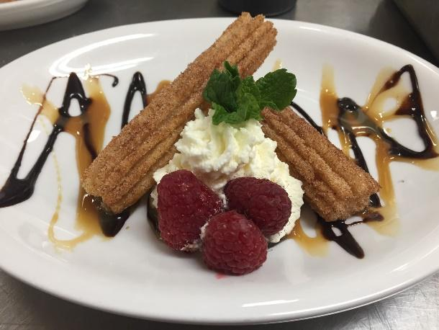

Fruit skewers with vanilla-honey yogurt dip: fresh kiwi, strawberry, cantaloupe, and grape on a skewer served with a vanilla-honey yogurt dip in a ramekin on top of a large rectangular plate. Takes 20 minutes to prepare and 5 minutes to plate.

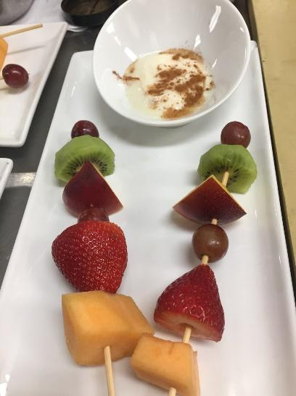

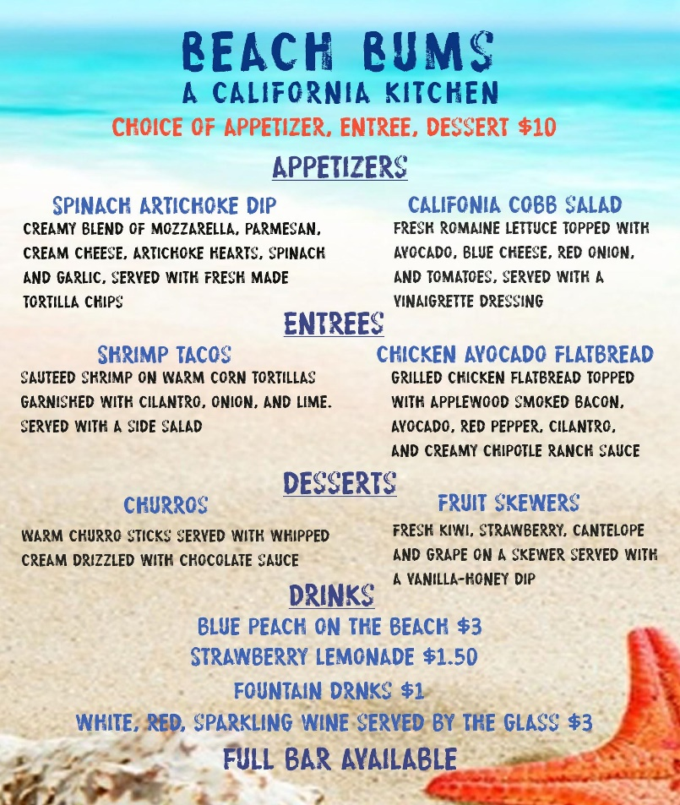

Execution of Menu in Kitchen

Salad- Maintain cold foods at 41 degrees or below. Salad will be placed in a medium-sized bowl. Once lettuce is tossed in dressing, place in middle of bowl. Place avocado slices on top and sprinkle the blue cheese and tomatoes over. 10 min

Artichoke Dip- Cool from 140 degrees to 70 degrees within two hours and to 41 degrees within 4 hours of reaching 70 degrees. Artichoke dip will be scooped into separate ramekins and placed on the side of an oval platter with tortillas chips. 25 min

Chicken Flatbread- Cook chicken to 165 degrees and cool. Then, cool from 140 degrees to 70 degrees within two hours and to 41 degrees within 4 hours of reaching 70 degrees. Cut the flatbread into four pieces and place on a medium, square plate. 5 min

Shrimp Tacos- Cook shrimp to 145 degrees and cool. Place three tacos on an oval platter with two lime wedges on either side to hold the tacos upright. 6min

Churros- Remain frozen until oven, day of service. Place two churros on a small plate, one crossed over the top of the other at the tips of the churros. Drizzle chocolate sauce on churros and spray whipped cream in the middle of the crossed churros. 5 min

Yogurt and Fruit- Maintain at 41 degrees or below. Scoop yogurt into a flat-rimmed dessert bowl and place on rectangular platter. Place three skewers on the platter in a pyramid formation. 1 min

