Back of the House Training Manual

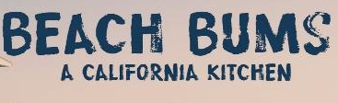

Training Manual

Our restaurant is Beach Bums California Cuisine on April 25th, 2018. Our theme is California style food with some beachy vibes surrounding the restaurant. We want to bring the beach to the desert.

Hours of Operation:
11:00 AM to 12:45 PM

Mission Statement:
Beach bums will provide a one-of-a-kind experience that brings people together for tasteful food, amazing service, and beachy fun.

Our Team:
Victoria Roberts, Executive Chef, 702.469.3704, roberv2@unlv.nevada.edu

Celeste Lozano, Sous Chef, 702.682.9282, lozanc1@unlv.nevada.edu

Weifang Zhou, Pastry Chef and Chief Steward, 702.408.4859, zhouw3@unlv.nevada.edu

Positions
On our meal day, everyone will have specific job duties. Victoria and Celeste will be responsible for checking the freshness of food, coordinating the activities of cooks, determining the best presentation of food, ensuring quality of each meal, inspecting kitchen equipment for cleanliness, and monitoring sanitation policies. Lastly, Weifeng will manage desserts and make sure kitchen stays clean throughout service. On top of their main line duties, all BOH employees must:
- Prepare food for service.
- Communicate and cooperate with the executive and sous chefs.
- Maintain a clean and safe station.
- Prepare all items in accordance with recipes, pictures, and instructions
- Ensure food follows all SNHD guidelines.
- Adhere to all safety and sanitation guidelines.
- Maintain attention to detail when plating food; i.e., proper portion sizes, plate is clean, all food is cooked to quality and up to safety standards.

Managers
Victoria- Executive Chef
- Adhere to all safety and sanitation guidelines and ensure all employees do the same.
- Ensure all plated items being sent out meet service standards.
- Communicate with employees the items that are being ordered when tickets come in and ensuring they are placed properly.
- Ensure orders are prepared in a timely manner.
- Check all orders for accuracy.
- Serve as liaison between all back of house staff and managers.
- Assist all BOH employees.

Celeste and Weifeng- Sous Chefs
- Adhere to all safety and sanitation guidelines and ensure all employees do the same.
- Ensure all plated items being sent out meet service standards.
- Communicate with employees the items that are being ordered when tickets come in and ensuring they are placed properly.
- Ensure kitchen stations are clean and safe and set with equipment and utensils.
- Assist all BOH employees.
- Empty and replace trash bags.
- Ensure dishes are not pilling up.

Kitchen Floor Plan with Station Layout

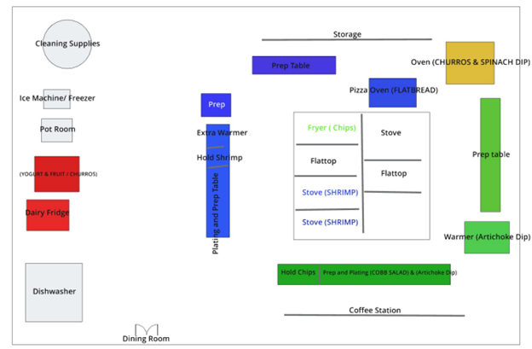

This is the layout on how we want the kitchen to look. Hopefully this will have a nice flow for back of house to get the dishes out in time.
In green, is our appetizers.
In blue, is our entrees.
In red, is our desserts.
In orange, is a combination of appetizers and desserts

At each station, we will be providing printed versions of all prep and service recipes for each item

Menu Descriptions, Execution in Kitchen, and Plating
Cobb Salad: fresh romaine lettuce topped with avocado, blue cheese, red onion, and tomatoes, served with a vinaigrette dressing on a medium circle plate. This takes 20 minutes to prep, cook, and plate.
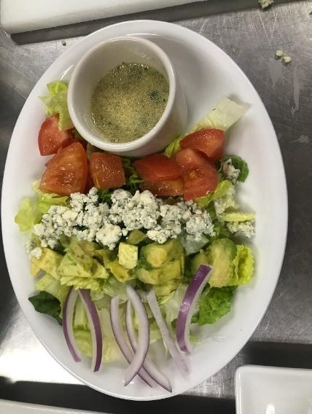
Spinach artichoke dip: creamy blend of mozzarella, parmesan, artichoke hearts, spinach, and garlic, served with tortilla chips on a rectangular plate with a deep oval shaped dish for dip. Takes an hour and a half to prep but will be prepped day before and 10 minutes to cook/plate.

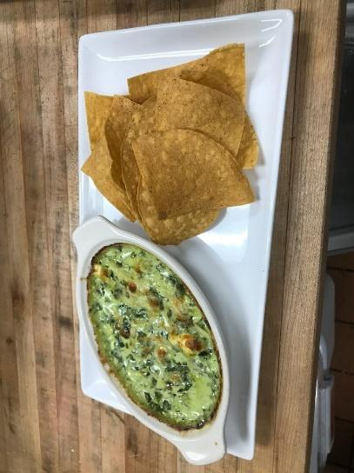

Shrimp tacos: sautéed shrimp on warm corn tortilla, garnished with cilantro, lime, and a sour cream avocado sauce on a deep clay circular plate. Takes 15 minutes to prep with 5 minutes to cook.

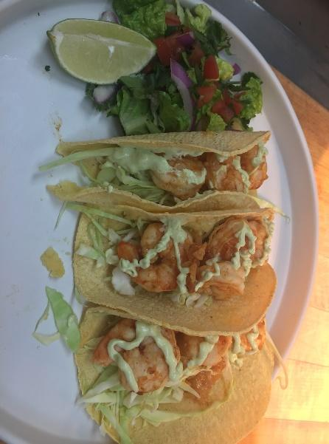

Chicken Avocado flatbread: Chicken flatbread topped with Applewood smoked bacon, avocado, red pepper, cilantro, and creamy chipotle ranch sauce on a large square plate. Takes 20 minutes to prep and 30 minutes to cook.
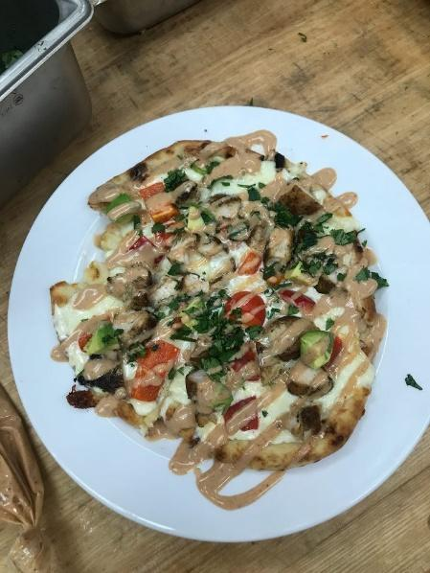
Churros: warm churro sticks drizzled with chocolate sauce in an oval small dessert dish. Takes 5 minutes to cook and 5 minutes to plate.

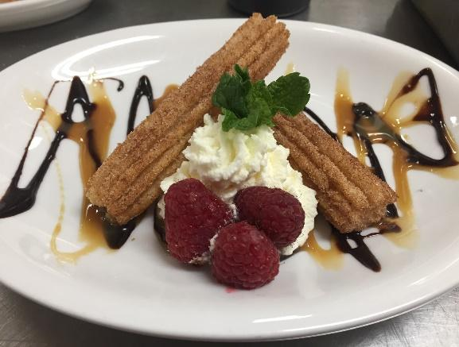
Fruit skewers with vanilla-honey yogurt dip: fresh kiwi, strawberry, cantaloupe, and grape on a skewer served with a vanilla-honey yogurt dip in a ramekin on top of a large rectangular plate. Takes 20 minutes to prepare and 5 minutes to plate.

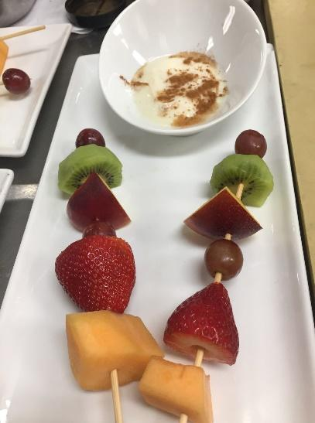

Food Stations
Salad- Maintain cold foods at 41 degrees or below. Salad will be placed in a medium-sized bowl. Once lettuce is tossed in dressing, place in middle of bowl. Place avocado slices on top and sprinkle the blue cheese and tomatoes over. 10 min

Artichoke Dip- Cool from 140 degrees to 70 degrees within two hours and to 41 degrees within 4 hours of reaching 70 degrees. Artichoke dip will be scooped into separate ramekins and placed on the side of an oval platter with tortillas chips. 25 min

Chicken Flatbread- Cook chicken to 165 degrees and cool. Then, cool from 140 degrees to 70 degrees within two hours and to 41 degrees within 4 hours of reaching 70 degrees. Cut the flatbread into four pieces and place on a medium, square plate. 5 min

Shrimp Tacos- Cook shrimp to 145 degrees and cool. Place three tacos on an oval platter with two lime wedges on either side to hold the tacos upright. 6min

Churros- Remain frozen until oven, day of service. Place two churros on a small plate, one crossed over the top of the other at the tips of the churros. Drizzle chocolate sauce on churros and spray whipped cream in the middle of the crossed churros. 5 min

Yogurt and Fruit- Maintain at 41 degrees or below. Scoop yogurt into a flat-rimmed dessert bowl and place on rectangular platter. Place three skewers on the platter in a pyramid formation. 1 min

Highly Perishable Food and how to handle them
Perishable foods are foods that have not undergone a preservation process such as drying, salting or canning. so fresh fruit and vegetables, fresh meat, eggs, cheese, bread etc. Highly perishable foods will be refrigerated within 2 hours, 1 hour if the temperature is higher than 90 degrees Fahrenheit (32.2 degrees Celsius). These foods will be kept at 40 degrees Fahrenheit or below frozen at 0 degrees Fahrenheit. To avoid condensation, our entrees will not be covered before refrigerating.
Chicken- We are going to defrost frozen chicken properly before cooking by storing all our meat in the refrigerator properly (wrapped in plastic)
Shrimp- - Follow traditional HPF standard rules. Additional rules will be stored carefully and will be placed in the coldest part of the refrigerator no more than 3 days.

Cooling Stations
The temperature danger zone is the range between 41˚F and 135˚F (5˚C and 57˚C). Harmful bacteria grow well in that zone. And within that zone, bacteria grow even faster between 125˚F and 70˚F (52˚C and 21˚C). Food must pass through this temperature range quickly to reduce this growth.
The general rule: Foods that need time and temperature control for safety (TCS food) must be cooled from 135˚F (57˚C) to 41˚F (5˚C) or lower within six hours.
First, cool food from 135˚F to 70˚F (57˚C to 21˚C) within two hours.
Then cool it from 70˚F to 41˚F (21˚C to 5˚C) or lower in the next four hours.
If the food hasn’t reached 70˚F (21˚C) within two hours, it must be reheated and then cooled again. If cool the food from 135˚F (57˚C) to 70˚F (21˚C) in less than two hours, use the remaining time to cool it to 41˚F (5˚C) or lower. However, the total cooling time cannot be longer than six hours.

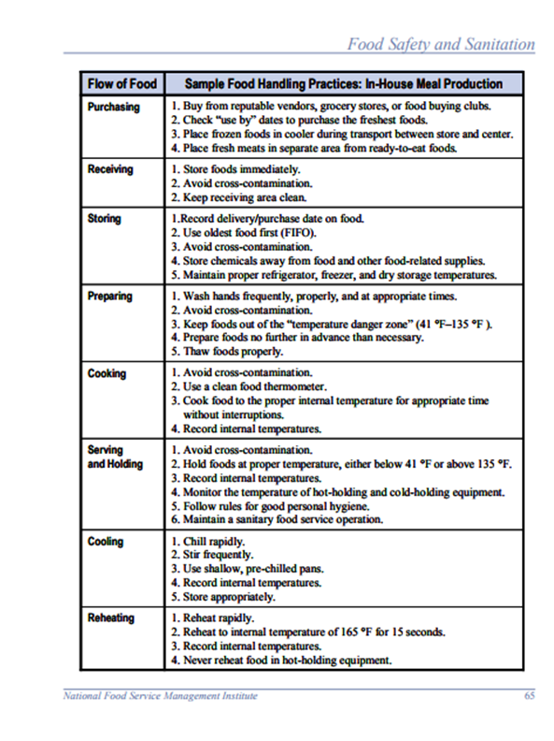

Pull Day Timeline (4/24/18)

8:00am:
- Prepare the alfredo sauce that will used for both the artichoke dip and flatbread and let cool.
- Cut and prep all items for salad.
- Prep yogurt bowls.
- Cook, cut, and store bacon.

9:30am:
- Make artichoke and separate into individual ramekins for service the next day.
- Prep side salad for tacos.
- Prep avocado and sour cream dip for tacos.
- Prep chipotle ranch dip for flatbread.

11:00am:
- Marinate and prep shrimp.
- Cook, cool, and cut chicken for flatbread.
- Cut peppers for flatbread.
- Cut and skew fruits for fruit skewer dessert.

12:30pm:
- Ensure all items are stored properly.
- Clean dishes and kitchen.
- Begin all prep for dining room that can be taken care outside of dining room.

Timeline of Food Prep and Execution

Day Before Meal:
8AM-2PM - (ENTIRE TEAM) Prep Cobb Salad dressing, Spinach Artichoke dip, marinate shrimp, onion side for Shrimp Tacos, sauce for Shrimp Tacos, entire flatbread, and vanilla honey yogurt.

Day of Meal:
7:00 am: All BOH managers should be ready for setup:
- Executive Chef, Victoria Roberts controls, checks and supervises the kitchen operations and ensures all the ingredients for the Grilled chicken flatbread & Spinach artichoke dip.
- Sous Chef, Celeste Lozano check all ingredients for cobb Salad & Shrimp tacos.
- Pastry Chef and Chief Steward, Weifeng Zhou check all ingredients for the churros & Fruit skewers. Open dish-washing machine, and make sure it is clean and work properly.
- Prep mise en place for employees

7:30 am: All BOH managers should ensure:
- Stations are clean and sanitized.
- All the ingredients and necessary tools should on each station.
- Executive Chef, Victoria Roberts start to season chicken breast with salt and pepper to taste, brush naan bread with olive oil for chicken flatbread. Slice baguette and toast, also, mix together Parmesan cheese, spinach, and artichoke hearts. Combine remaining ingredients and mix with spinach mixture.
- Sous Chef, Celeste Lozano place all the ingredients into large mixing bowl for the Cobb Salad. Wash shrimps, wipe dry and mix with seasoning for shrimp tacos.
- Pastry Chef and Chief Steward, Weifeng Zhou cut all fruits for skewers, make sugar and cinnamon for the churros.

8:00 am: All staffs should be ready for setup:
- Managers should double check all BOH staffs’ uniforms, hat, and non-slip shoes.
- Managers should ensure each staff follows the sanitation guideline.

8:05 am: All BOH managers have a meeting with all BOH staffs.
- Managers should make sure all BOH staffs understand recipes, portion size, and food presentation.

8:30 am: Make sure all stations are setup properly, and all staffs work properly on each station.

9:00 am: Prepare food and ready for restaurant open
- Executive Chef, Victoria Roberts oversee and instruct employees making chicken flatbread & Spinach artichoke.
- Sous Chef, Celeste Lozano oversee and instruct employees making tacos and salad.
- Pastry Chef and Chief Steward, Weifeng Zhou oversee and instruct employees making desserts

10:40 am: All BOH managers have a meeting with all BOH staffs.
- Make sure all staffs know their own responsibility.
- Everyone on their own stations before opening.
Have FOH Meeting for FOH Staff

11:00 am: Restaurant open
- Executive Chef, Victoria Roberts coordinate and manage kitchen and BOH staffs, check all food on main line before it goes out.
- Sous Chef, Celeste Lozano coordinate and manage tickets and ensure appetizers are set properly.
- Pastry Chef and Chief Steward, Weifeng Zhou ensure all staffs follows the sanitation guideline and all stations are always clean and sanitize, check all desserts.

Positions of Kitchen Staff

Salad station: Anthony Jamieson & Patricia Medina

- Chop lettuce.
- Toss lettuce in dressing.
- Slice avocados.
- Place lettuce and dressing mixture in medium-sized bowl.
- Place sliced avocado on top.
- Sprinkle diced tomatoes and crumbled cheese.
- Follow all safety and sanitation guidelines.

Dip station: Marina Ruffo & Chad Tam

- Reheat artichoke dip in oven.
- Place in warmer.
- Sprinkle parmesan cheese over dip.
- Place on oval platter with handful tortilla chips.
- Follow all safety and sanitation guidelines.

Taco station: Miriam Sol Toraya & Olivia Barnaby

- Heat shrimp mixture in pan.
- Heat tortillas on flat-top.
- Place shrimp mixture in tortillas and sprinkle with cilantro.
- Place three tacos on platter with two lime slices and side salad.
- Follow all safety and sanitation guidelines.

Flatbread station: Taylor Phillips & Sara Sadaro

- Brush naan bread with olive oil.
- Spread tablespoon of alfredo sauce on bread.
- Sprinkle cheese, pre-cooked chicken, bacon, and peppers on top.
- Heat in oven.
- Dice avocado.
- Remove flatbread from oven and let cool.
- Sprinkle avocado and cilantro on top of flat bread and drizzle chipotle ranch mixture on top.
- Cut into four pieces.
- Place on platter.
- Follow all safety and sanitation guidelines.

Churro station: Tianze Yang & Daiki Hayashi

- Bake churros in oven.
- Roll in cinnamon sugar mixture.
- Place on platter, one crossing over the other.
- Drizzle chocolate sauce over the top.
- Spray small amount of whipped cream in the middle.
- Follow all safety and sanitation guidelines.

Yogurt station: Tanner Jackson

- Lightly sprinkle yogurt bowl with cinnamon.
- Place yogurt bowl on platter.
- Place two skewers on platter.
- Follow all safety and sanitation guidelines.

Dishes: Yedam Lee & Zixuan Wu

- Ensure all dishes are being cleaned, dried, and put away in a proper and timely manner.
- Make sure dishes are not piling up.
- Ensure bussers are organizing the dishes in a proper manner.

Uniform
Back of the House: You must wear a Chef Hat, Coat, Pants, and Apron. Black socks and solid black non-slip shoes.
All employees must follow safety and sanitation guidelines and be groomed by maintaining their personal hygiene and having clean clothes.

Hygiene Policy
All employees must wash their hands daily throughout their shift.
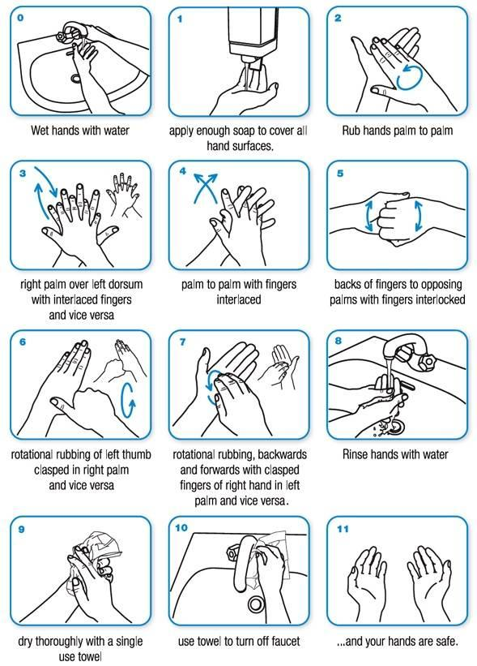
All employees must look business professional and be groomed by maintaining their personal hygiene and having clean clothes.

Hand washing:
Hands must be washed and dried before starting work with food, after restroom use, between tasks and if work is interrupted. For hand washing to be effective, washing must include the backs of the hands, palms, exposed arms, between fingers and under fingernails. Hands should be rubbed vigorously with soap for a minimum of 20 seconds, then rinsed and dried with a clean paper towel.

Clothing:
Employees should wear clean uniforms when preparing or serving food products or washing and sanitizing equipment and utensils. Personal belongings should be stored away from food handling, preparation and storage areas. If employees routinely change clothing at the establishment, a room should be provided for this use. Changing areas should be separate from food preparation and storage areas.

Hair restraints:
Employees who prepare food should wear hair coverings such as hair nets, hats or scarves. Bearded employees should wear beard nets. Employees such as counter staff, hostesses, wait staff and bartenders may not be required to wear hair restraints if they present a minimal risk of contaminating food and equipment.
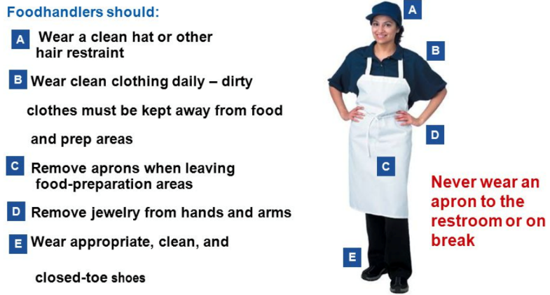

Fingernails and jewelry:
When preparing food, employees should:
- Keep their fingernails trimmed so they are easy to clean.
- Wear gloves when working with food if wearing fingernail polish or artificial nails.
- Not wear jewelry on the arms and hands. This does not apply to a plain ring such as a wedding band.

Cuts, wounds and sores:
All cuts, wounds or open sores on the hands and arms must be covered by a waterproof bandage. Single-use gloves must be worn over any bandage on the hands and fingers.
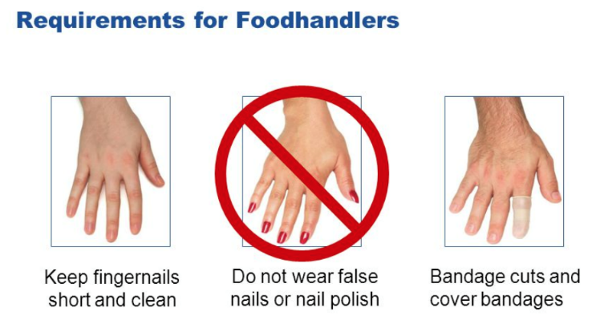

Ill or infected employees:
Employees with the following symptoms should notify their supervisor immediately:
• Fever
• Sneezing and coughing
• Diarrhea or vomiting
• Sore throat with fever
• Jaundice
Ill employees should not be allowed to prepare or handle food, sanitize equipment or perform other duties that present potential for possible contamination. This includes handling utensils and linens.

Back of House Checklist:

Day Before Meal:
- Have station map ready
- Have all recipes printed
- Know what staff members oversee what station
- Make sure all equipment needed is in store and ready for use
- Prep any items needed ex:
1. Chicken
2. Bacon
3. Dressings
4. Shrimp
5. Cut limes
- Make sure all ingredients are in sight and ready to go the next day
- Make sure all prepped items are stored and cooled down in accordance to health regulations
- Make sure all items are labeled so staff knows what items are to be used
- Make sure we are aware how many prepped items we have and for how many guests

Day of Meal Before Opening (Check - In):
- Set up all stations needed with equipment and sanitation*
- Put up recipes at their designated stations
- Check and gather all needed ingredients and prep items
- Ensure POS system is functioning and printing orders servers input
- Check in staff and make sure everyone is in proper uniform- and have their cards
- Ensure all staff is following proper SNHD policies and procedures
- Hold an effective Pre-shift with BOH team
- Assign staff to proper stations
- Ensure staff is aware of the food they will be plating
- Ensure staff is aware of the process in which to execute their assigned dishes
- Make sure plates are at hand and ready according to the dish being plated
- Ensure proper communication and organization within kitchen staff is in place

Day of Meal Closing Procedure (Check - Out):

- Break down all food stations
- Make sure all kitchen equipment and dishes are properly washed and sanitized
- Ensure any leftover ingredients are properly wrapped, labeled, and placed fridge
- Sanitize kitchen tops and make sure all stations are wiped down
- Communicate with FOH ensuring all dirty dishes are placed by the dishwasher
- Air dry all kitchen utensils and equipment
- Put kitchen utensils and equipment away in their proper spots
- Sweep and mop kitchen
- Break down dishwasher sink and clean
- Ensure all kitchen is left clean and organized before any BOH staff leaves

Below are all the recipes so you can look over to see how you will making each item.
PREP RECIPE

PRODUCT NAME: California Cobb Salad Dressing  Final Pan for Service: 1/9 pan  TEMPERATURE: no heat |  | YIELD: 4 servings  PORTION SIZE: 2 cups  COOKING TIME: 10 min

INGREDIENTS | QUANTITY |  | PROCEDURE
 | WT | VL
Vegetable oil |  | 6 oz | - Chop parsley and place all ingredients into large mixing bowl.
Cider vinegar |  | 1 oz
Lemon juice |  | 1 oz
Dijon mustard |  | 1 oz
Parsley |  | ½ oz

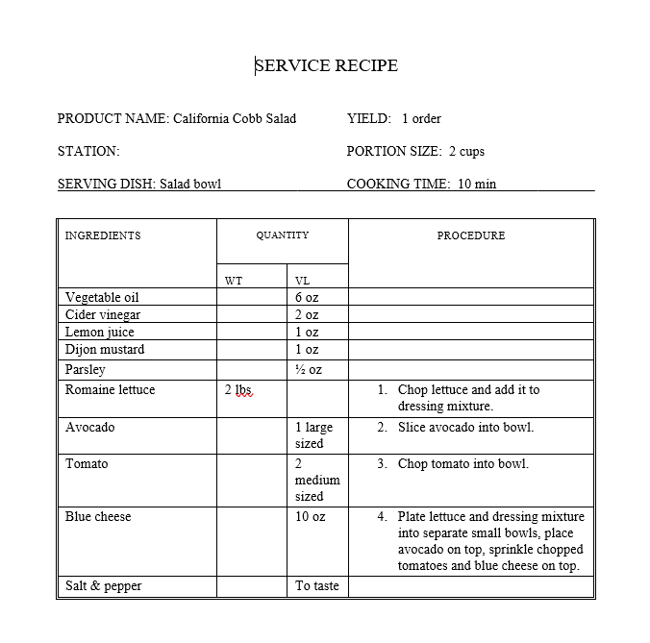

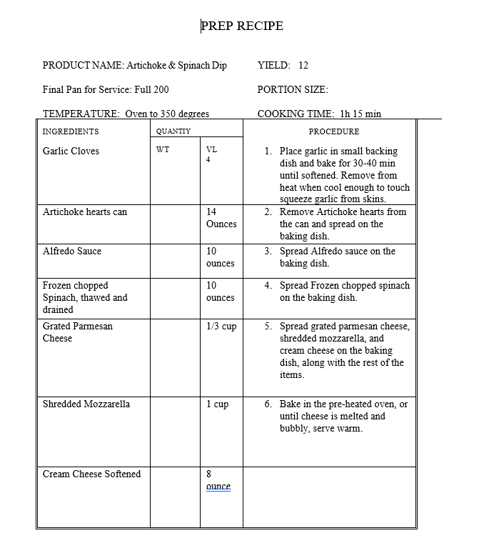

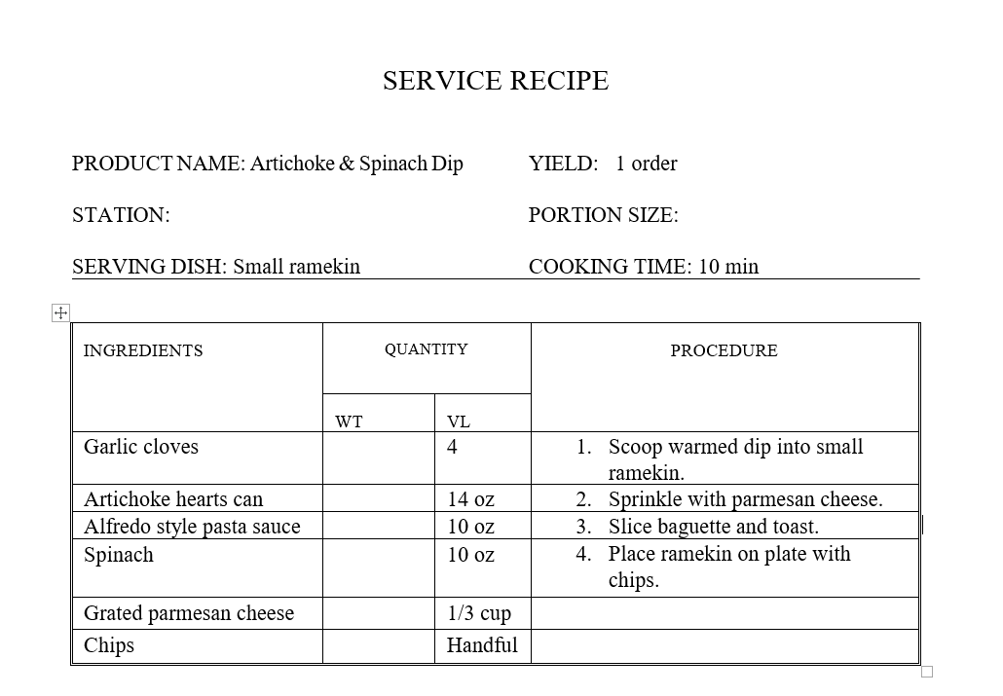

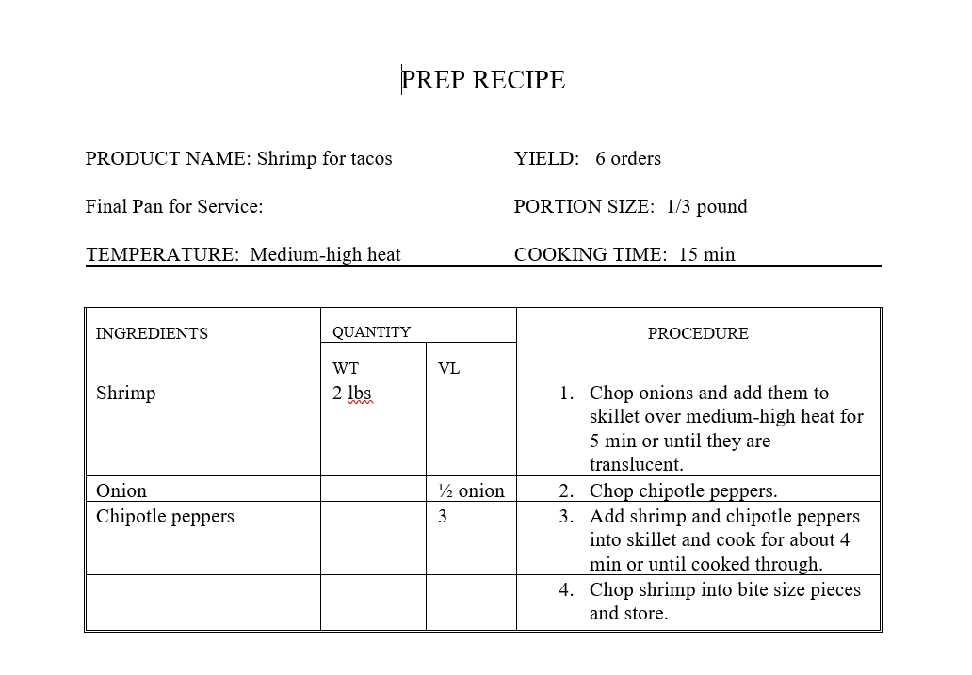

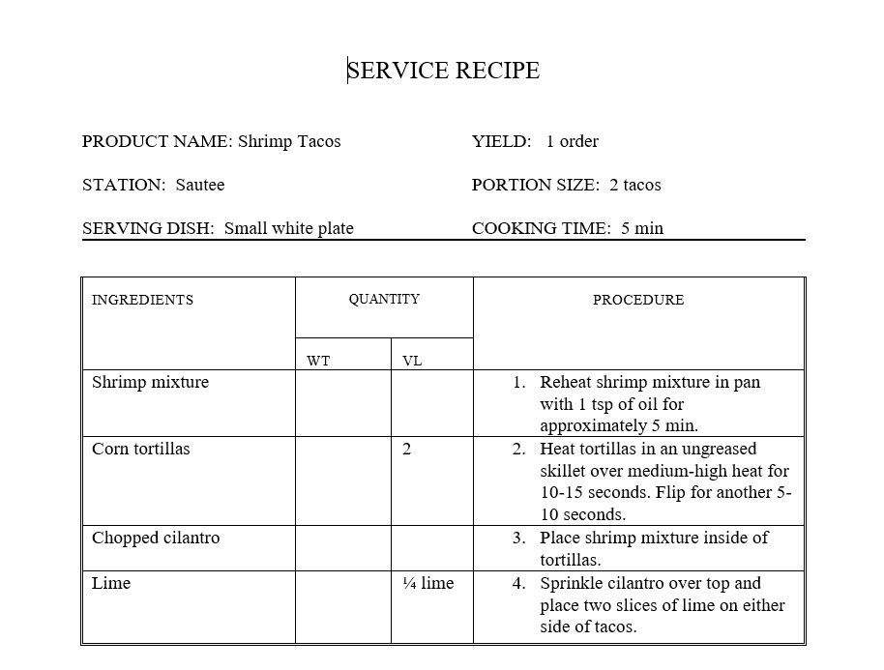

PRODUCT NAME: Chicken for flatbread  Final Pan for Service: 200  TEMPERATURE: Medium-high heat |  | YIELD: 1 breast  PORTION SIZE: 1 breast for each flatbread  COOKING TIME: 10 min
PREP RECIPE

INGREDIENTS | QUANTITY |  | PROCEDURE
 | WT | VL
Chicken breast |  | 1 | - Season chicken breast with salt and pepper to taste.
Salt |  |  | - Sauté chicken in pan on stove over medium-high heat for about 3-4 min on each side or until cooked through.
Pepper |  |  | - Dice chicken and set aside.

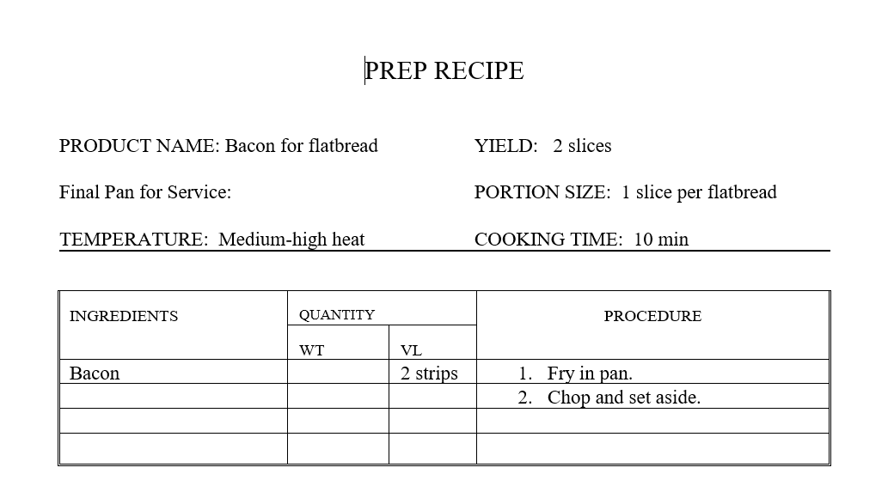

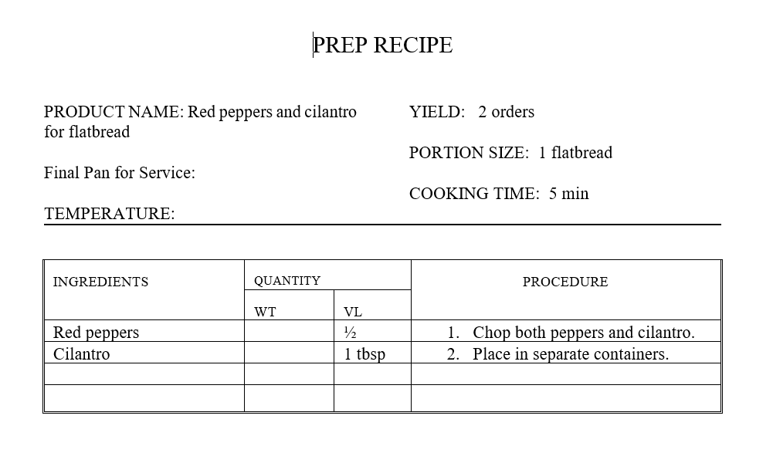

PREP RECIPE

PRODUCT NAME: Chipotle ranch for flatbread  Final Pan for Service:  TEMPERATURE: |  | YIELD: 1 cup  PORTION SIZE: 1/16 cup  COOKING TIME: 5 min

INGREDIENTS | QUANTITY |  | PROCEDURE
 | WT | VL
Ranch dressing |  | 1 cup | - Whisk together chipotle seasoning and ranch
Chipotle seasoning |  | ½ can

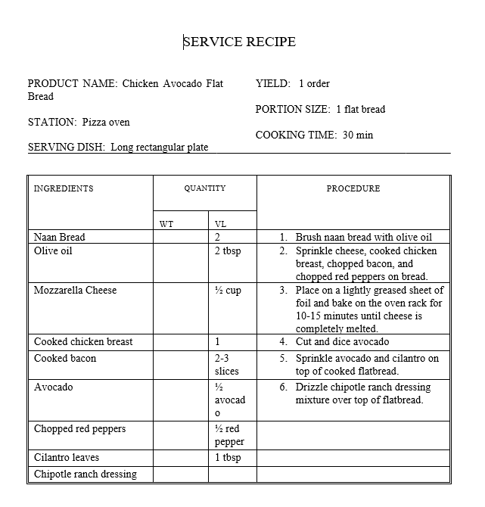

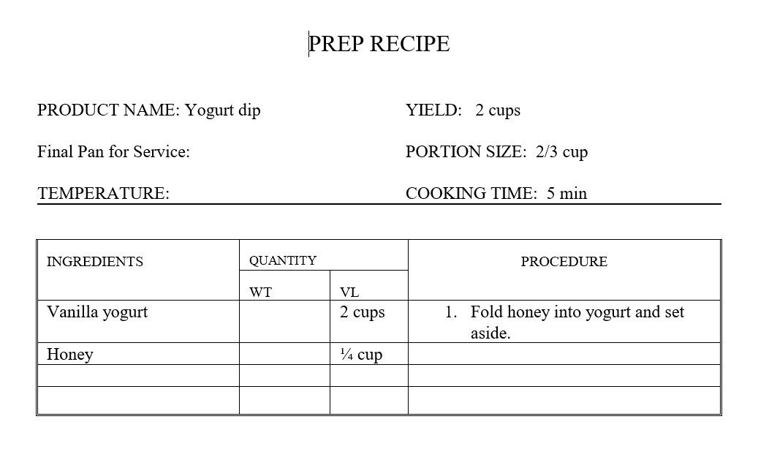

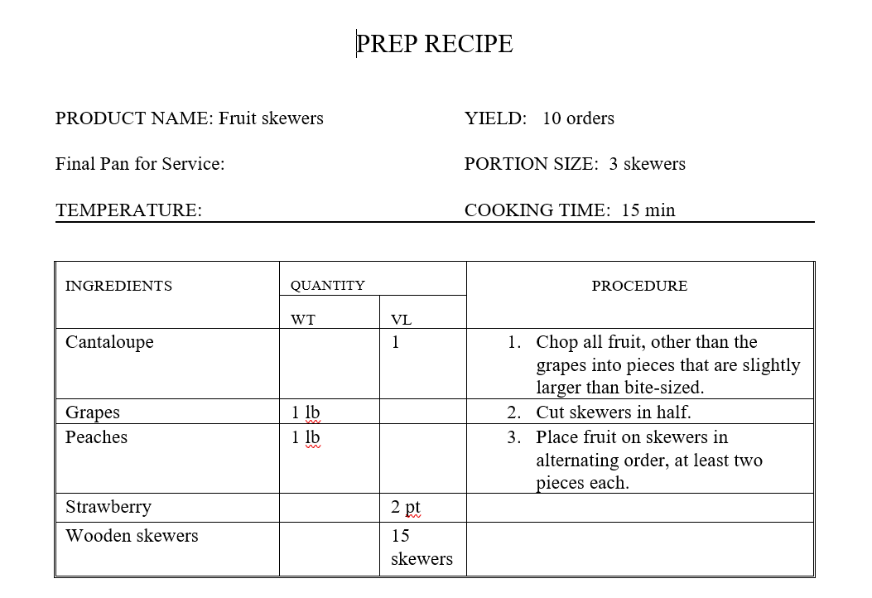

SERVICE RECIPE

PRODUCT NAME: Fruit Skewers with Vanilla-Honey Yogurt Dip  STATION: Dessert  SERVING DISH: Long rectangular plate and ramekin |  | YIELD: 1 order  PORTION SIZE: 2 skewers  COOKING TIME: 5 min

INGREDIENTS | QUANTITY |  | PROCEDURE
 | WT | VL
Long wood skewers |  | 2 skewers | - Chop fruit and place 2 pieces of each fruit on skewer, alternating between.
Chopped fruit |  | 8 pieces | - Place yogurt mixture into small ramekin and sprinkle with ground cinnamon as garnish.
Yogurt mixture |  | 1/2 cup | - Place fruit skewers and ramekin on plate.

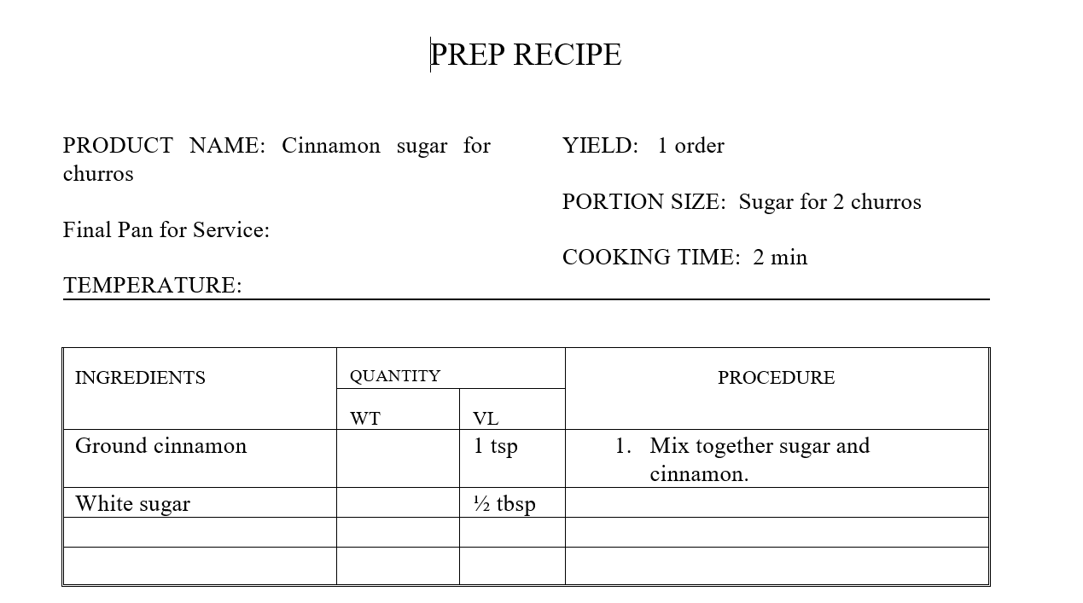

SERVICE RECIPE

PRODUCT NAME: Churros  STATION: Oven  SERVING DISH: Small rectangular plate |  | YIELD: 1 order  PORTION SIZE: 2 churros  COOKING TIME: 7 min

INGREDIENTS | QUANTITY |  | PROCEDURE
 | WT | VL
Churro |  | 1 | - Bake churros based on information on packaging or until golden.
Caramel syrup |  | 1 tsp | - Roll churros in cinnamon and sugar mixture.
Ground cinnamon |  | 1 tsp | - Plate churros with whipped cream and drizzle with chocolate and caramel syrup.
White sugar |  | ½ tbsp
Chocolate syrup |  | 1 tsp

